Instructions for delegates

Accessing the eProgram
- We will use an eProgram that will provide all of the links and information you will need to participate in the conference. The eProgram is housed on the website of the Deakin Geelong STEM Hub.
- Delegates (non-presenting) will have access from Thursday October 14
- Access the eProgram here: https://www.geelongstemhub.org/lobby
- Some pages of the eProgram will require a password, which will be emailed on October 14.
- Go to the Lobby where all of the different Pages of the eProgram are explained.
- You do not need to sign up to sessions beforehand. You can attend any session you like.

Zoom Rooms
- There are 5 Zoom Rooms. These are accessible from the eProgram pages: Day 1 and Day 2

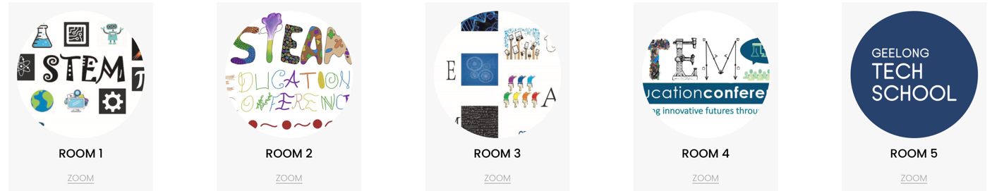

- Each room has a dedicated Zoom link that is active for the whole conference.
- The Zoom links are provided in the eProgram. Always use these links.
- A Zoom Master will be available in each room in case you have questions or would like assistance.

Accessing a presentation or workshop
- Find out about the workshops and presentations by looking at the abstracts, available from the Abstract page; or from the Day 1 or Day 2 pages by clicking on the author name/s.
- To access a Zoom Room, go to the page in the eProgram for the Day (Day 1 or 2). Find the session you want and click on the ‘Zoom’ link
- Be ready to enter the Zoom Room you want to enter on time, if possible.
- Be aware that if there is a presentation in your Zoom Room beforehand, they will be active until the end of their designated time.

Paper presentations
- There are two Paper Sets with five streams. The papers are sorted into themes to assist in selection.
- You can attend papers from different themes in the one Paper Set if you wish.
- Presentations are for 20 minutes: 15 minutes to present, 5 minutes to ask questions.
- The question time will be chaired by the Zoom Master. You can ask questions in the Chat during the presentation. Participants can raise their hand during question time to ask a question, then the Zoom Master will invite you to unmute and ask your question. Depending on how many people are in your session, this controlled process might be relaxed and you may be able to ask questions freely.

Workshops
- There are four Workshop sets.
- Workshops are 50 minutes, expect the Geelong Tech School workshops are ‘doubles’.
  - The presenter will decide how the session will be used for presenting, input from delegates and activities.
- Some workshops have materials to access, download or get ready beforehand. These are marked in the program with ** next to the author’s names and you can see what is required in the abstracts.
- We would discourage workshop hopping, simply because you might missing something important if you come in half way. Also, some will be using breakout rooms and other online programs so it will be difficult to manage situations where new people are arriving after half way through.

Social opportunities
- We have set up social areas where you can mix with others. We are using the Wonder.me platform for this – it is a virtual meeting place where you can wander around room and ‘bubble’ with others to talk – you can ‘work the room’ if there are lots of people there. The Wonder Rooms will be open for the whole conference so use them whenever, organise to meet someone to catchup, use them in the breaks. Also we will use them for the Virtual Breakfast where we will all meet prior to the day commencing on Day 2, and for the scheduled Networking time and Trade show.

Useful hints:
- If you are comfortable and if your bandwidth allows, please do turn on your ‘Video’ as it is nicer to speak to faces rather than black screens.
- You might like to use a Zoom background. Here’s how: https://support.zoom.us/hc/en-us/articles/210707503-Changing-your-Virtual-Background-image . You can use you own images as backgrounds, eg. try this site for examples: https://unsplash.com/backgrounds/apps/zoom
- Close other applications or tabs that you might have open to maximise performance of your computer (it will run faster!)
- Lighting: try to use soft front lighting if possible, avoid backlighting
- For help, please use the conference email: stemedcon21@deakin.edu.au

