Chemical Science Year 5/6

Purposes of the Project: This sequence of activities has been structured to attend to several key research outcomes. To see more: https://imslearning.org/
- Engage in an interdisciplinary approach to Mathematics and Science learning that focusses on common concepts with synergistic, mutual gain to support deeper learning in both;
- Focus on learning outcomes, including assessing these outcomes;
- Teachers and students as co-researchers;
- Refine guided inquiry teaching and learning approaches;
- Facilitate student modelling and representation construction work;
- Teacher led strategies of modelling – invent, evaluate, refine, extend and use with meaningful, interesting tasks for students;
- Longitudinal tracking of students modelling and learning through the process above; and
- Produce exemplary learning sequences.
KEY CURRICULUM OUTCOMES:

Chemical sciences | 3 & 4 | 5 & 6
Objects are made of materials that have observable properties | A change of state between solid and liquid can be caused by adding or removing heat | Solids, liquids and gases behave in different ways and have observable properties that help to classify them
Everyday materials can be physically changed or combined with other materials in a variety of ways for particular purposes | Natural and processed materials have a range of physical properties; these properties can influence their use | Changes to materials can be reversible, including melting, freezing, evaporating, or irreversible, including burning and rusting

Sequence Overview
- Using particle ideas to explain changes of state in water – melting, evaporation.
- Extending particle ideas to model dissolving of sugar
- Establishing modeling as a key process – the partial nature of representations
- Linking the micro-structure of materials to properties
- Developing inquiry skills: questioning, planning, observing, communicating
- Developing measures to allow experimentation and comparison
- Data modeling – tables and graphs work

Lesson sequence
Week | Activity
1 | Mapping water in the school – introducing particle ideas. Eucalyptus oil evaporation – modeling the process using particle ideas.
2 | Modeling phase transitions solid liquid gas using particle ideas. Evaporation of puddle. Modeling using role play, drawing, 3D model. Set up evaporation experiment – under what conditions will water in a container evaporate quickest?
3 | Working on results of evaporation experiment. Disappearing handprint. Story of a water molecule.
4 | Dissolving different sugars – measuring times of dissolving and thinking about volume-surface area ratio. Modeling dissolving with a particle model.
5 | Consumer science – paper towel investigation. Devising an experiment to compare different paper towels for their mopping up ability. Measurement and scoring as a mathematical move.

Possible additional lessons
- Further consumer science activity – testing materials for waterproofing qualities.
- Physical and chemical changes – acid base reaction versus dissolving
- Candle experiments – demonstration: what’s burning? What are the products? How does the candle work?
- Candles under a jar. Timing how long a candle takes to go out under different volume jars. – Volume measurement, timing and graphing.

LESSON 1 – Mapping water in the school (Pre-test)
(Approx. duration – 60 mins)
Session focus | Resources & Preparation | Lesson Outline  (NB: time allocations a guide only) | Assessment and Data
SCIENCE concepts and representational processes:  MATHEMATICS concepts and representational processes: | Pre-test collection  Maths & Science Book  Maths & Science Book  Image of the board  Image of the board  Maths & Science Book  Maths & Science Book | Learning Intention:  PRE-ASSESSMENT OF KNOWLEDGE AND SKILLS  15 minutes  Pre-test for all students. Teacher read task with students answering independently. Answers can be shown through text or drawings with labels.  Introduction  Present a map of the schoolground. Each student has a copy of the map to stick in their Maths & Science book.  Students are challenged to explore the school to identify all the places where water exists, in any form. “Where is water found? Give some examples”  Ask – what do we mean ‘any form’? Encourage a discussion of water existing as ice, liquid, or in mixtures, and look for the suggestion that water exists in the air.  Group exploration  Groups are assigned to different regions including regions where there are refrigerators that may have ice – perhaps the staff room?  Groups colour in the map and annotate with words and diagrams the different places water can be found. They need to provide evidence of water. For each location they claim there is water, they report:  - Where is the water?  - What form is the water in?  - How do you know? What evidence do you have?  Reporting back and discussion  Groups report back. Write a list on the board that is representative of the variety of different places. E.g. in trees and plants and leaves, in the soil, in milk and fruit etc, in pipes, in our bodies …  Encourage suggestions that water exists in the air. For instance if it doesn’t come up, ask -after it rains everything is damp and there are puddles. Where does the water go?  If they suggest a water cycle, ask ‘if it goes to the clouds does that mean it’s in the air on the way?’  Ask for evidence that there might be water in the air (condensation in the laundry when the clothes dryer is on, fog on the windows on cold mornings, humidity, the air in the bathroom when a hot shower is running, steam from a kettle – where does that go?  How can we think of water existing in the air?  Review  On the board construct an agreed statement about  - The variety of places that water is found  - The different forms that water is in  Students construct a summary report and construct a diagram showing the forms of water in different places.  If time: eucalyptus oil activity  Pour a small amount of eucalyptus oil on a saucer. Ask students to put up their hands when they smell the oil.  Discuss – Why does the smell appear first closer to the oil? What’s happening that we can smell the oil? What is it that is travelling to our noses? How can we represent what’s happening?  Have students represent what they think is happening, using a drawing and annotation, to explain what’s happening so we can smell the oil. Choose a few students’ representations to ask ‘what does this show?’ ‘Does it help us explain what is happening?’ | FORMATIVE:  SUMMATIVE:  RESEARCH ARTEFACTS:  - Collect pre-tests

LESSON 2 – Representing Evaporation
(Approx. duration – 60 mins)

Session focus | Resources & Preparation | Lesson Outline  (NB: time allocations a guide only) | Assessment and Data
SCIENCE concepts and representational processes:  MATHEMATICS concepts and representational processes: | Maths & Science Book | Learning Intention:  Puddle evaporating activity  Raise the question: what happens to a puddle of water, once the sun comes out?  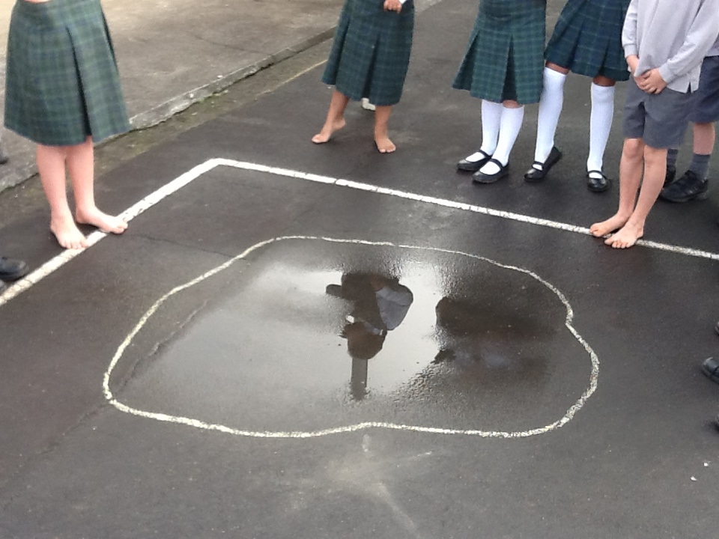  Describe this investigation of a puddle – drawing chalk lines around the puddle and seeing it shrink.  https://www.youtube.com/watch?v=iRLqAhaniyg  is quite good for ideas of investigating evaporation but tends to give the answers in terms of water going into the clouds.  Ask – what is happening? Pour a small amount of water on a plate – what will happen over the day to this? If it dries, where does it go? What is going on?  Introduce the term ‘evaporation’.  Role play  Organise a role play – we are going to model, with our bodies, water changing from solid, to liquid, to gas (see the notes in the appendix). “Each of you is a molecule of water” (unpack the word ‘molecule’ as a particle of water – some will know about H₂O).  Students form in groups (of 6-8?) who are to represent a) solid water, then b) what happens as the ice melts to form liquid water, then c) what happens when the liquid becomes a gas.  Have groups comment on what they are doing – Prompt with questions:  - In a solid, will you move at all? (water molecules will vibrate, in ice, but not move around) If you are solid, what can we say about how the molecules are connected?  - If you are a liquid .. what tells us that you can move around? Do you move further apart? (in fact water is one of those strange substances where the volume DECREASES when it melts.  - In a gas, how fast will you move compared to when the liquid molecules  Drawing representation  Students are now challenged to represent, using an annotated drawing at the molecule level, the change from solid to liquid to gas as ice is heated.  Select a few children to transfer their representations to the board. Focus on how they represent the particles, their spacing, and their speed. Commend different ways of doing this successfully.  Plastic bead representation  Demonstrate a jar of water evaporating using a jar full of plastic beads, representing particles of water in liquid form.  Ask ‘what does this model show about water in a jar?’. What doesn’t it show? (it doesn’t show the movement, the size is of course wrong, water molecules don’t look like beads)  Ask students to come up and use the model to show how evaporation occurs. They explain as they take beads out into the air. Challenge their accounts. Encourage them to have the beads move randomly and quickly round the room.  Ask – which molecules will leave the water (those at the surface, that are moving fastest)  Introduction of evaporation experiment  Ask – how can we speed up its ‘drying’? Focus on heat, and moving air (wind) as factors. What sorts of days are good for drying clothes on the line?  Use a hair dryer to demonstrate how warm moving air over the puddle on the plate hastens the drying.  Ask – what will determine how quickly a glass of water will evaporate? As students make suggestions, ask them to come to the board and explain why using a representation.  Perhaps have a diagram on the board representing water molecules in a beaker, as a prompt.  Move the discussion towards three main variables: 1) heat (of air or of the water), 2) a breeze /air movement (could be modeled as the air moving across the surface to ‘pick up’ the water molecules, 3) surface area, and 4) open and closed.  List the factors/variables on the board. Ask – how will we set up comparisons to test these?  Possible comparison experiments: inside and outside, in the fridge or in a heated area, near a fan and not, with a lid and not (perhaps have one with gauze over), same amount of water but different surface area. There may be other ideas that are interesting.  Discuss with the class how to set the experiment up. Move them towards having the same amount of water but in different conditions (control for volume) – Perhaps given each group a volume of 100ml.  Discuss how each group (2-3 students) will investigate one factor and assign tasks. With the surface area, encourage groups to combine to have 3-4 different surface areas so they can see if there is a clear trend that they can graph. (They will need to work out how to measure the area)  Mark on the side of the jar the water level to start. They may check each day and make a fresh mark to track evaporation. These can be measured (height of water) to allow graphing of progress.  Groups then set up their experiments and write an introduction to the report describing:  - The question they are investigating  - Their hypothesis / prediction and why they think this.  - Their method  This should be modeled on the board. | FORMATIVE:  SUMMATIVE:  RESEARCH ARTEFACTS:

LESSON 3 – Investigation report – representing evaporation
(Approx. duration – 60 mins)
Session focus | Resources & Preparation | Lesson Outline  (NB: time allocations a guide only) | Assessment and Data
SCIENCE concepts and representational processes:  MATHEMATICS concepts and representational processes: | Maths & Science Book | Learning Intention:  Following on from last lesson  The first part of the lesson will consist of recording results, and writing a report of the investigation.  Students measure the amount of water left in their different jars using a measuring cylinder and record this. They express evaporation as an amount missing from their original.  They write a report presenting their results, and a representation of what they think is the reason (mechanism) for the difference in results, using the following template:  - Present your results  - Explain these results – use text and a diagram  - Discuss whether you think the result is convincing  - Write a brief conclusion  See Appendix 2 for an example.  Construct a table on the board, presenting the amount of water evaporated under each condition. Have each group enter their results.  Lead a discussion on what we have learnt as a class from this exercise.  - Can we say which factors have an effect? Which have the most effect?  - Are there any contradictory results?  Generate, on the board, a conclusion concerning evaporation, in terms of which factors affect evaporation, and why.  e.g. Evaporation depends on surface area. This is because molecules escape from the surface and if there are more at the surface, more can escape in a given time period. Doubling the area caused twice the amount of evaporation (students can show their representations for class comment and discussion).  If there is time: Evaporating handprint  Students wet their hand and make a handprint on a paper towel or coloured paper. They draw around the handprint and watch as the towel/paper dries. It’s quite nice to do this with two handprints and put one in a (page sized) ziplock bag. See https://www.youtube.com/watch?v=iRLqAhaniyg  They are challenged to represent what is happening in terms of water molecules.  If there is time: Cartoon of a molecule  Introduce the idea of a 4-step cartoon (workshop this briefly on the board – for instance the story of how I got to school?)  Challenge students: Tell me the story of one water molecule in a puddle that is drying up. What happens to it? What causes that? Where does it end up? | FORMATIVE:  SUMMATIVE:  RESEARCH ARTEFACTS:

LESSON 4 – Dissolving Sugar
(Approx. duration – 60 mins)
Session focus | Resources & Preparation | Lesson Outline  (NB: time allocations a guide only) | Assessment and Data
SCIENCE concepts and representational processes:  MATHEMATICS concepts and representational processes: | Maths & Science Book | Learning Intention:  In this lesson we will extend our particle model of matter to investigate sugar dissolving.  Dissolving a sugar cube  Introduce this activity with the following instructions:  - Put a sugar cube in a small dish.  - Use an eyedropper to drop water onto the cube, 10 drops at a time.  - Draw what the cube looks like after each 10 drops.  - What evidence do you have that the sugar is not simply ‘disappearing’?  - Imagine you have a really powerful microscope that can see what is happening at the level of sugar molecules and water molecules. Represent what you think you could see through such a microscope.  Dissolving different sugars  Equipment for each group:  - 2 glasses or containers that are the same, 2 spoons, a timer.  - Sugar cube, sugar, coffee sugar, brown sugar  - Access to hot water.  Discuss with the class – what happens when we stir sugar into water?  Each group then stirs half a teaspoon of sugar into a cup of water, observing closely what happens.  Children represent in their books:  - What do you observe as the stages of dissolving?  - Imagine what is happening at the particle level. Represent what you think happens to the sugar in the water as it dissolves?  Discuss with the class, constructing notes on the board:  - What might affect the time it takes for the sugar to dissolve? (temperature of the water, whether you stir or not, amount of water). Why might these variables affect the dissolving rate?  - If you were going to test whether the amount of water made a difference, how would you do that? What would you keep the same? What would you measure? What would you need to be clear about (e.g. how to judge when the sugar is completely dissolved).  Show the class the different sugars. Ask for predictions as to which would dissolve the quickest, which the slowest. Again take notes on the board.  Ask for ideas about how to design an experiment to compare the dissolving rate for the different sugars. What (variables) would need to be kept the same?  Each group then decides on one variable they are going to test. They must present their plan for discussion before proceeding.  They then conduct the experiment, and report on the results using the following template:  - What question are we investigating?  - What do we predict will happen?  - Why do we think that? (use words and drawings)  - Our method – what we did.  - What did we vary?  - What were we careful to keep the same?  - What did we measure?  - Our results – use a table  - Explanation and conclusion – what do our results tell us? Use words, and drawings. | FORMATIVE:  SUMMATIVE:  RESEARCH ARTEFACTS:

FINAL LESSON – Testing paper towels and cloths (Post-test)
(Approx. duration – 60 mins)

Session focus | Resources & Preparation | Lesson Outline  (NB: time allocations a guide only) | Assessment and Data
SCIENCE concepts and representational processes:  MATHEMATICS concepts and representational processes: | Maths & Science Book  Post-test (revisit pre-test from the start) | Learning Intention:  In this activity students should investigate which brand of paper towel is best for mopping up water spills or drying hands. They should report their findings as a consumer report, scoring each towel on different criteria.  Lead a discussion on the following points, before groups decide on their method.  - What are the important features we want from a paper towel?  - If we have a list of these features (e.g. amount of water it can soak up, softness, ability not to fall apart, cleanness of mop-up) how will we measure them scientifically?  (For instance, amount of water soaking up can be done by seeing how much the water level drops in a jar after a piece of towel is dipped in it; effectiveness might be measured by seeing how many towels are needed to mop up a standard spill, the diameter of spread of one drop of water on each towel could be measured, wet strength and dry strength might be measured by putting standard weights on)  - How can we give these features a score?  - How can we give an overall score?  Each group then works out a plan and conducts the tests comparing the paper towels.  Each group conducts their investigation. Individuals write a report describing:  - Introduction to the investigation  - A description of the features being tested and a method for each  - Results for each feature  - An overall scoring and summary  - A recommendation of the ‘best’ paper towel and its features.  Equipment  Measuring cylinders, droppers, jars, 4-5 brands of paper towel, surfaces that can be wet, towels for mopping up, water containers, brass weights | FORMATIVE:  SUMMATIVE:  RESEARCH ARTEFACTS:  - Pre-test updated as post-test

Additional lessons if time
Session focus | Resources & Preparation | Lesson Outline  (NB: time allocations a guide only) | Assessment and Data
SCIENCE concepts and representational processes:  MATHEMATICS concepts and representational processes: | Maths & Science Book  You will need:  • a clip-lock sandwich bag  • vinegar  • sugar  • a cup measure  • a teaspoon.  You will need:  • a clip-lock sandwich bag  • vinegar  • baking soda  • a cup measure  • a teaspoon. | Learning Intention:  Key ideas: In a chemical reaction, substances change to new substances, with entirely different properties. Substances can totally change in a chemical reaction. A gas can be formed in a chemical reaction.  Where did the sugar go?  Measure a quarter of a cup of vinegar into a clip-lock sandwich bag. Add a flat teaspoon of sugar, and shut the bag. Mix the sugar and vinegar around. What did you find? Where has the sugar gone?  This activity is merely included to emphasise that the bicarb soda effect is very different to a dissolving phenomenon. Students should be encouraged to use the word ‘dissolve’, and to think of this as total breakdown of the sugar grains and dispersal of the sugar into the vinegar. This is a physical change, and in principle reversible.  Froth and bubbles  Measure a quarter of a cup of vinegar into a clip-lock sandwich bag. Add a flat teaspoon of baking soda, and quickly shut the bag. What happens to the baking soda? Where has it gone? What has happened to the vinegar? Has it changed?  This activity demonstrates a chemical reaction between the baking soda and the vinegar. The quantities suggested inflate the bag nicely, but you may have to deal with demands to try the experiment again using much larger quantities. It is quite possible to blow a hole in the bag with greater amounts, and no real harm will be done. This is an acid–base reaction to form water and a salt (sodium acetate) and carbon dioxide. The questions are designed to draw attention to the fact that the substances are no longer the same. Students might try, after the fuss has settled, to add more bicarb to see if any vinegar is left. Or add more vinegar to see if any bicarb is left. If they smell inside the bag they will notice the vinegar smell has almost gone. What is left is a salt dissolved in water. The vinegar and sodium bicarbonate no longer exist, but their constituent atoms now form the basis of quite different materials. | FORMATIVE:  SUMMATIVE:  RESEARCH ARTEFACTS:

Session focus | Resources & Preparation | Lesson Outline  (NB: time allocations a guide only) | Assessment and Data
SCIENCE concepts and representational processes:  MATHEMATICS concepts and representational processes: | Maths & Science Book  You will need:  • a dinner candle • a knife  • wax from a chopped-up candle  • string  • matches.  .  You will need:  • candles of various heights  • matches  • glass jars of various sizes  • a mat to place the candle on | Learning Intention:  Key idea: Burning is a chemical change involving the production of new substances.  The burning candle  Make as many observations as you can to answer the questions:  - How does a candle stay alight?  - What is burning?  Look at the candle carefully. Make a list of the things you can see.  Light the candle. What is changing? Can you notice any clues in the flame? What is the wax doing?  Light a match. Blow out the candle and quickly bring the burning match close to the wick. What do you notice? Is it the wick that is burning?  Hold a piece of string upright and light the top end. Does it keep burning? Is it the wax burning?  Break off a piece of candle wax with a knife. Light it with a match. Does it burn? Is it a combination of factors?  Wrap a piece of string in wax, like a wick, and light it. Watch carefully what happens to the flame as the wax starts to melt. Does it keep burning?  Candle in a jar  Light a candle and put the lit candle on the mat. What do you think will happen if you put a glass jar over the top of the candle? Try it and see. Why did the candle go out? Look at the bottom of the upturned jar. What can you see? What caused the blackening? What is the black stuff? Where does it come from? What does a candle need to keep burning? Vary the volume of the jar. Does a candle stay alight twice as long if the jar volume is doubled? Try three candles of different heights in the same jar. Predict if they will go out at the same time. Try it—observe. Explain. Does the jar need to be sealed at the bottom? Hold the jar above the surface, with the rim just below the flame. Does the candle still go out?  Teaching note: In this activity students may refer to the oxygen running out or being used up. Sometimes they think the oxygen has been driven out of the jar by the candle. Questions such as ‘What has happened to the oxygen ... Where has it gone?’ can produce some interesting responses. The essential science understanding is that oxygen has reacted with the wax under the high-temperature conditions in the flame, and is used up. The time taken for the candle to extinguish is complicated by the fact that it will go out not when the last oxygen in the jar is gone, but when the flame no longer has access to oxygen because of its replacement with carbon dioxide. The carbon dioxide, although it normally is more dense than air, rises to the top of the jar because it is hot. The jar fills with carbon dioxide from the top down. Therefore the tallest candle in the jar will go out first. The time taken for a candle to go out will be roughly proportional to the volume of the jar if a short candle is used. You will find that the candle will go out eventually, provided the rim of the jar sits slightly lower than the flame. The carbon dioxide collects in the jar even though it is open to the air. The last part of the activity is sometimes done with the jar standing in water. Water is drawn up into the jar as the candle goes out. The heated air from the candle flame expands, taking up space. However, when the flame is extinguished the air cools and contracts. The water fills the contracting space. The simple answer to the question ‘Why does the candle go out?’ is that the oxygen is used up. Test the details of this hypothesis by investigating the time taken for a candle to go out under different conditions. | FORMATIVE:  SUMMATIVE:  RESEARCH ARTEFACTS:  - Pre-test updated as post-test

APPENDIX 1 - Teacher Notes

Constructing Representations to Learn in Science
Some of the activities in this sequence are based on a sequence we have written about, that was developed for Years 5/6.

Lesson 1: Water in the school environment. | Group work to list, on a map, areas where water exists and in what form. Brainstorm – where is it, how do you know?
Lesson 2: How can you show there is water in things? | Activities to provide evidence that water exists in various nominated places - soil, leaves, food, air.
Lesson 3: Introducing the particle representation. | Context of an evaporating pool of water to discuss what is happening leads to a range of ideas about the particle idea and a set of representations (dot drawings, plastic bead , annotated sequenced drawings of what happens at the surface as particles come away).  Eucalyptus oil / perfume activity. Role play
Lesson 4: Explaining evaporation and condensation. | Disappearing handprint activity (in groups).  Comparison of rate of evaporation of dishes of water in different places.
Lesson 5: Drying a cloth | Students are given standardised cloths dipped in standard amounts of water and challenged to dry them quickly (Group work ).

Excerpts from the book

Chapter 4: Structuring learning sequences

Russell Tytler, Peter Hubber, Vaughan Prain
We have argued in this book for an approach to teaching and learning science based on the principle that learning needs to be seen as a process of induction into a set of subject specific disciplinary literacies. Further to this, we have argued that a guided inquiry approach based on the principle of student representation construction provides a powerful response to the problems identified in the literature concerning student learning of key science concepts. This position aligns with Vygotskian notions of mediation of learning through language, conceived of as including the multiple representations through which we know in science, and with pragmatist perspectives on the role of language in learning.
The principles underpinning the representation construction approach we described and exemplified in Chapter 3. The key elements of the approach are:
- Representational challenges that involve students constructing their own representations;
- Evaluation, negotiation, and refinement of these representations in class and individual discussion; and
- Explicit discussion of the role of representation in learning and knowing.
Thus, the approach involves a continual back-and-forward between students producing representational responses in small group or individual tasks, and teacher led discussion, in the public arena of the classroom, leading to shared understandings of the appropriateness and efficacy of various representations, and their role. The aim is to build students’ representational resources associated with key science concepts, in a way that is more open and epistemologically defensible than is normally the case in teacher dominated pedagogical approaches.
The representational challenges that are central to the approach are varied, and this variation will be explored in this chapter. However there are two key features of representational challenges that distinguish the approach from other student-focused approaches to school science. We see representational challenges as different to the types of tasks often undertaken that involve replication of ideas or processes in new situations. A representational challenge needs to involve some new coordination or synthesis of existing representations – a fresh orchestration of elements. In this sense it will involve a claim concerning how a phenomenon should be represented and explained. The other feature is that it has the potential to individuate – the different representations will not converge upon one ‘correct’ account but will allow for individual variation in describing or explaining. Thus, these challenges align with problem solving/ investigative approaches that offer a variety of solutions. Unlike many open investigations, however, they serve a clearly defined conceptual agenda within the sequences.
Chapter 3 did not focus on the details of how these sequences are structured, how the approach might vary depending on the particular conceptual territory, or the particular purposes and character of the challenges and communal discussions. In working with the small number of teachers, we generated sequences in six conceptual areas – animals in the school-ground, water, energy (primary school sequences), and forces, substances, and astronomy (secondary school sequences). In this chapter we will draw on the video records and planning notes from these sequences to explore variations in the sequencing and purposes of the challenges and the classroom discussions, and the on-the-ground factors that drive these variations.
The aim of the chapter is primarily to lay out, in a practical way, how the pedagogy operates in different conceptual circumstances, as both an elucidation of the principles, and advice for teachers as to how to approach teaching and learning from this perspective.

The sequences
Figure 4.1 is a representation of the sequences for the Year 5/6 water unit, for lessons 1, 3 and 5. These are chosen to show variation in the structure. This form of representation of the approach emphasizes the movement back and forward between a) challenges – mainly representational but sometimes investigative – in which students generate representations/ideas, and b) class/group discussions led by the teacher in which these ideas are subjected to communal scrutiny. In an important sense, this movement between individual/small group, and communal processes, mirrors knowledge-building practices within science itself.
Each of these lessons shows a similar pattern of alternating challenge and class discussion, but the grain size of the movement between these varies, depending on the nature of the task and the amount of material dealt with in the discussion. In lesson 1 for instance, the discussion around how water might exist in the air was prolonged and included significant student input regarding their experience of humidity, leading to suggestions that water might exist as molecules in the air. Lesson 3 (described in detail in Chapter 5) is unusual for the fast pace with which representational challenges occurred, and the multiple representations used.

Figure 4.1: The structure of the learning sequences in Lessons 1, 3 and 5 of the water unit (Year 5/6)
Lesson 1 How can we think about/ represent water existing in different places, in different forms?

Challenge:
What investigation might we run to demonstrate water in air?
Discussion:
Clarification of claims leading to extended discussion of how water might exist in air

Challenge:
Represent where water exists, on a map of the school
Challenge:
Draw a cartoon showing what happens over time to a molecule.

Discussion:
Clarification and scaffolding of the drawings, conservation of molecules
Challenge:
Using beads to represent evaporation with focus on individual molecules (whole class challenge and discussion)

Challenge:
How can we represent, in drawing, solid – liquid – gas transitions
Discussion:
Clarification of the behaviour of molecules in the three states
Challenge:
Role play of solid and liquid and gas

Lesson 3: Refinement of the molecular model – size, spacing, conservation, energetics and narrative of individual molecules
Discussion:
Video of puddle evaporating and posing of question – what’s going on?
Lesson 5: The conditions for evaporation- how do these look at the molecular level? (Energetics)

Challenge:
Drying cloth task. Students represent what happens
Discussion:
Setting the scene for the drying cloth challenge. Scaffolding molecular ideas using the bead model
Discussion:
Critique of drawings, discussion using bead model, students refine their work. Discussion on how to represent speed.
Challenge:
Represent what happens to the handprint using a molecular diagram.
Discussion:
Summarising the main points from the lesson.
Discussion:
Evaluation of student reps.
Discussion:
Introduction to handprint task.

From Chapter 5

Lesson sequence illustrating the role of multi-modal representations (from ‘Representing to
Representation | Teacher moves, student actions
- Video of puddle evaporating. | T1 summarizes video issue concerning energy required to evaporate the puddle. There is a brief discussion leading to the question: What is actually going on?
- Role play | T1: You are all water molecules. I want you to imagine you are water molecules, in the solid state, I want you to move to show me what you would look like.  Students discuss movement: No, each one sort of moves – [pushes the other student and moves to and fro]
- Teacher uses jiggling body to emphasise movement. | T2: They [students] are moving, is that correct? Do molecules in a solid state move?  T1: Yes they move.
- Use of role play to have students simulate solid, liquid, gas | T2 leads question-response discussion where he establishes the greater movement in liquids (students model a liquid compared to solid) and increased spacing for gas: Gas! Show me!  Students move away from group members, scattering around the hall. All continue vibrating
- Drawing challenge: show solids liquids, gases. | T2: Have you shown what is the difference between solid water molecules, liquid water molecules, and gaseous water molecules? Did you show that difference? You have bodily moved, very well … how would you indicate that in a diagram?  Students draw molecules in the solid, liquid and gas states (Figure 5.2)

Figure 5.2: Student drawing of molecules in the solid, liquid and gas states
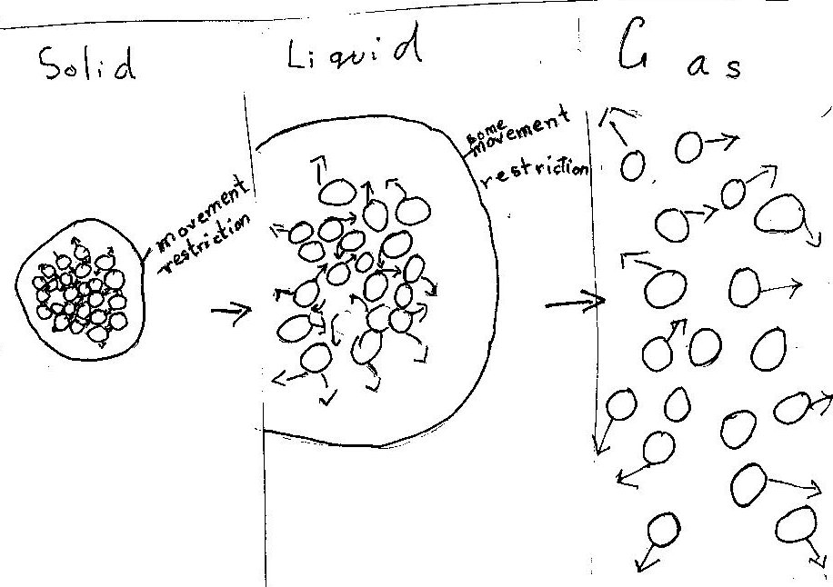

Representation | Teacher moves, student actions
- Teacher uses beads now to model a focus on individual molecules responding to an energy source – vibrates them – some spill. | T1: Come back again to that gas molecule …when we had that heat source, that energy coming in is this what happens?  A student comes to the container, picks up a bead and moves his hand in a haphazard motion above the head.  T1 challenges this by demonstrating dispersal by shaking beads out –models randomness of distribution  T1: Which molecules are the first ones to go?  Students: Top ones … Ones that had started moving faster … More heated ones … Ones that get more energy
- Bead demonstration | T1: In your diagram, there may be need to show a three dimensional diagram or a series of diagrams, think about not just two-dimensional.  T1: Okay let us give these molecules, beads, a human form [picks up a bead and points to it]. Here is George, he is here vibrating in water as a solid, then there is more energy he moves more in a liquid state, and then here is Molly …
- Drawing challenge  T1 models storied drawing on board | T1: Tell me a story about one water molecule, about what happens to it. Let’s do it in four frames. Remember, label, say why is he here, what does he actually need?  Students work on their diagram narrative (Figure 5.3)

Figure 5.3: A student narrative diagram showing an individual molecule
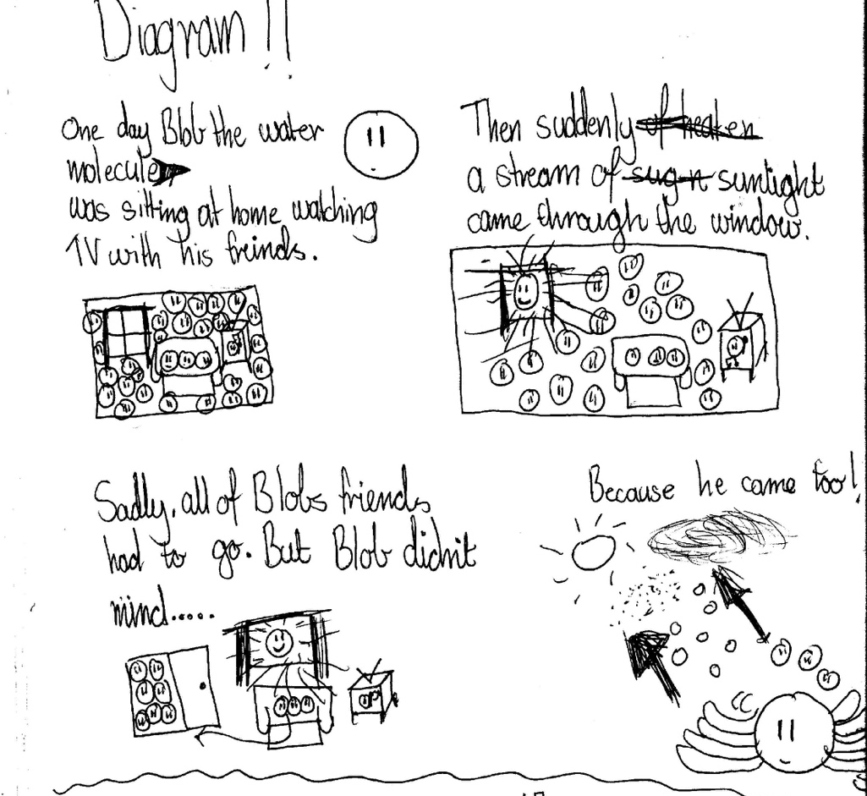

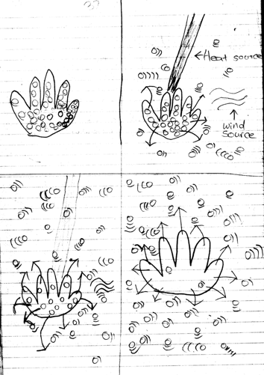
Disappearing handprint responses
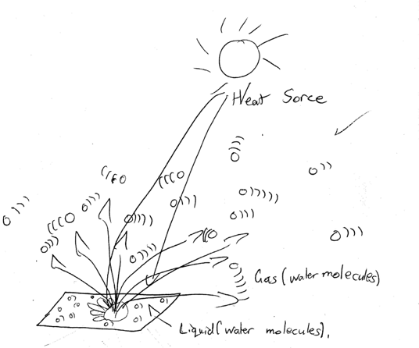

Some Post test responses

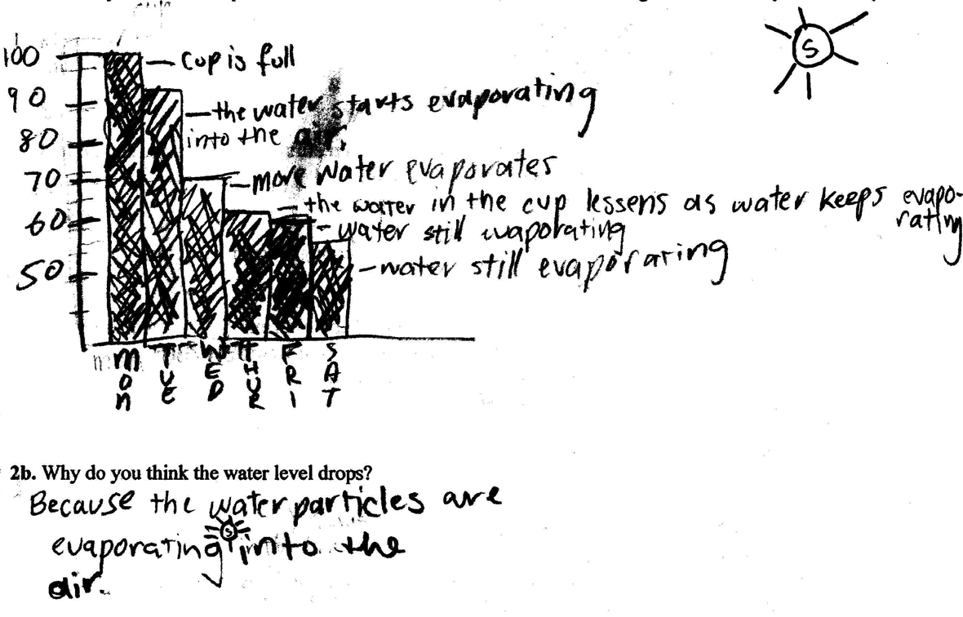

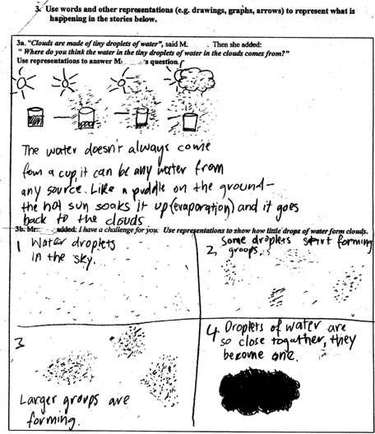

Appendix 2: Example of an investigative report

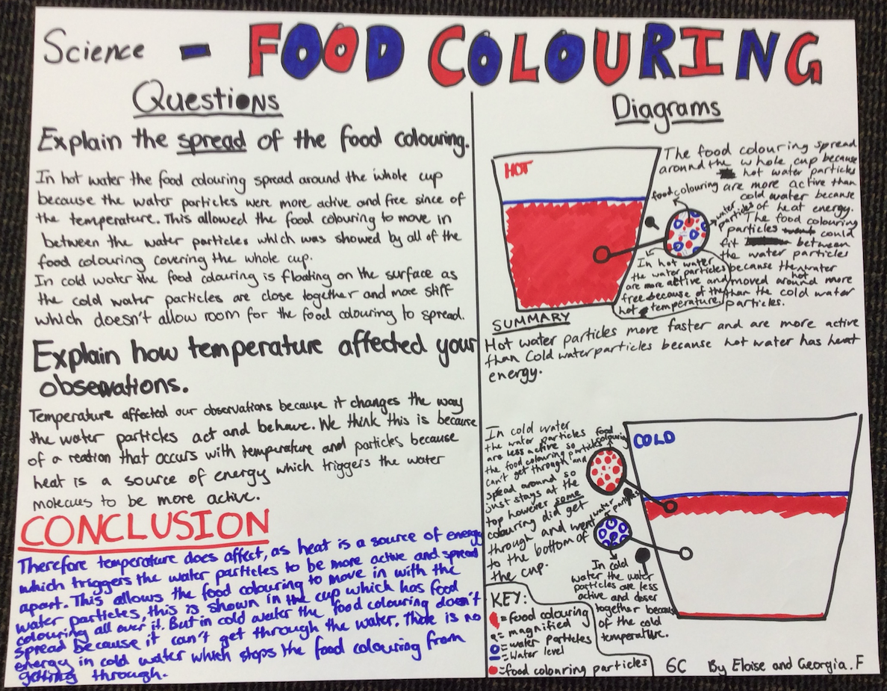

APPENDIX 2 - References and Resources

APPENDIX 3 - Curriculum Links
Chemical sciences | 3 & 4 | 5 & 6
Objects are made of materials that have observable properties | A change of state between solid and liquid can be caused by adding or removing heat | Solids, liquids and gases behave in different ways and have observable properties that help to classify them
Everyday materials can be physically changed or combined with other materials in a variety of ways for particular purposes | Natural and processed materials have a range of physical properties; these properties can influence their use | Changes to materials can be reversible, including melting, freezing, evaporating, or irreversible, including burning and rusting

