**Science**

C:\Documents and Settings\x\Local Settings\Temporary Internet Files\Content.IE5\36X8YEH4\MC900391018[1].wmf

**How can I become more environmentally friendly?**



**Activities**

C:\Program Files\Microsoft Office\MEDIA\CAGCAT10\j0305257.wmf

* Explore the consequences of floating plastics on our waterways.
* Define buoyancy.
* Make predictions and perform an experiment.
* Make suggestions to improve your family’s use of the Earth’s resources.

You have learnt about plastics and how they can be useful to us. You also learnt about biodegradability and how many plastics don’t break down easily in nature.

Look at this picture:

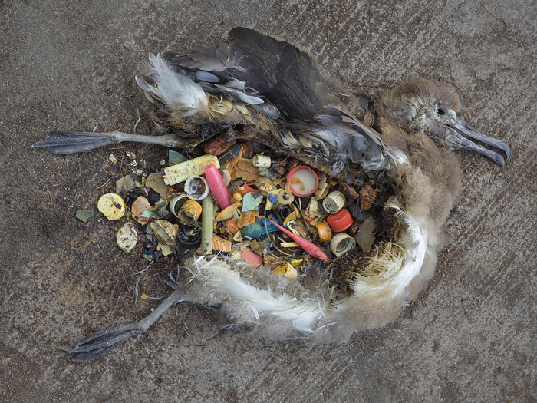

Talk to an adult about your thoughts about this image.

**C:\Documents and Settings\x\Local Settings\Temporary Internet Files\Content.IE5\36X8YEH4\MC900326752[1].wmfFOR YOU TO DO: Experiment: Does it float?**

**C:\Documents and Settings\x\Local Settings\Temporary Internet Files\Content.IE5\36X8YEH4\MC900312152[1].wmf**Introduction: If something floats in water we say it is buoyant. In this experiment you are going to predict if common household items, such as plastic bottles and glass jars are buoyant or not. You will then test your prediction.

Purpose: To explore the buoyancy of common household items.

Materials (What you need):

* A large basin to hold water or a bath
* A collection of household items such as:
* Plastic bottles
* Icy pole sticks
* Bottle tops
* Glass jars
* Metal jar lids
* Drinking straws
* Plastic cups
* Plastic spoons
* Paper cups

Method: Fill in the table below of all the household items you are going to test:

|  |  |  |  |  |  |
| --- | --- | --- | --- | --- | --- |
| Item | Predict | Observe | Item | Predict | Observe |
|  |  |  |  |  |  |
|  |  |  |  |  |  |
|  |  |  |  |  |  |
|  |  |  |  |  |  |
|  |  |  |  |  |  |

Tick next to the ones that you predict will float (are buoyant).

Test each of the items listed using the basin of water. Fill your results into the table above.

Conclusion: Write a sentence describing what you discovered after doing this experiment.

**C:\Documents and Settings\x\Local Settings\Temporary Internet Files\Content.IE5\36X8YEH4\MC900292204[1].wmfSo what’s the big deal if it floats anyway?**

Sometimes our rubbish ends up in our waterways. This makes our natural environment look dirty. But this isn’t the only consequence. Lots of our wildlife such as seabirds and fish cannot tell the difference between food and plastic. In fact, seagulls that are searching for food at sea will swoop and gobble up a floating bottle top lid thinking it’s a fish! We know this happens because this rubbish has been found in dead seabirds’ guts. The plastic in their tummies means there is less space for proper food. The bird begins to starve because they are not getting enough nourishment.

How can this affect baby birds? (think – how are baby birds fed?)

**FOR YOU TO DO: Activity – Improving my family’s environmental behaviours**

Have you ever been to a birthday party where food was served on disposable plastic plates? Did you use plastic knives, forks and spoons to eat the food? What about the balloons? Disappointingly most plastics are used for a very short amount of time – sometimes just the amount of time a birthday party lasts. We have adopted a “throw away” culture when it comes to plastics. Is there a better way? List your ideas in the box below:

How environmentally friendly are you and your family? Answer these true false questions.

|  |  |
| --- | --- |
| Behaviour | T or F? |
| I always take a reusable bag to the shops. |  |
| I take toys, books and clothes that are in good condition to an opportunity shop. |  |
| I always switch off the light when I am not in the room. |  |
| My family never uses a clothes drier to dry clothes. |  |
| My family uses a compost bin for kitchen scraps. |  |
| I always remember to check for the recycle symbol on plastics before putting them in the recycling bin. |  |

C:\Documents and Settings\x\Local Settings\Temporary Internet Files\Content.IE5\CISVT2XC\MC900232141[1].wmf

Count up the total number of TRUE answers: _______

If you scored six TRUE answers, you and your family are environmental superheroes! Well done.

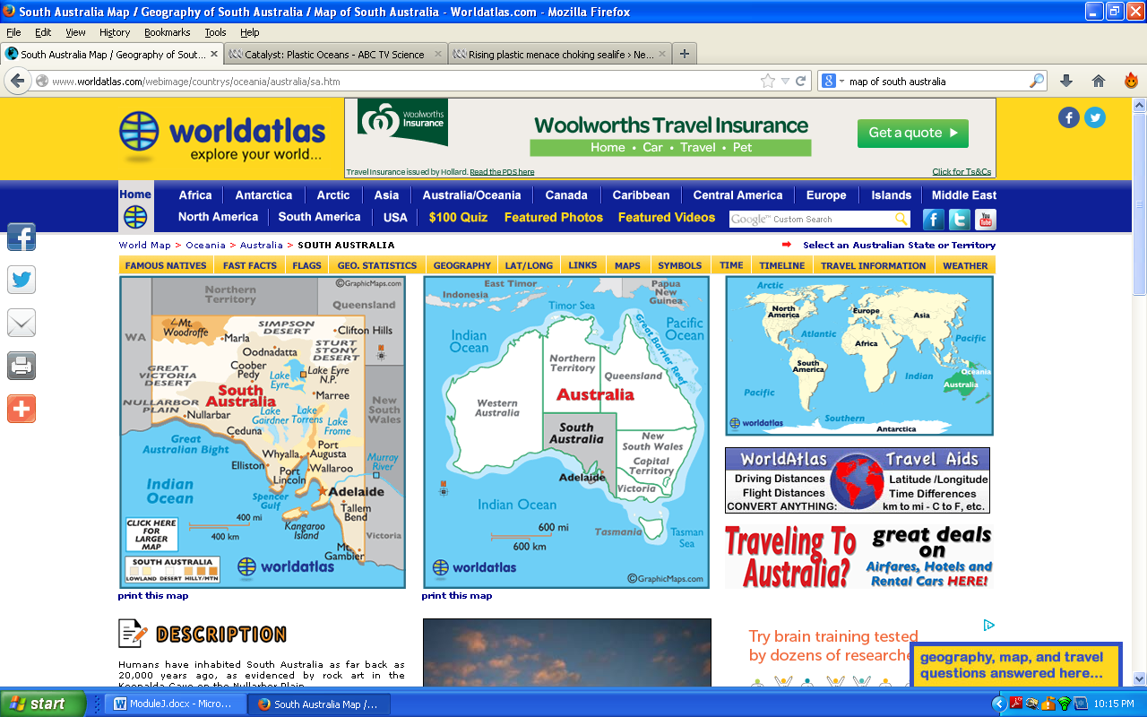**DID YOU KNOW?**

http://www.worldatlas.com/webimage/count

Finding plastic inside the guts of seabirds is common in most parts of Australia, with one exception – South Australia.

Environmental scientists believe this is because of South Australia’s refund policy on plastic bottles.

People living in South Australia collect their plastic bottles (and cans) because they can take them to a recycling centre and get paid some money for returning them! Look closely at the label on a plastic bottle to locate the refund information. Copy it in the space below:

**FOR YOU TO DO – Evaluation**

Tick the box that describes your learning.

|  |  |  |  |
| --- | --- | --- | --- |
|  | I am good at this | I am nearly there | I need help with this |
| Define buoyancy |  |  |  |
| Explain why pollution is a problem for seabirds |  |  |  |
| Make a prediction and test my prediction with an experiment |  |  |  |
| Make suggestions to improve my family’s use of the Earth’s resources |  |  |  |

**Activities**

C:\Program Files\Microsoft Office\MEDIA\CAGCAT10\j0305257.wmf

* Reflect on your own activities and how reduce, reuse, recycle and rethink.

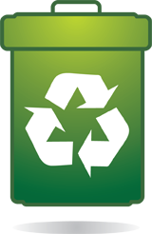

Here are some slogans and phrases that you may have heard or read on signs:

“Don’t be a litter bug”

“Keep Australia beautiful”

“Please dispose of thoughtfully”

All these give the same message: don’t drop rubbish. It is against the law to pollute our environment and people and companies can get big fines if they pollute the environment.

**Do you think the message is getting through to people?**

You’ve heard of the 3 R’s – Reuse, Reduce, and Recycle. There is another – Rethink.

C:\Users\lmarcon\AppData\Local\Microsoft\Windows\Temporary Internet Files\Content.IE5\K975LXFD\MC900391018[1].wmf**FOR YOU TO DO: Activity - The four R s**

Think of 4 things that you can:

* Reduce
* Reuse
* Recycle, or
* Rethink

Fill in the table. I have given an example.

|  |  |  |
| --- | --- | --- |
| Item | Which R? | Description |
| Water / electricity | Rethink and Reduce | I made sure my dishwasher was completely full before turning it on |
|  |  |  |
|  |  |  |
|  |  |  |
|  |  |  |

**Did you know?**

In April 2010, there was a massive explosion at a BP oil rig off the Gulf of Mexico in America. Tragically, 11 innocent workers died. This was also a horrific environmental disaster. Lots of wildlife in the area was killed and damaged from the oil leaking into the water. People couldn’t go swimming at the beaches and it took months to stop the leak. BP had to pay a big fine of $4.5 billion (US dollars).

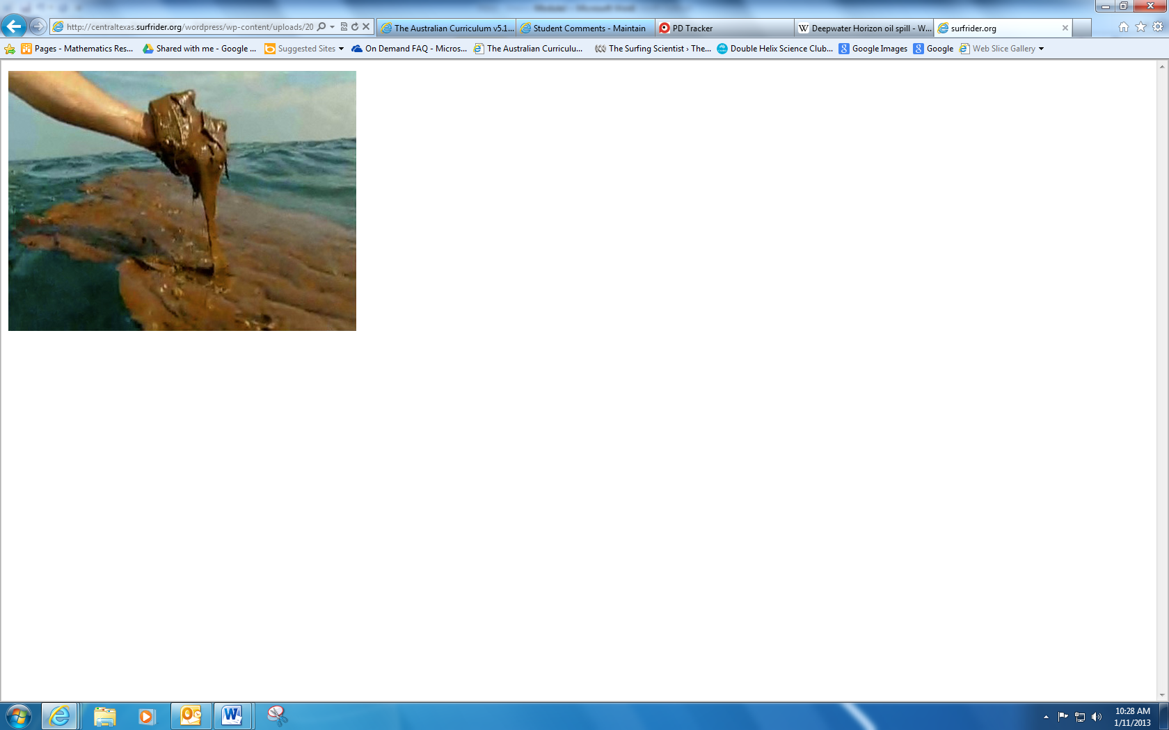

http://centraltexas.surfrider.org/wordpr

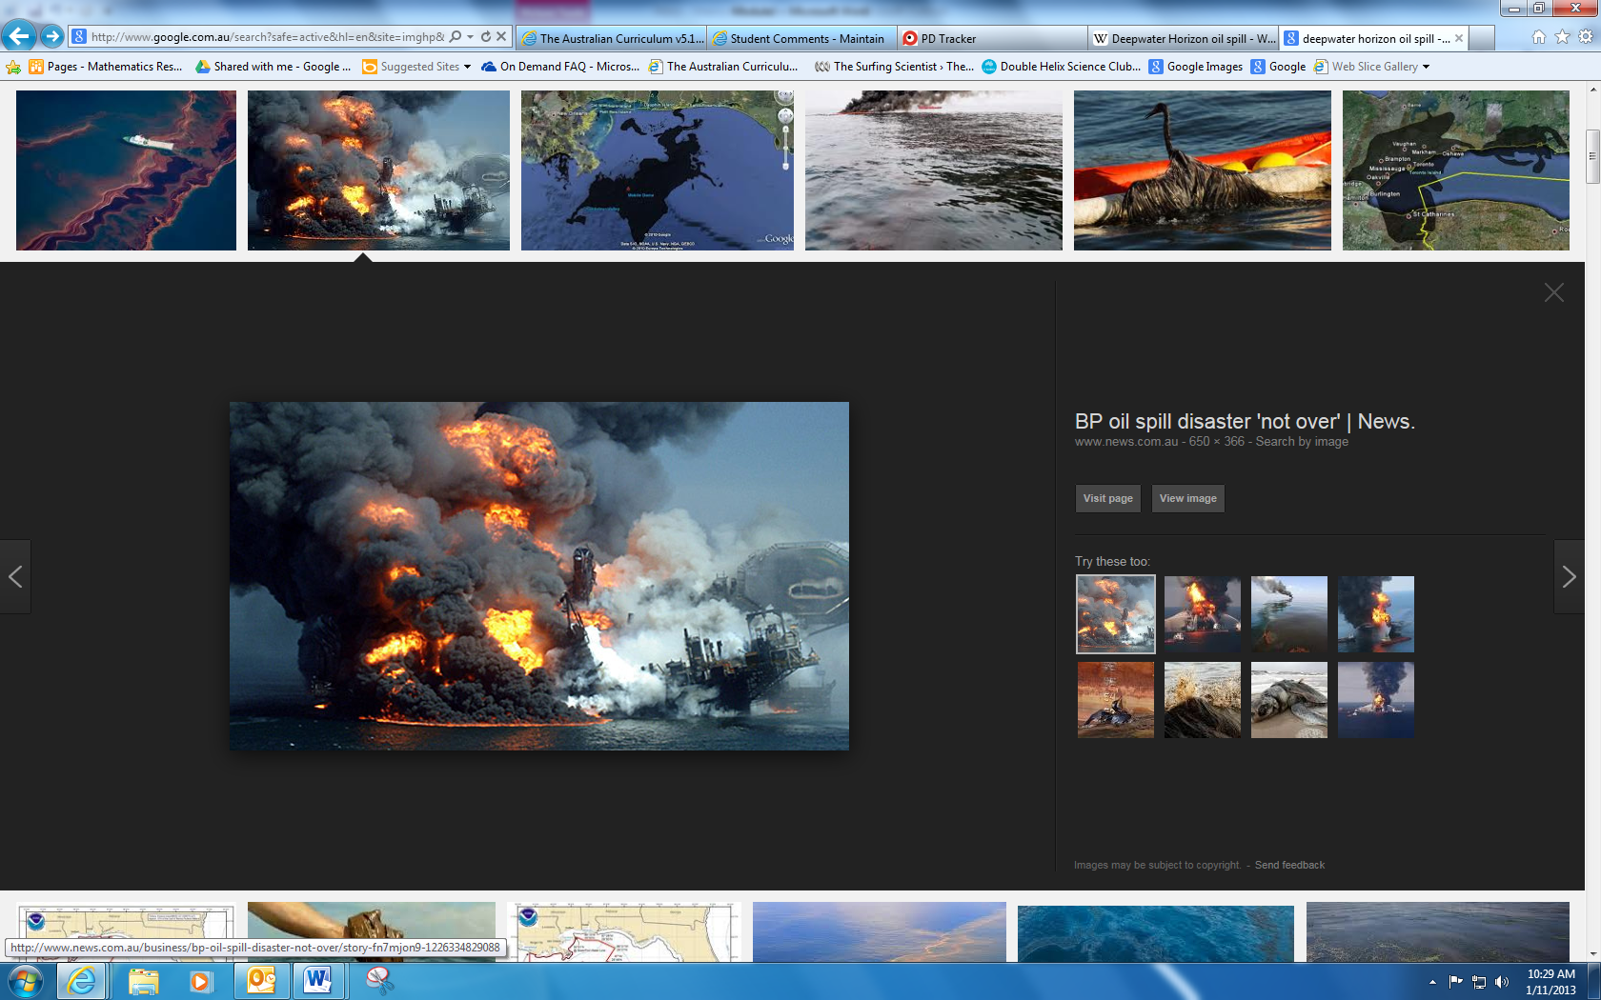

http://resources3.news.com.au/images/201