**Science Inquiry**

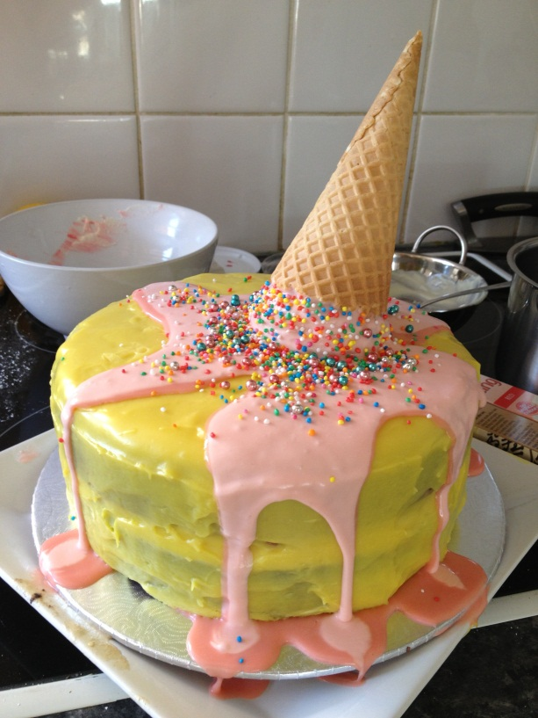

***Can we reverse the change?***



**Learning Intentions**

* You will learn about the physical properties of some common substances.
* You will learn how to make accurate observations during experiments and how to record them.
* You will learn how to carry out an experiment to investigate the solubility of common materials in water.
* You will learn what happens when common substances are heated or cooled.
* You will learn the difference between reversible and irreversible changes caused by heat.

**Materials you will need:**

* White granular sugar
* Cooking salt
* Ground pepper
* Teaspoon for measuring
* A measuring cup
* Ice-cold water
* Freshly boiled water
* Two clear thick glass tumblers
* Spoon for stirring
* Pen and note paper

**CONTENT DESCRIPTIONS FOR SCIENCE**

|  |
| --- |
| **Science understanding (Chemical Science)**   * + Changes to materials can be reversible, including melting, freezing, evaporating, or irreversible, including burning and rusting [(VCSSU077)](https://victoriancurriculum.vcaa.vic.edu.au/Curriculum/ContentDescription/VCSSU077) |
| **Science Inquiry Skills**  **Questioning and predicting**   * + With guidance, pose questions to clarify practical problems or inform a scientific investigation, and predict what the findings of an investigation might be based on previous experiences or general rules [(VCSIS082)](https://victoriancurriculum.vcaa.vic.edu.au/Curriculum/ContentDescription/VCSIS082)   **Planning and conducting**   * + With guidance, plan appropriate investigation types to answer questions or solve problems and use equipment, technologies and materials safely, identifying potential risks [(VCSIS083)](https://victoriancurriculum.vcaa.vic.edu.au/Curriculum/ContentDescription/VCSIS083)   + Decide which variables should be changed, measured and controlled in fair tests and accurately observe, measure and record data [(VCSIS084)](https://victoriancurriculum.vcaa.vic.edu.au/Curriculum/ContentDescription/VCSIS084)   **Recording and processing**   * + Construct and use a range of representations, including tables and graphs, to record, represent and describe observations, patterns or relationships in data [(VCSIS085)](https://victoriancurriculum.vcaa.vic.edu.au/Curriculum/ContentDescription/VCSIS085)   **Analysing and evaluating**   * + Compare data with predictions and use as evidence in developing explanations [(VCSIS086)](https://victoriancurriculum.vcaa.vic.edu.au/Curriculum/ContentDescription/VCSIS086)   + Suggest improvements to the methods used to investigate a question or solve a problem [(VCSIS087)](https://victoriancurriculum.vcaa.vic.edu.au/Curriculum/ContentDescription/VCSIS087)   **Communicating**   * + Communicate ideas and processes using evidence to develop explanations of events and phenomena and to identify simple cause-and-effect relationships [(VCSIS088)](https://victoriancurriculum.vcaa.vic.edu.au/Curriculum/ContentDescription/VCSIS088) |

**WHAT IS THAT MATTER?**

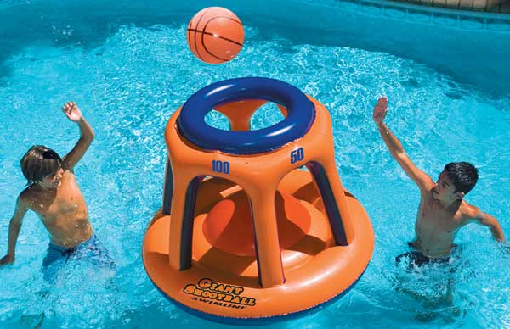

What do people, plastic, air, and water have in common? They all have matter. That means they are made up of tiny particles that take up space and we can weigh them.

Every substance found on Earth can be grouped into one of three physical states of matter: solid, liquid, or gas.

In order to figure out which state of matter a substance fits in, we have to examine its properties. The properties we look at are shape, mass, and volume.

The properties of a substance are things we can measure.

This week we will take a closer look at these properties.

**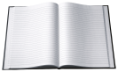 *Read the following information***

**The physical properties of the states of matter**

**–things that can be measured**

**Mass**

Mass is the amount of matter a substance has. We determine this by weighing the substance.

**Volume**

We can measure **volume** to determine the amount of space the matter takes up.

**Shape**

**Shape of solids**

Theshapes of **solids** are easy to recognise. Solids have a definite shape. Rocks are solids. They are made up of tiny particles that are packed closely together that hold the solid in a definite shape that does not change—unless we break it using force.

**Shape of liquids**

**Liquids** do not have definite shape, but they still have definite mass and volume. Liquids are similar to solids because their particles are close together, but what makes a liquid different, is that those particles can move around. As a result, liquids can change shape by flowing.

If you’ve ever spilled a glass of milk, then you know it spreads out across the floor. It does this because the milk is taking the shape of the floor. Since liquids do not have a definite shape of their own, they will take the shape of their containers. This is why the same amount of milk can look different in a tall glass, a wide mug, or spread out on your kitchen floor.

**Shape of gases**

**Gases** do not have definite shape or volume. Like liquids, gasses will take the shape of their containers. If a gas is not in a container, it will spread out indefinitely. This is because the particles in a gas are spaced farther apart than in a solid or a liquid. Being spread out like this allows them to move around freely.

Think about the air you breathe every day. Air is a mixture of gases. We breathe in the oxygen gas part of the mixture.

Air is spread across the empty space around the Earth. You’ve probably also noticed that you cannot see the air. But you can feel it moving as a breeze or wind.

We use gases in various ways every day. There is air in the tyres of your family car and your bicycle. There is gas pumped to your gas stove or stored in BBQ bottles for cooking purposes.

**The three states of matter**

**Water is a strange substance. It is the only one on Earth that can be a solid, liquid and a gas at the same time.** Think about a glass of liquid water with ice cubes on a hot and humid day. Where is the water gas vapour? It is the humid feeling in the air!

When trying to remember the three states of matter, think about water. If it freezes into a solid, it becomes ice. Its particles are packed together keeping its shape. Of course, we know water can also be a liquid. It flows in rivers or it can be poured from a glass. When water evaporates it becomes water vapour.

|  |  |
| --- | --- |
| *You can see three different states of matter in this picture.*  *The kettle is made of solid matter.*  *The water inside the kettle is liquid.*  *When the liquid is heated, it becomes water vapour, which is a gas.*  *The particles of the three states of matter are shown in little squares.* | http://www.daviddarling.info/images/molecules_in_water.jpg |

**Changing physical states**

It is possible to **change** the **physical state of substances**.

1. You can turn a solid to a liquid, you can turn a liquid to a gas and back again by **changing the temperature**. *This is called changing the states of matter.* **There are 3 states of matter.** These are **solid, liquid and gas.**The picture below explains how the temperature changes from one state into another.

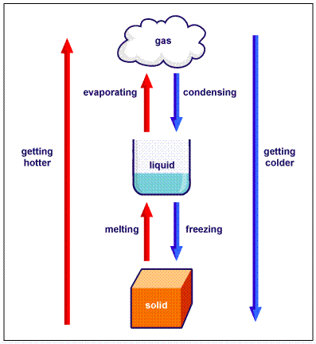

1. We can **dissolve substances** to change their physical properties. *This changes the shape of the crystals* that make up the substances.

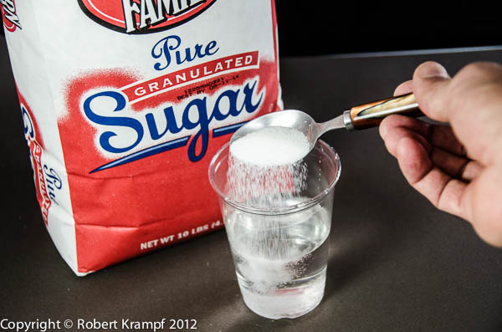

1. You can *change the shape of a solid using force*. You can break or bend some solids into a different shape such as bending a metal bar.

Unlike melting, freezing and vaporising, changing the physical shape of a solid is sometimes not reversible, for example you cannot fix paper after you tear it.

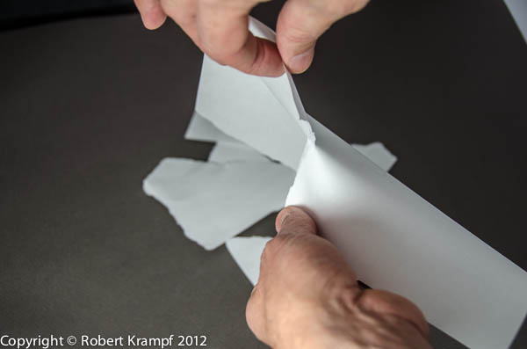

**Description: MCj04247880000[1] Complete the following worksheet**

After reading the previous pages, choose a word from the word list to complete each sentence below:

|  |  |  |  |
| --- | --- | --- | --- |
| solids | gases | liquids | volume |
| shape | container | particles | space |
| chair | vinegar | ice | air |
| gas | melting | mass | matter |
| reversible | irreversible | change | states |

1. The three basic states of matter are: _____________________________,

_____________________________ and ____________________________.

1. All matter is made up of tiny ______________________.
2. Volume is the amount of ______________________ that matter takes up.
3. Mass is the amount of ___________________________ an object has.
4. Liquids take the shape of their __________________________.
5. The three physical ___________________ of matter are solid, liquid and gas.
6. __________________________ do not have a definite shape or volume.
7. __________________________ do not have a definite shape, but they do have a definite volume.
8. _________________________ have a definite shape and volume.
9. ______________________ and _____________________ are examples of solids.
10. _____________________ is an example of a liquid.
11. ____________________ is a mixture of gases.
12. Solid ice is _______________________ when it is changing into a liquid.
13. When a puddle of rain water is evaporating on the ground, the water is turning into a __________________. Sometimes a gas is also called a vapour.
14. Melting, evaporating and freezing are called a __________________ in the states of matter. They are ____________________ physical changes.
15. Breaking glass is a/an ____________________ physical change.

**DISSOLVING**

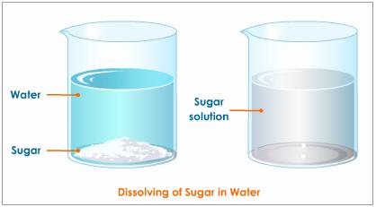

Some substances are able to dissolve in water. They are called soluble substances.

Others cannot dissolve in water. They are called insoluble substances.

Temperature affects the solubility of substances in water.

* Make a prediction – is sugar more soluble in HOT water or COLD water?

** *Read the following information***

**What is dissolving?**

When you add some sugar to water, the solid sugar crystals seem to disappear. But the water is sweet now so we know the sugar is there somewhere. But where?

We spoke earlier of substances being made up of particles. **When two substances are dissolved together, their particles become mixed up together**. See the diagram below.

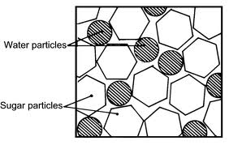

When two substances, like sugar in water, are completely dissolved together, we call them a solution.

If you keep adding so much sugar into the water, there will come a time when no more sugar can dissolve anymore, we then have a saturated solution.

**Temperature** affects how much of one substance you can dissolve in another.

This week you will carry out an experiment to look at how temperature affects the solubility of some substances.

**Description: MCj02921160000[1]Description: MCj04247880000[1]Experimenting with solutions**

**Aim:**

What is the effect of temperature on dissolving substances in water?

**You will need:**

* White granular sugar
* Cooking salt
* Ground pepper
* Teaspoon for measuring
* A measuring cup
* Ice-cold water
* Freshly boiled water
* Two clear thick glass tumblers
* Spoon for stirring
* Pen and note paper

**Method:**

What safety precautions must you take when handling hot water? ____________________________________________________________________________________________________________________________________________________________________________________________________________________________________________________________________________________________________________________

* 1. **Dissolving sugar**

1. Place one measuring cup of the ice water into a glass tumbler.
2. Put a teaspoon of sugar into the cold water and stir with the spoon until the sugar disappears. You now have a **solution**.
3. Repeat this process (remembering to count the number of teaspoons of sugar you put into the water) until the sugar stops dissolving. At this point, the sugar starts to gather on the bottom of the glass rather than dissolving. This is now called a **saturated solution**.
4. Write down how many teaspoons of sugar you have added to the cold water.
5. Place 1 cup of boiling water into another glass tumbler and repeat the steps above. Be careful! If the tumbler is not thick enough, it might crack.
6. Rinse out the glass tumblers.
   1. **Dissolving salt**
7. Place one measuring cup of the ice water into a glass tumbler.
8. Put a teaspoon of salt into the cold water and stir with the spoon until the salt disappears. You now have a **solution**.
9. Repeat this process (remembering to count the number of teaspoons of salt you put into the water) until the salt stops dissolving. At this point, when salt starts to gather on the bottom of the glass rather than dissolving, you have made a **saturated solution**.
10. Write down how many teaspoons of salt you added to the cold water.
11. Place 1 cup of boiling water into another glass tumbler and repeat the steps above. Be careful! If the tumbler is not thick enough, it might crack.
    1. **Dissolving pepper**

Repeat the above steps using ground pepper.

**Results:**

|  |  |  |  |  |  |
| --- | --- | --- | --- | --- | --- |
| Number of teaspoons of sugar needed to get a saturated solution | | Number of teaspoons of salt needed to get a saturated solution | | Number of teaspoons of pepper needed to get a saturated solution | |
| Ice water | Very hot water | Ice water | Very hot water | Ice water | Very hot water |
|  |  |  |  |  |  |

**Discussion questions:**

1. Did the hot or cold water dissolve more sugar? _____________

If the hot water dissolved more, how many times more did it dissolve? _______________________________

1. Did the hot or cold water dissolve more salt? _____________

If the hot water dissolved more, how many times more did it dissolve? _______________________________

1. What was easier to dissolve, salt or sugar? _______________

What was the difference in solubility between the salt and the sugar? _________________________________________________________________________________________________________________

1. Did any pepper dissolve in either hot or cold water? _____________________________________________________
2. Why was it important to measure everything exactly and repeat exactly the same process with all three substances?

________________________________________________________________________________________________________________________________________________________________________________________________________________________________________________________________________________________________________________

**Conclusion**

Complete the following sentences:

1. Sugar and salt are ____________________________________ in water. They can form a solution.
2. If too much salt or sugar is added to water, they begin to settle to the bottom of the glass. No more can dissolve and we have a _________________________ solution.
3. Heat ______________________________(hint: increase or decrease) the solubility of sugar and salt.
4. Pepper is _____________________________ in either hot or cold water.

Identify which step or steps involve a **chemical change**.

__________________________________________________________________________________________________________________________________________________________

Is chemical change a reversible or an irreversible change? _____________________________________________________________