**Science Inquiry**

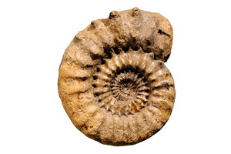

**What are fossils and what can we learn from them?**



**Activities**

**Fossils**

Here’s our local palaeontologist (someone who studies fossils) fossicking for fossils. Fill in the speech bubbles with words or phrases that you think of when you hear the word “fossil”.

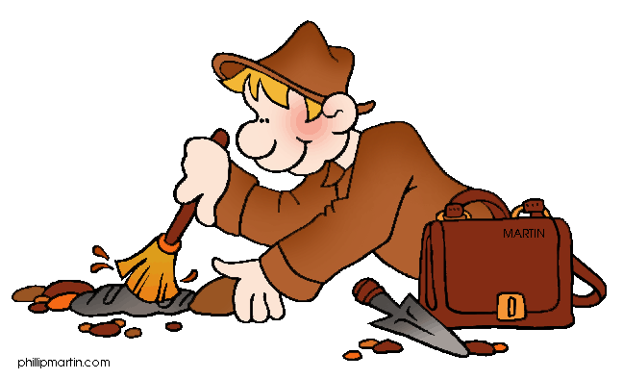

A fossil is a “hint” from the past. Some fossils can be very old. They can include animals, plants or even footprints of animals.

The “bones” of fossils that you see in museums are not actually bones at all. They are the fossilised casts of the bones.

In order to make a fossil, an impression or mould of the animal or plant needs to be made first. Then the mould is filled in with minerals from the surrounding rocks to form a cast – this is the fossil.

**DID YOU KNOW:**

Have you watched the movie “Jurassic Park”? It is a science fiction film about a wildlife park of cloned dinosaurs living on an island. Cloned animals are all identical and are created from just one parent.

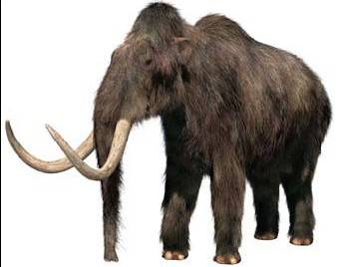Well, now Scientists are not far from recreating extinct animals, just like in the film Jurassic Park.

In May 2013, Russian Scientists discovered a frozen Woolly Mammoth believed to be about 15 000 years old. It was found in ice on a remote island in the Artic. The very interesting thing about this is that it still had blood in its body! This could allow scientists to clone the extinct animal!

Do you think it is ok to bring extinct animals back alive by cloning? Have a chat with an adult about this.

You can read more about the amazing Woolly Mammoth discovery at this website:

<http://www.smh.com.au/technology/sci-tech/tusk-tusk--its-a-woolly-tale-of-mammoth-blood-20130530-2nep2.html>

**Activities**

C:\Program Files\Microsoft Office\MEDIA\CAGCAT10\j0305257.wmf

* List places around Victoria that contain significant fossilised remains.
* View a media file about Geology and what we can learn from it.
* Complete a crossword about key ideas gained from watching the media file.

Fossils are important to Scientists and Palaeontologists because they give us clues about what the Earth was like a long time ago. The only reason we know dinosaurs existed is because of fossils!

Fossils usually form when sediment (like mud, sand, silt and clay) cover the dead animal or plant quickly. When the layers of sediment harden over the years, they turn into sedimentary rocks. This is what the Victorian tourist attraction, the 12 Apostles are.

**FOR YOU TO DO: Activity – Interactive and crossword**

Watch the interactive from the ABC splash website  
<http://splash.abc.net.au/media/-/m/30618/geology-reveals-how-earth-changes?source=upper-primary-science>

Now complete the crossword about the key ideas you learned from this interactive.

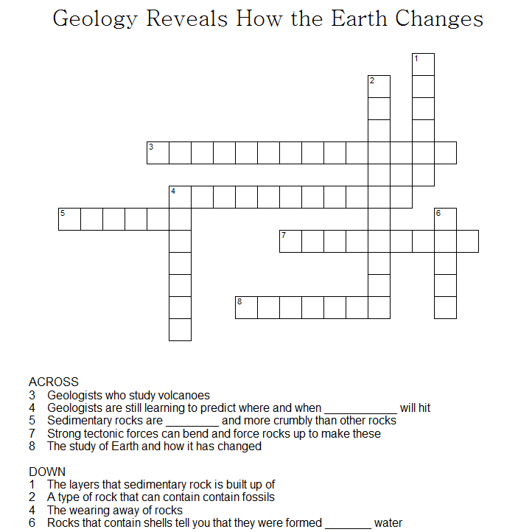

Have you ever visited these places in Victoria: San Remo, Inverloch, Apollo Bay, Cape Otway, Kilcunda, Cape Paterson. These are all places where fossils of dinosaurs have been found. In fact, Australia’s first dinosaur fossil, the Cape Paterson Claw, was discovered near Inverloch in 1903 by William Hamilton Ferguson.

**FOR YOU TO DO: Activity – Mapping Victoria’s Fossil locations**

Using an atlas or map of Victoria, mark in the places underlined.

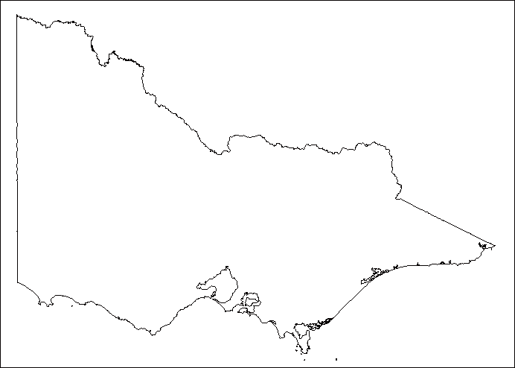

C:\Users\lmarcon\AppData\Local\Microsoft\Windows\Temporary Internet Files\Content.IE5\K975LXFD\MC900140189[1].wmf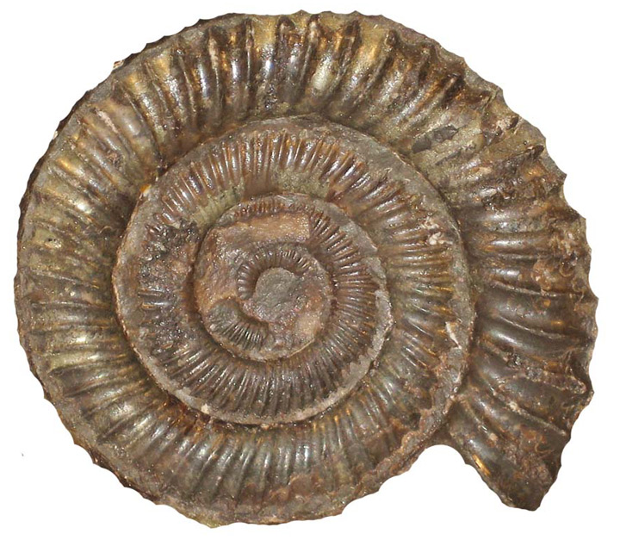

**Did You Know…**

Do you know what this creature is? It’s an “ammonite” – an ancient mollusc (snails are molluscs) that lived in the ocean. It is thought that the animal lived inside the protective shell, just as snails do today. When the ammonite needed to flee from a predator, it would fill its spiral chambers with water to quickly sink and escape. Ammonites lived when the dinosaurs did and died out around the same time. Fossils of ammonites have been found ranging in size from 1 cm to over 2 metres in diameter!