**Science Inquiry**

C:\Users\lmarcon\AppData\Local\Microsoft\Windows\Temporary Internet Files\Content.IE5\XGYY5H84\MC900186210[1].wmf

**How are all living things connected?**

**Activities**

C:\Program Files\Microsoft Office\MEDIA\CAGCAT10\j0305257.wmf

* Define a producer and consumer.
* Know the difference between a herbivore, omnivore and carnivore.
* Use a computer program to construct a food web.
* Use a computer program to give examples of herbivores, omnivores and carnivores.

C:\Users\lmarcon\AppData\Local\Microsoft\Windows\Temporary Internet Files\Content.IE5\XGYY5H84\MC900311078[1].wmfThe Ryan family were holidaying at the Grampians in the Victorian countryside. The 3 siblings, Mary, Xavier and DJ were relaxing at the caravan park while they waited for dinner to cook. It was very noisy because the crickets were chirping away noisily in the grass.

Mary: Hey Xavier, look over there! There’s a mob of kangaroos eating the grass on the footy oval.

Xavier: Cool! Let’s go and see them.

*The three siblings walk towards the oval. On their way, they saw a kookaburra feasting on a dead lizard.*

*When they got to the oval, they also noticed some emus pecking at the ground.*

DJ: Look at those big birds over there eating the dirt!

Mary: They’re called Emus, DJ. I think they are eating ants or worms living in the dirt.

DJ: Look out guys! I just saw an eagle taking a swipe at the dead lizard too. The kookaburra has flown off.

Xavier: Wow, I didn’t know kookaburras ate flowers!

Mary: No. That’s not a Kookaburra. It’s a honey eater. Look at its long beak. Can you see how it’s sucking the nectar out of that Eucalypt flower?

*The children are closer to the oval and they can see that some kangaroos are eating the grass and others are eating some seeds that some children have dropped behind.*

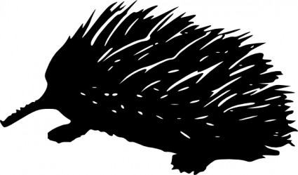Xavier: Ok, Mary. Is that an echidna over there? What do you think they eat?

Mary: Let’s go and take a look.

*The children creep slowly towards the echidna.*

DJ: Ahhh. There’s an ant on me. Get it off!

Xavier: Me too!

Mary: Settle down, they’re only ants but I think we’d better turn back. I think we are walking towards an ant’s nest.

*The children make their way back to the caravan park. Time to eat.*

**FOR YOU TO DO: Activity – What Eats What?**

In this dialogue, the 3 children make some interesting observations about animals and what they eat.

Fill in the table with the name of the animal and the food it eats. I have done the first one for you.

|  |  |
| --- | --- |
| **Animal** | **Food** |
| Crickets | Grass |
|  |  |
|  |  |
|  |  |
|  |  |
|  |  |
|  |  |

Animals that eat other animals are called carnivores.

Animals that eat plants are called herbivores.

Animals that eat both animals and plants are called omnivores.

Carnivores, herbivores and omnivores are CONSUMERS. They eat food to get their energy.

Plants are PRODUCERS. The make their own food. They don’t need to eat anything!

**DID YOU KNOW:**

Below is a picture of a Venus Fly Trap plant. It is actually a producer and a consumer! In this picture the worm is about to become lunch for the Venus Fly Trap! Don’t you think it should be called the “Venus Worm Trap”?

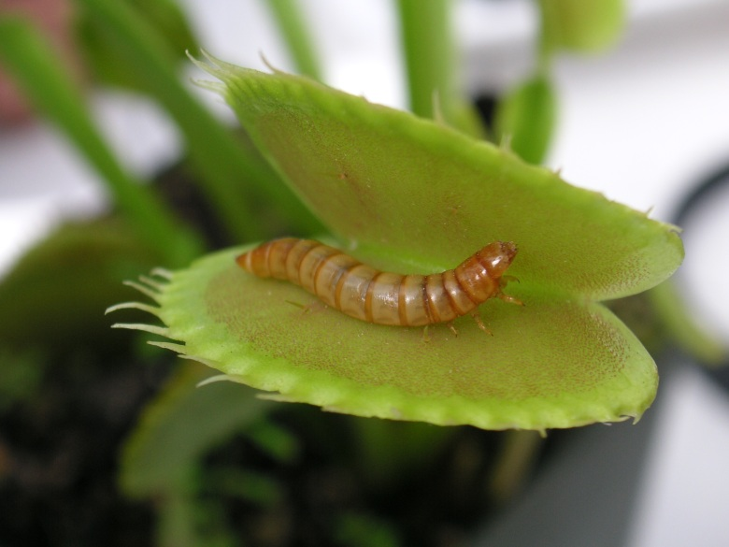

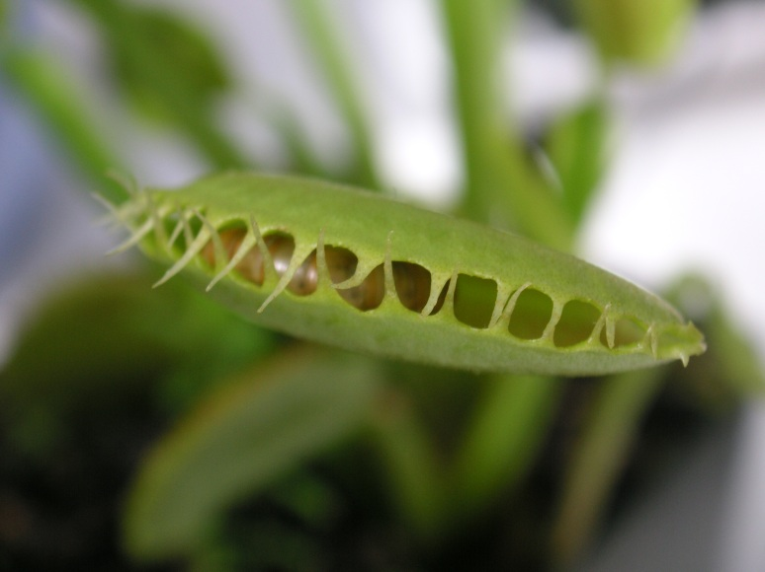

**Activities**

C:\Program Files\Microsoft Office\MEDIA\CAGCAT10\j0305257.wmf

* Explore ideas about recycling and composting.
* Define what decomposers are.
* List some common decomposers.
* Describe the role decomposers have in our environment.
* Explain why decomposers are important to us.

**FOR YOU TO DO: Activity - Brainstorm -What does a compost bin have to do with recycling?**

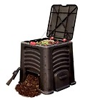

**FOR YOU TO DO: Activity – Cloze the gaps about composting**

Word List:

|  |  |  |  |
| --- | --- | --- | --- |
| smaller | scraps | compost | landfill |
| left | little | beds | grow |
| worms | break | fungi | terrific |

Composting is a _________ way of doing our __________ bit for the environment. When food scraps are composted, less rubbish goes into ___________. The food ___________ are broken down into smaller and ____________ scraps so that all that is _________ is nutrient rich ___________. This is excellent to put on garden ________ so plants get all the nutrients they need to _________ strongly. Special agents called decomposers “eat” or break down the food scraps. Decomposers such as fungi, _________, and microscopic bacteria help ________ down the food scraps. Moulds and mushrooms are common examples of _______.

**FOR YOU TO DO: Activity – Viewing fungi in action**

<http://splash.abc.net.au/media/-/m/104122/?source=upper-primary-science>

Or simply go to <http://splash.abc.net.au>

And follow these links:

Upper Primary – Science –Fungi – How they grow

This video clip mentioned an experiment. If you have a mushroom at home you could have a go at it.

**FOR YOU TO DO: Activity – Creating patterns from mushrooms**

C:\Users\lmarcon\AppData\Local\Microsoft\Windows\Temporary Internet Files\Content.IE5\JQ2551LD\MC900348993[1].wmfYou will need:

* A mushroom (no stalk)
* A sheet of white paper
* A bowl

Place the mushroom cap down on the sheet of white paper. Cover it with a bowl and leave it overnight.

Check to see if any patterns have been made on the paper.

Cut out or draw your pattern in the space below.

C:\Users\lmarcon\AppData\Local\Microsoft\Windows\Temporary Internet Files\Content.IE5\XGYY5H84\MC900036442[1].wmfThe underside of the mushroom contains the gills. When spores come out of the gills, beautiful patterns are created on the paper.

**DID YOU KNOW…**

C:\Users\lmarcon\AppData\Local\Microsoft\Windows\Temporary Internet Files\Content.IE5\79QX6KKZ\MC900432171[1].wmf

Mushrooms are a type of fungus. Fungi are unusual because they are not plants, even though they can grow in soil.

Fungi recycle plants after they die and turn them into rich soil. If we didn’t have these, the Earth would be buried in several feet of rubbish and life on our planet would soon disappear!

A toadstool is a type of mushroom that is poisonous. They can often be brightly colored. You should not eat mushrooms / toadstools that you see growing in your garden. It is often hard to tell the difference between a poisonous mushroom and a safe one.

**For you to do – Evaluation**

Tick the box that describes your learning.

|  |  |  |  |
| --- | --- | --- | --- |
|  | I am good at this | I am nearly there | I need help with this |
| I can define what decomposers are. |  |  |  |
| I can list some common decomposers. |  |  |  |
| I could explain the role of decomposers. |  |  |  |
| I understand how composting is good for our environment. |  |  |  |
| I could brainstorm ideas about composing and recycling. |  |  |  |