**Science Inquiry**

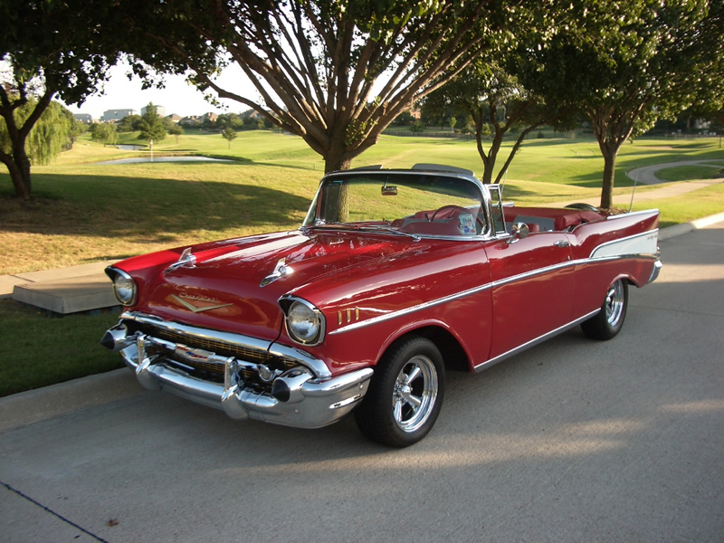

**How are natural and processed materials useful to us?**

**Activities**

C:\Program Files\Microsoft Office\MEDIA\CAGCAT10\j0305257.wmfBy the end of these activities, you will:

* Study a car and list some materials in it.
* Match the basic material with where it is found in a car.
* Describe how the materials were useful in the car.
* Complete a crossword about natural and processed materials.
* Describe the difference between natural and processed materials and give an example.

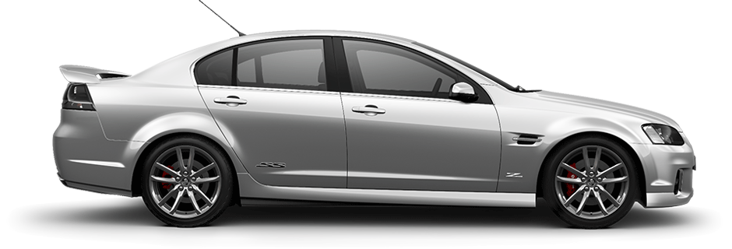**FOR YOU TO DO - Activity 1: Car Study**

Cars are an important

form of transport for us. Hardly a day goes by when we don’t use a car. Today we are going to study a car to see how the basic materials contribute to its function – transport. Go out and take a look at your family car or look at the pictures on this page.

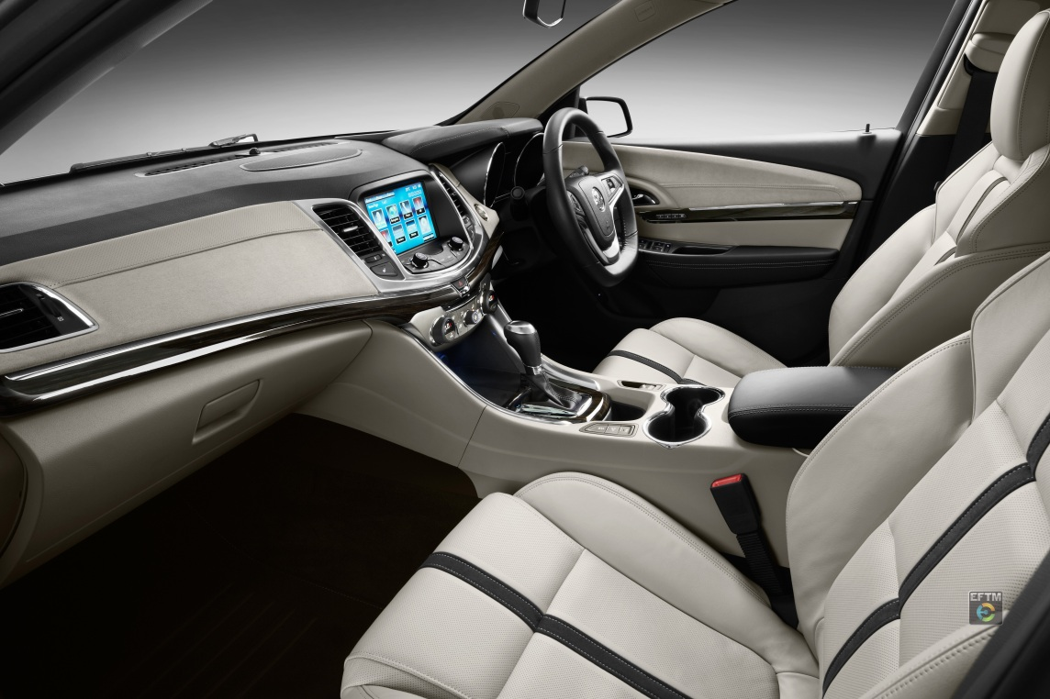

Now complete the table below. It lists the basic materials in the car, where it is found and out how this helps the car work properly. Some information has been filled in for you.

|  |  |  |
| --- | --- | --- |
| BASIC MATERIAL | WHERE IT IS FOUND | HOW IT HELPS THE CAR |
| Steel | * Around the outside of car * In engine * Nuts and bolts in car door hinges | * Protects passengers and interior * Moves the passengers * Allows doors to open / close easily |
|  | * In clear windows * In side and rear-view mirrors |  |
| Fabrics (wool, acrylic) | * As carpet * In seatbelts |  |
| Plastics |  |  |
|  |  |  |

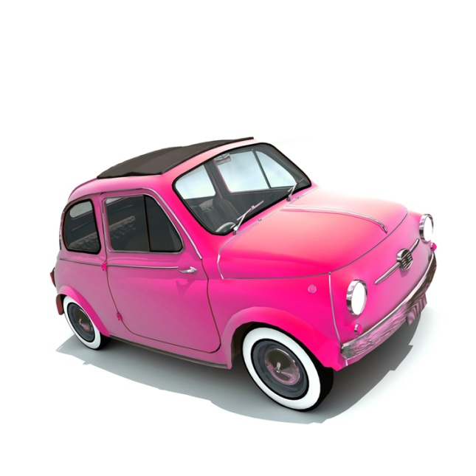

Some of the materials that you listed are natural, some are made by people. The materials made by people are called processed.

C:\Users\lmarcon\AppData\Local\Microsoft\Windows\Temporary Internet Files\Content.IE5\XGYY5H84\MC900048071[1].wmf

**FOR YOU TO DO – Activity 2: Crossword**

Hints for this crossword can be found from the table in activity 1.

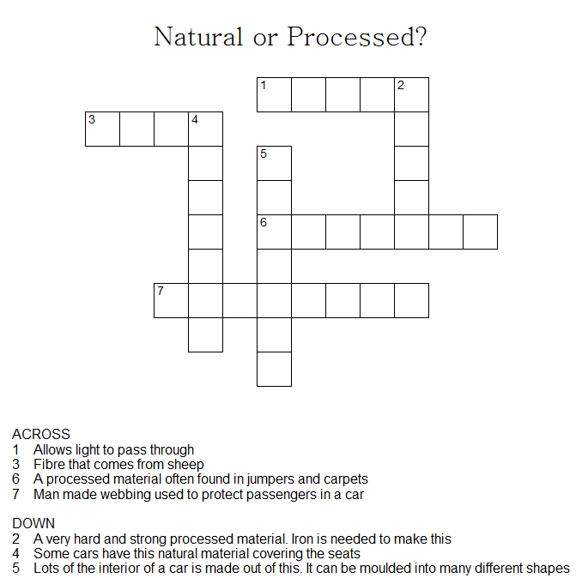

**DID YOU KNOW**

Have you ever been in a new car? Did it smell different? People often describe a “new car smell”. What they actually smell are the vapours produced from the plastics and glues used in the interiors. Today, used car yards spray “new car” aerosols to try and copy the smell of a new car in older vehicles they are trying to sell!

C:\Users\lmarcon\AppData\Local\Microsoft\Windows\Temporary Internet Files\Content.IE5\JQ2551LD\MC900437779[1].wmf

**For you to do – Evaluation:** Tick the box that describes your learning.

|  |  |  |  |
| --- | --- | --- | --- |
|  | I am good at this | I am nearly there | I need help with this |
| I could study a car and list some materials in it. |  |  |  |
| I could match the material with where it is found in a car. |  |  |  |
| I could describe how the materials were useful in the car. |  |  |  |
| I could complete a crossword. |  |  |  |
| I know the difference between natural and processed materials. |  |  |  |

**Activities**

C:\Program Files\Microsoft Office\MEDIA\CAGCAT10\j0305257.wmf

* Find packages from around your home and describe their uses.
* Decide the best use for a package.
* Make a prediction about an experiment.
* Perform an experiment in a safe manner.
* Give reasons for experimental results.
* Identify if a test was fair.
* Suggest improvements to the design on an experiment.

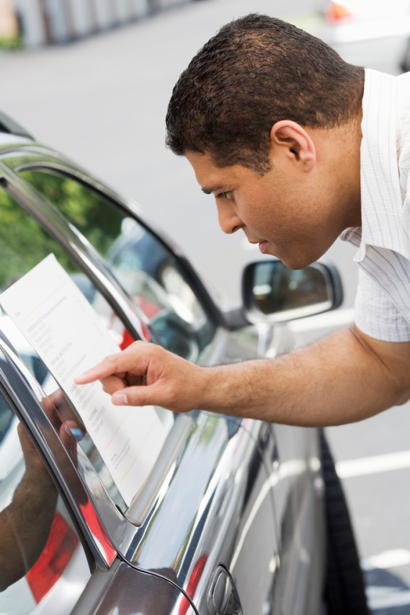

You have investigated the different materials that are found in cars and why they are useful. Tick what you remember:

I found different materials in a car.

Different materials have different jobs to do.

Metal makes the car strong.

Leather or fabric makes the car comfortable.

Glass protects drivers from wind / air / rain and lets the driver see the road.

Rubber cleans the windscreen.

Today we will examine some common packages and determine the different properties of these.

C:\Users\lmarcon\AppData\Local\Microsoft\Windows\Temporary Internet Files\Content.IE5\K975LXFD\MC900078628[1].wmf**FOR YOU TO DO – Activity: Packages around my home**

Have a hunt around your home and collect these packages. Tick the ones that you manage to find:

|  |  |  |  |
| --- | --- | --- | --- |
|  | Bubble wrap |  | Cling wrap |
|  | Egg carton |  | Plastic bag |
|  | Cereal box |  | Milk Carton |
|  | Newspaper |  | Take-away food container |
|  | Waxed paper |  | Foil |
|  | Plastic milk bottle |  | Plastic orange juice bottle |
|  | Moulded plastic (like that found in children’s new toys) |  | Brown paper bag |

Choose 3 of these packages and fill in the table below. An example is provided.

|  |  |  |
| --- | --- | --- |
| Package | Its use | Why it works well |
| Milk carton | Holds milk | * It is waxed so it doesn’t leak * It is easy to pour from * It is opaque so it doesn’t let light in which can spoil the milk |
| 1) |  |  |
| 2) |  |  |
| 3) |  |  |

C:\Users\lmarcon\AppData\Local\Microsoft\Windows\Temporary Internet Files\Content.IE5\JQ2551LD\MC900291928[1].wmf**FOR YOU TO DO – ACTIVITY : THE LUNCHBOX CHALLENGE**

You are on a mission to work out the best package to wrap your lunch in so it keeps coolest, and therefore, freshest!

C:\Users\lmarcon\AppData\Local\Microsoft\Windows\Temporary Internet Files\Content.IE5\XGYY5H84\MC900012913[1].wmfInstead of using a real sandwich, we are going to use an ice block. That way you don’t need a thermometer. You can easily tell which one works best because it will be the one that has melted the least!

To investigate this you will need:

* A selection of packaging materials (e.g. cling wrap, foil, take away food container, waxed paper, paper bag)
* Some ice cubes (equal size)
* Scissors
* A timer
* Some elastic bands
* A large, flat tray or flat plate

The packaging materials I will test are: (Choose two or three)

|  |  |  |
| --- | --- | --- |
| 1) | 2) | 3) |

Make a prediction:

I think __________________ will work the best at stopping my ice cube from melting.

I think __________________ will work the least at stopping my ice cube from melting.

C:\Users\lmarcon\AppData\Local\Microsoft\Windows\Temporary Internet Files\Content.IE5\O1MM9CQ8\MC900293654[1].wmfMethod:

* Cut each of your materials so that they are all approximately the same size
* Wrap an ice cube in each of your test materials and fasten them with an elastic band. Leave them on the tray
* Leave one ice cube in the freezer and one on the bench sitting on the tray – these are your controls. You will use these to compare your experimental ice cubes to.
* Start timing for 20 minutes

Results:

Compare your results to each other and to the controls.

1. The packaging material that worked best was _____________.
2. The packaging material that worked least was ____________.
3. Why do you think we included the controls (the ice cube in the freezer and the unwrapped ice cube on the tray)?

________________________________________________________

________________________________________________________

________________________________________________________

1. Looking at your results, give a reason why certain packaging materials work better at keeping the ice cold.

____________________________________________________

____________________________________________________

____________________________________________________

1. Did you get any unexpected results? Which ones were they?

____________________________________________________

____________________________________________________

1. Do you think this experiment was a fair one? YES NO
2. If you were to do this experiment again, what changes would you make to improve the design?

____________________________________________________

____________________________________________________

____________________________________________________

1. The manufacturers of school lunchboxes “Lunchboxes R Us” has asked you to recommend the best material they should use in their lunchboxes. What will be your recommendation and why?

**DID YOU KNOW…**

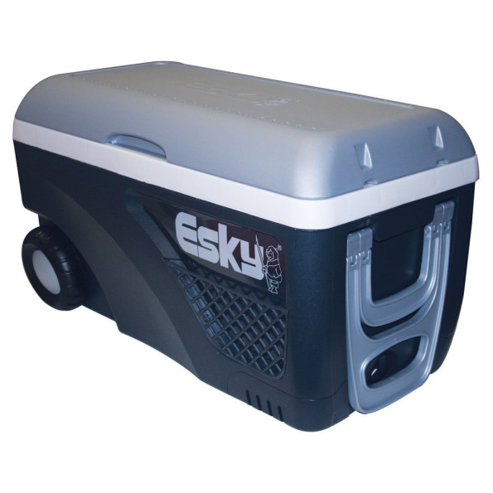In 1952, Australian refrigeration company, Malley’s, made a cooler made from steel, with cork sheeting for insulation. It was called the “Esky”. Later, the design was changed so that it now has a much lighter outer shell (polypropylene) and an insulating inner layer (polyurethane).

The Esky has been used as a life saving device. On January 5th 2012, 2 children and 2 adults were rescued from the ocean after they were found clinging to an Esky in waters of Sydney Heads. You can find out more about this amazing rescue at:

<http://www.smh.com.au/nsw/four-found-clinging-to-esky-after-boat-sinks-20120105-1plt4.html#ixzz2UBHVcQ3X>

**For you to do – Evaluation**

Tick the box that describes your learning.

|  |  |  |  |
| --- | --- | --- | --- |
|  | I am good at this | I am nearly there | I need help with this |
| I could find packages from around my house and describe their uses. |  |  |  |
| I could decide the best use for each packages. |  |  |  |
| I could make a prediction about an experiment. |  |  |  |
| I completed an experiment in a safe manner. |  |  |  |
| I could give a reason for my results. |  |  |  |
| I could identify if a test was fair. |  |  |  |
| I could suggest improvements to the design of an experiment. |  |  |  |