Exploring the Burning of a Candle
Written by Deakin Science Ed @Geelong

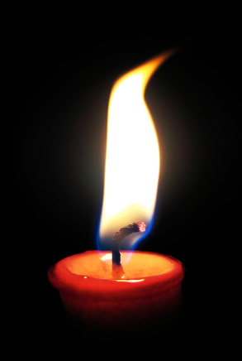
Investigation 1: Burning candle
In this activity, we will explore the phenomenon of candle burning.

Watch the video https://vimeo.com/418415736 (password: 123456)
Answer the following questions:
- Look at the candle carefully. Make a list of the things you can see.

- Ask Mum and Dad to light the candle. Write down as many observations as you can about a candle.
  - How does a candle stay alight?
  - What is burning?
  - What is the wax doing?
  - What is changing? Can you notice any clues in the flame?

Watch the video on this website “what happens when a candle burns?” https://www.nationalgeographic.org/media/burning-candle/
- Why does the candle change its weight after burning?

Investigation 2: Candle in a jar
In this activity, we will explore burning as a chemical change involving the production of new substances.
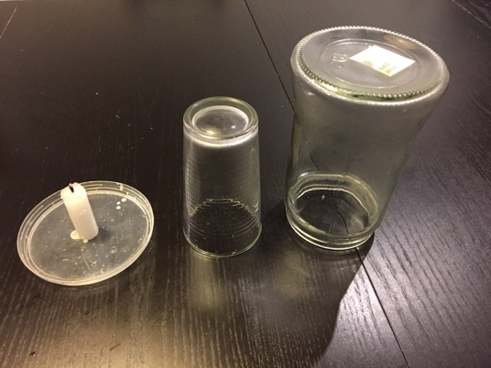
You will need:
- Candles of various heights
- matches
- glass jars of various sizes
- a plastic lid to place the candle on

Conduct investigations to explore burning as a chemical change.
- Light a candle and put the lit candle on a plastic lid. What do you think will happen if you put a glass jar over the top of the candle?
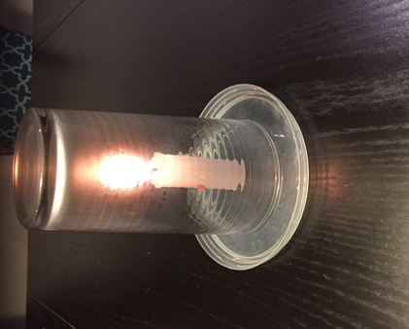

- Try it and see. Why did the candle go out?

- Lift the jar. What do you notice? Why does the plastic lid stay on the jar?

- Look at the bottom of the upturned jar. What can you see? What caused the blackening? What is the black stuff? Where does it come from? What does a candle need to keep burning?

- Try a big jar. Does a candle stay alight twice as long if the jar volume is doubled? How can you investigate into this? Design and conduct an investigation using the investigation planner on the page 4.

- Try three candles of different heights in the same jar. Design and conduct an investigation using the investigation planner on page 5.
- Predict if they will go out at the same time.
- Try it—observe. Explain.
- Does the jar need to be sealed at the bottom? Hold the jar above the surface, with the rim just below the flame. Does the candle still go out?

Do you think you can light up a candle without touching the wick? Watch the short experiment video https://vimeo.com/418422129 (Password: 123456). Explain why this is possible.

My Investigation Planner
Question for my investigation
I will keep the same
I will observe or measure
This is what I predict will happen and reasons for my prediction:

This is what I observed:

This is how I show and explain the results:

My Investigation Planner
Question for my investigation
I will keep the same
I will observe or measure
This is what I predict will happen and reasons for my prediction:

This is what I observed:

This is how I show and explain the results:

