Science Inquiry

*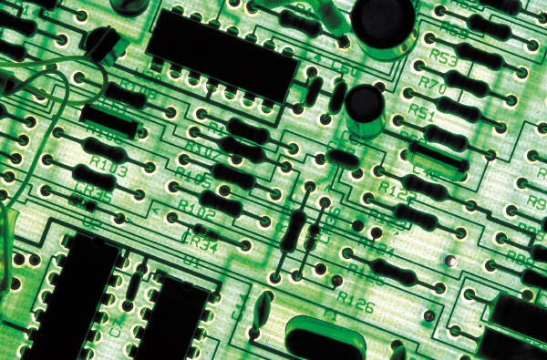*

*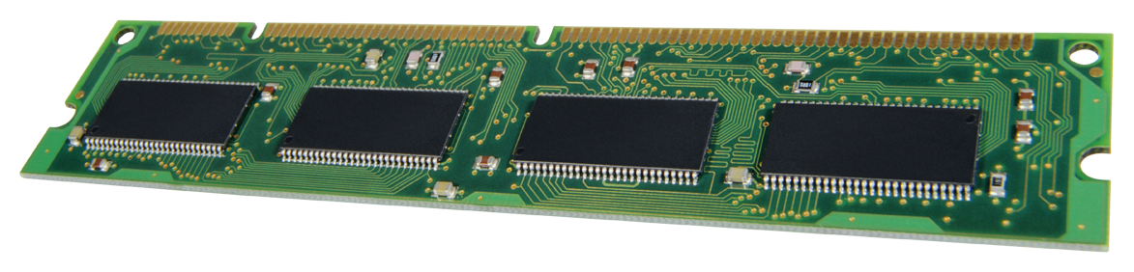*

*What makes an electrical circuit work?*



**Content Description**

*Energy from a variety of sources can be used to generate electricity; electric circuits enable this energy to be transferred to another place and then to be transformed into another form of energy*

[*(VCSSU081)*](https://victoriancurriculum.vcaa.vic.edu.au/Curriculum/ContentDescription/VCSSU081)

**Electricity**

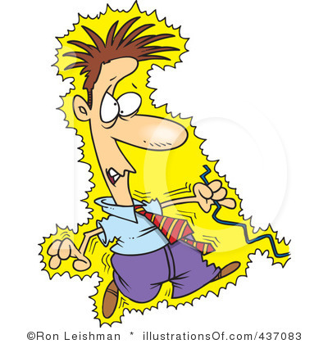Electricity - we can’t see it, but we would use it every day.

Where does our electricity come from? List some ideas:

…………………………………………………..………………………………………….

…………………………………………………..………………………………………….

…………………………...………………………………………………………………….

…………………………………………………..…………………………………………………………………………………

…………………………………………………..………………………………………………………………………………..

…………………………...……………………………………………………………………………………………………….

In the chart below, write or draw how you have used electricity in the past 24 hours:

|  |  |  |
| --- | --- | --- |
|  |  |  |
|  |  |  |
|  |  |  |

**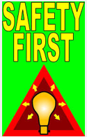**

**Remember These Safety Tips:**

* Electricity can be **DANGEROUS**
* Always pay attention to warnings
* Never use electrical devices near water
* Never touch switches with wet hands
* Always hold the plastic part of the plug when plugging in and unplugging devices
* Never stick scissors, pens, fingers or conductors into a socket
* Ensure all equipment is safely stored and used correctly.

What do you know?



Here are two common sources of electricity. Write these words into the Venn diagram. The centre part contains words that apply to both.

appliances, devices, mains, electricity, power,

store, generate, replace, recharge, socket,

AC/DC, chemical, energy, portable, mains.

**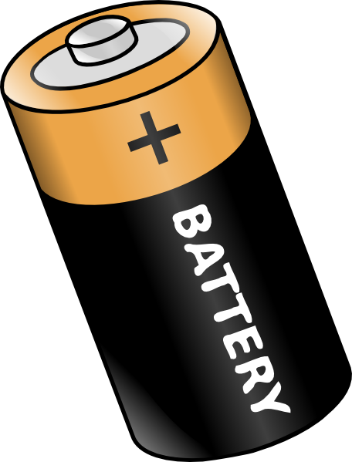**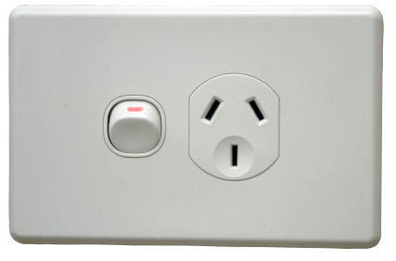

Identify appliances or devices which use mains power (socket in the wall) or battery power. Look around your place to find other appliances and add them to the appropriate column.

|  |  |
| --- | --- |
| **Mains Power** | **Battery Power** |
|  |  |

|  |  |  |  |
| --- | --- | --- | --- |
| Television | Torch | Computer | Fridge |
| TV Remote | Washing Machine | Remote Control Car | **Mobile phone.** |

“Word Power” – knowing electrical words. To work with electricity you need to know what the words mean. Find their meanings and draw a simple diagram to represent the word.

|  |  |  |
| --- | --- | --- |
| *appliance* | *bulb* | *buzzer* |
| *circuit* | *component* | *conductor* |
| *cell* | *electricity* | *motor* |
| *resistance (resistor)* | *wire* | *mains power* |
| *electron* | *insulator* | *symbol* |

|  |  |  |
| --- | --- | --- |
| *negative* | *positive* | *proton* |
| *short circuit* | *switch* | *energy* |

**Investigate** electricity and electrical circuits:

Select one or two topics that interest you from this link:

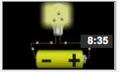

http://www.neok12.com/Electricity.htm

Discuss what you have seen and read with your supervisor.

Write in your own words a summary of what makes an electrical circuit work.

Identify the components that make up a circuit.

Draw and label a circuit:

|  |
| --- |
|  |

**How does a basic electrical circuit work?**

**Did you mention these key ideas?** Tick each feature you mentioned in your explanation:

A simple electrical circuit needs:

* a power source,
* two conducting wires (one end of each being attached to each terminal of the cell),
* a small lamp / motor to which the free ends of the wires leading from the battery are attached.

An electric circuit is an unbroken path.

An electric current exists and/or is able to flow along this path.

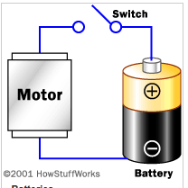When the connections are made properly, the circuit will “close” and current will flow through the circuit and light the lamp.

When circuit is broken, the flow of electricity is interrupted, the circuit is “open” and the lamp will no longer light or the motor will not run.

Switches open and close the circuits.

See another explanation at:

<http://science.howstuffworks.com/electricity5.htm>

Write a report, in your own words, with diagrams to explain how electrical circuits work.

|  |
| --- |
|  |
|  |
|  |
|  |
|  |
|  |
|  |
|  |
|  |
|  |
|  |
|  |
|  |
|  |
|  |
|  |
|  |
|  |
|  |
|  |

Description: bd20016_

**Optional Extra Activity**

If you would like to experiment with a more advanced website for making electrical circuits, visit the link below. You can try to apply what you know about circuits to create a range of different circuits and gadgets. To use this properly to set up a circuit, find and read the instructions.

<http://tinyurl.com/decvsci2>

or

<http://www.cleo.net.uk/consultants_resources/science/circuitWorld/index.html>



What are the human made sources of electricity? List the ones you can think of:

|  |
| --- |
|  |

<http://tinyurl.com/decvsci3>

or

<http://www.youtube.com/watch?v=20Vb6hlLQSg>

*(Even though the video is about America, Australia’s electrical system is similar – except that we do not use nuclear power plants to generate electricity.)*

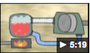

These are methods by which we create electricity / power for our homes.

Which do you think is the most common source of electricity in Australia?

Put in order the numbers 1 – 6 to show the MOST common (1) to the LEAST common (6) form of electricity production in Australia.

|  |  |
| --- | --- |
| ….…..bioenergy\* | ……...coal |
| ……...natural gas | ……...rooftop solar systems |
| ……...hydropower | ……...wind |

*\*Bioenergy is electricity produced from organic matter of recently living plant or animal origin. It is available in many forms such as agricultural products, forestry products, and municipal and other waste.*

Write in order the methods that are the MOST destructive to the environment, to the LEAST destructive.

*Most environmental impact*: …………………………………………..

…………………………………………..

Medium environmental impact: …………………………………………..

…………………………………………..

…………………………………………..

*Least environmental impact:* …………………………………………..

Compare your answers to this graph:

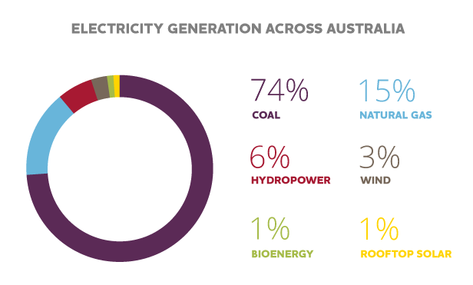

*Most environmental impact:* coal

*Medium environmental impact:* natural gas, hydropower, wind.

*Least environmental impact:* bioenergy, solar panels

Choose one of these forms of generating electricity. You will investigate this and create a ‘mini project’.

|  |  |  |
| --- | --- | --- |
| bioenergy | coal | hydropower |
| natural gas | solar panels | wind |

**ELECTRICITY – MINI PROJECT**

**I would like to investigate:**

……………………………………………..……………………………………

**What do I want to learn?**

My Inquiry questions about my topic:

……………………………………………..………………………………………………………..………………………………

……………………………………………..………………………………………………………..………………………………

……………………………………………..………………………………………………………..………………………………

……………………………………………..………………………………………………………..………………………………

……………………………………………..………………………………………………………..………………………………

……………………………………………..………………………………………………………..………………………………

……………………………………………..………………………………………………………..………………………………

Where will I find information about my topic?

……………………………………………..………………………………………………………..………………………………

……………………………………………..………………………………………………………..………………………………

……………………………………………..………………………………………………………..………………………………

……………………………………………..………………………………………………………..………………………………

How will I show what I have learnt? How will I present my project?

……………………………………………..………………………………………………………..………………………………

……………………………………………..………………………………………………………..………………………………

……………………………………………..………………………………………………………..………………………………

You are on your own! Investigate your power generation source and create a report to show what you have learnt.

|  |
| --- |
| <http://tinyurl.com/decvsci4>  or  <http://www.youtube.com/watch?v=KkRwuM4S8BQ> |

What did you find interesting about the video? ………………………………………

In your own words, explain your understanding of how a battery works.

|  |
| --- |
|  |
|  |
|  |
|  |
|  |
|  |
|  |
|  |
|  |

**Battery – chemical re-action to produce electricity.**

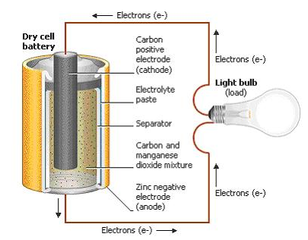

**Chemical Cells (Batteries)**

A common source of electrical power is dry cell battery – like the one you would find inside a torch or other small appliance.

A torch battery contains chemicals. It is a ‘dry cell’ battery because it does not contain liquid.

Common dry cell batteries consist of a rod surrounded by a chemical paste in a metal case. The chemicals in the paste keep taking electrons from the rod and giving them to the case. Electrons have a negative electric charge.

This leads to a build-up of **negative** charge on the case. The rod becomes positivebecause it has **lost negative electrons.** When the wires of the **circuit** are **connected,** the electrons can flow from the negative case through the circuit to the rod. This creates a continuous flow of electrical current.

**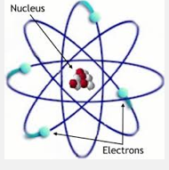Insulators and Conductors**

**Conductors** are materials that electricity **can flow through easily**.

These materials are made up of atoms whose **electrons** can move away freely.

Some examples of conductors are:

|  |  |  |
| --- | --- | --- |
| * Copper | * Aluminum | * Platinum |
| * Gold | * Silver | * Water |
| * People and Animals | * Trees |  |

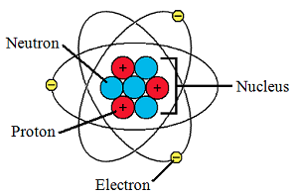**Insulators** are materials **opposite of conductors.**

The atoms are not easily freed and are stable. They prevent or block the flow of electricity. Some examples of insulators are:

|  |  |
| --- | --- |
| * Glass | * Porcelain |
| * Plastic | * Rubber |

The rubber or plastic on an electrical cord provides an **insulator** for the wires. By covering the wires, the electricity cannot go through the rubber and is forced to follow the path on the aluminum or copper wire that is inside the rubber.

Electricity will always find the **shortest path to the ground,** using ‘conductors’ if they are in its path. Your body is 60% water. That makes you a good **conductor** of electricity. If a power line has fallen on a tree and you touch the tree, you become the path or conductor for the electricity to get to the ground. You would be electrocuted as the electricity travels through your body.

Watch this video clip to find out more about insulators and conductors:

<http://tinyurl.com/decvsci7>

or

<http://www.youtube.com/watch?v=_JUeL9RJD9U>



Look around your home. Find common objects that would make good insulators or good conductors:

|  |  |
| --- | --- |
| **Conductors of electricity:** | **Insulators for electricity:** |
|  |  |

|  |  |  |  |
| --- | --- | --- | --- |
| Tick or colour the column that shows how well you understood your Science work: ( = I still need help; = I did OK. = Excellent! |  |  |  |
| I recognise the need for a complete circuit to allow the flow of electricity |  |  |  |
| I investigated electrical conductors and insulators to find out what they are and what they do. |  |  |  |
| I compared different sources of power: mains and a dry cell battery |  |  |  |
| I can explain how a dry cell battery works to generate power. |  |  |  |
| I investigated one electricity generation method in detail and created a mini project to show how electricity is generated.. |  |  |  |
| I understand that an electrical circuit requires a power source, wires, a switch and appliance /device (light bulb, motor, buzzer) and that the circuit must be closed to be active. |  |  |  |

**Electricity & Power Glossary**

|  |  |
| --- | --- |
| **Appliance** | An appliance is any item in your home, which uses electricity |
| **Battery** | A battery (cell) is the component that provides electrical power to a circuit. Without power a circuit is incomplete, small appliances often use batteries that store electricity. Batteries eventually run down and need to be replaces or recharged. The correct term for a battery is a cell. |
| **Bulb** | A bulb is a component, when added to a complete circuit it will glow. If there are too many bulbs in a circuit they will get dimmer and if there is too much power they will glow brighter but might blow. |
| **Cell** | A cell is the correct word for a single battery. |
| **Circuit** | A complete circuit is when all the components and cells are set up correctly to allow for electricity to flow. If there are gaps, missing components of switches turned off a circuit is not complete and no electricity will flow. |
| **Component** | A component is an essential part of a circuit. A component can be anything from a bulb to a motor, cell or buzzer. If there are no components there could be a short circuit. |
| **Conductor** | Materials that can carry electricity are called conductors. Many materials conduct electricity, metals such as copper, steel and aluminium are all good conductors. |
| **Electricity** | Electricity is what powers most things around us. Electricity is like water in the way is works. Water flows through rivers and pipes and will stop if it cannot pass |
| **Electron** | An elementary particle with negative charge. |
| **Energy** | [Energy](http://www.altenergy.org/Glossary/energy.html) is the product of power and time, measured in Watt-hours (Wh). Energy is generated by the sun, and is stored in a variety of forms. It is locked into [biomass](http://www.altenergy.org/Glossary/biomass.html) (Earth’s environment) through the process of photosynthesis.  Burning biomass (coal, gas) releases energy. Energy is stored in the oceans where the movement of the earth and gravity release it through tides, temperature and winds. |
| **Force** | Amount of energy exerted on an object. |
| **Fossil Fuel** | Fuel consisting of the remains of organisms preserved in rocks in the Earth’s crust with high carbon and hydrogen content. |
| **Hydroelectricity** | Electricity generated by turbines that are powered by water. |
| **Insulator** | Materials that cannot carry electricity are called insulators. Wood plastic, glass and rubber are all good insulators. |
| **Mains Power** | Mains power is the power that is generated in the ‘electricity grid’. It is connected to your house from electrical wires outside of your home. |
| **Motor** | A motor is a component which when added to a circuit will spin. If a motor is added to a low power circuit it will spin slower, if there is too much power for a motor it will spin faster but could break. |
| **Negative (-)** | Cells have two ends, a positive and a negative. To complete a circuit the wire must connect from the positive (+) and loop around to the negative (-). |
| **Plug** | A plug goes into a mains socket to provide power to an appliance. Using plugs and sockets is a sage way of providing power to appliances. You must always be careful, as mains electricity can be very dangerous. |
| **Positive (+)** | Cells have two ends, a positive and a negative. To complete a circuit the wire must connect from the positive (+) and loop around to the negative (-). |
| **Proton** | A stable particle with positive charge equal to the negative charge of an electron. |
| **Resistance (Resistor)** | Resistance is like a force holding the electricity back, only allowing a certain amount of electricity through at a time. With normal wire, there is little resistance. If you use a special type of wire called resistance wire, the strength of power in a circuit will be reduced, as the circuit wires get longer. |
| **Short Circuit** | Electricity will always take the shortest route. If there is a direct connection from the positive end to the negative end of the battery/cell there will be a short circuit. A short circuit can be dangerous and damaging to components. |

|  |  |
| --- | --- |
| **Switches** | A switch is a controller for the circuit. When the switch is open or off, no electricity can flow. When a switch is closed or on, it allows electricity to flow through it. |
| **Symbol** | A symbol is the correct way of drawing of a component each component has a different symbol, it is important to know these. |
| **Turbine** | A machine in which the kinetic energy of water or gas is converted to mechanical energy as the fluid reacts to a series of paddles or vanes arranged in a wheel. |
| **Waterwheel** | A wheel driven by falling or moving water and used to power machinery. |
| **Wire** | Wire is a conductor, which allows electricity to flow through. Without wire a circuit is not complete and electricity will not flow. |

