Exploring Physical and Chemical Changes
Written by Deakin Science Ed @Geelong
Introduction
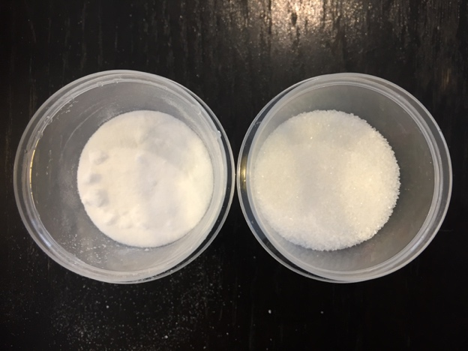
Baking Soda
Sugar

Watch this video https://vimeo.com/416623219 (Password: 123456)

Now prepare some sugar and baking soda in containers and answer the following questions:
- What differences can you see between sugar and baking soda? What is the difference in taste?

- What do you think will happen to sugar when you add vinegar to it? Explain.

- What do you think will happen to baking soda when you add vinegar to it? Explain.

Investigation 1: Froth and Bubbles
In this activity, we will explore the differences between physical change and chemical change.
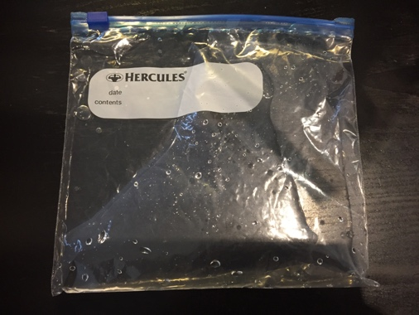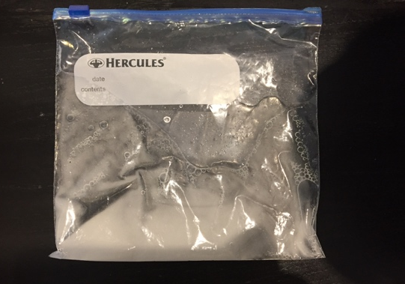

Watch this video to see the experiment by Victor and Annabeth https://vimeo.com/416629406 (Password: 123456)

You will need:
- two zip-lock sandwich bags
- vinegar
- sugar
- baking soda
- a cup measure
- a teaspoon

Conduct an investigation to explore the differences between physical and chemical changes

Take two zip-lock bags. Add 50ml of vinegar to each bag.

Put a teaspoon of sodium bicarbonate in one bag and a teaspoon of sugar in another bag. Quickly seal the bags. Observe what happens.

Use the investigation planner below:

Record your results: what did you observe?

Draw a diagram that explains what happened to the sugar in the vinegar.

Draw a diagram that explains what happened to the baking soda in the vinegar.

Open the bags and smell the liquid in each bag, can you still smell the vinegar in both bags? Describe and explain your thoughts.

My Investigation Planner
Question for my investigation
I will keep the same
I will observe or measure
This is what I predict will happen and reasons for my prediction:

This is what I observed:

This is how I show and explain the results:

Investigation 2: Balloon Blowout
In this activity, we will explore properties of carbon dioxide and air.
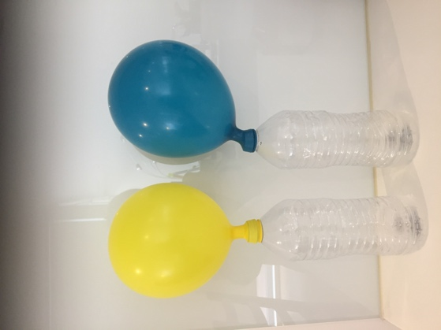
Watch this video to see the introduction to the experiment by Victor and Annabeth https://vimeo.com/416638130
(Password: 123456)

You will need:
- a small plastic soft-drink bottle
- a balloon
- a spoon
- a funnel
- vinegar
- baking soda

Conduct an investigation to explore the properties of carbon dioxide and air in a balloon
- Pour vinegar into a small plastic soft-drink bottle, to a depth of 2 to 3 cm.
- Put a teaspoon of baking soda into a balloon (you could use a funnel)
- Fit the mouth of the balloon tightly over the mouth of the bottle
- Lift the balloon to allow all the baking soda to fall into the vinegar.

Answer these questions:
- What causes the balloon to blow up? What has happened to the baking soda, and the vinegar?
What is in the balloon?

- Take the balloon carefully off the bottle, sealing it and tying it. Blow up another balloon to the identical size. Both balloons are not full of gas, and you can compare them. Do they feel the same? Do they drop at the same rate? Explain.

