Science Inquiry

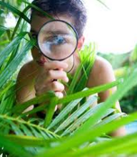 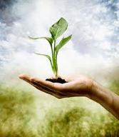

*Why do we need to look after Earth’s natural resources?*



|  |  |  |  |  |  |
| --- | --- | --- | --- | --- | --- |
| **Module C** | | **Science as Human Endeavour** | **Science Inquiry Skills** | **Learning Intentions** | **Materials List** |
| **Week 1** | (Part 1) | Scientific understandings, discoveries and inventions are used to solve problems that directly affect people’s lives.  Scientific knowledge is used to inform personal and community decisions. | Pose questions to clarify practical problems or inform a scientific investigation.  Communicate ideas, explanations and processes in a variety of ways. | Humans rely on Earth’s natural resources to survive and thrive.  Decisions humans make in their daily lives impact upon the way we use our natural resource.  Some resources are non-renewable, some are renewable.  Apply scientific process and knowledge to suggest ways to conserve natural resources. | Access to a range of internet sites – noted in the module. |
| **Week 2** | **What is Science?**  (Part 2) |

In the next 2 weeks you will study the importance of our natural resources, the scientific impact and community choices we make in using these resources. You will complete a **project** on a natural resource.

You will:

- learn about the difference between renewable and non-renewable resources

- develop an understanding of the positive and negative choices we make to our environment

- produce an article on an environmental issue

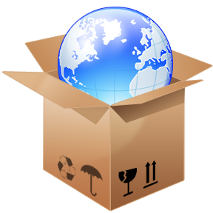

**Week 1:**

**What do you understand by the statement below?**

**“The living conditions we have today are a result of environmental impact and scientific discovery.”**

**With your supervisor, discuss what this statement means.**

Explain your understanding of ‘environmental impact’ and ‘scientific discovery’

|  |  |
| --- | --- |
|  |  |
|  |  |

What does the term ‘natural **resources’** mean?

**Natural resources:**

* are essential for life
* improve our standard of living
* materials or substances that occur in nature, such as minerals, forests, water and trees
* fertile lands that can be used for economic gain.

Find out more about Natural Resources from these sites:

<http://www.ehow.com/list_7260602_list-natural-resources-kids.html#page=3>

<http://www.nrdc.org/reference/kids.asp>

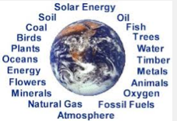

**Complete this on-line activity:**

<http://www.oresomeresources.com/media/flash/interactives/mining_makes_your_house/>

OR

<http://www.scootle.edu.au/ec/pin/FORRTJ?userid=138808>

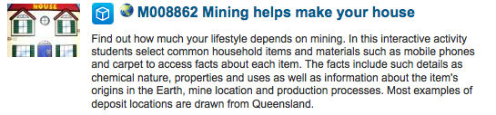

Look around where you are now.

Identify the **natural resources** that you can see, feel or hear.

Try to work out the **natural resources** that were used to build your home and items that are in your home (outside and inside,) food or items you use to make your life easier.

|  |  |  |
| --- | --- | --- |
|  |  |  |
|  | **Natural resources**  **around me.** |  |
|  |  |  |

**1. Natural Resources: will they last forever?**

We use many of the Earth’s natural resources every day. All the products we use come from a natural resource - minerals, timber, water and soil are just some of the natural resources we consume every day.

Some natural resources can be reproduced within a few years or decades – these are called **renewable resources**. Trees are an example of a **renewable resource.** There are resources that take hundreds, thousands or even millions of years to be made – these are called **non-renewable resources.** Oil, minerals, metals and soils are examples of these.

It is very important to use renewable and non-renewable resources wisely. If a resource is used and thrown away this resource becomes very rare. Sometimes resources become so rare they can no longer be used.

Wise use of resources includes not throwing away products that are reusable or recyclable. When these products are reused or recycled, it maintains resource availability and uses less landfill space.

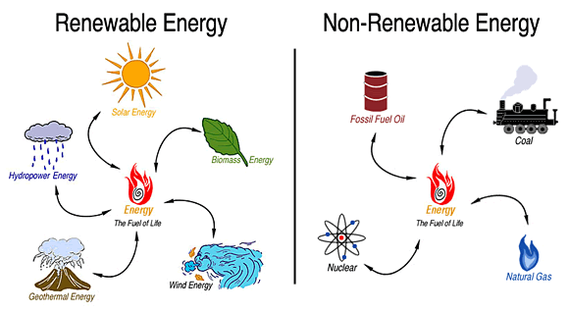

C:\Users\rrindzev\AppData\Local\Microsoft\Windows\Temporary Internet Files\Content.IE5\20CG4EDG\MC900132639[1].wmf**2. Our choices affect our environment.**

Humans have always depended on resources to provide them with life’s necessities and comforts: food, fuel, shelter, medicine and recreation. People make decisions about how to use the **natural resources** in their environment.

At the beginning of human civilisation, the Earth had many natural resources essential for human survival and that were mostly renewable - water, air, and plants. Oil and gas were discovered and used for many different things.

Over time, the use of these resources became the source of major inventions:

* water, oil and gas for electricity and travel
* trees for paper and furniture
* land for agriculture and development of living areas.

If we are not careful with our **natural resources** the survival of all life will become more difficult.

|  |
| --- |
| **Discuss these ideas with your family, supervisor or friends:**  Look at the list of **natural resources list** you made earlier.  Description: http://www.itmcomputing.com/blog/wp-content/uploads/2011/01/chatters.png1. Put a  next to the ones that you think are renewable and a  next to the ones which are NOT easily renewable in our life time.  2. Discuss the way your family has used natural resources in the past week:   * What are some of the natural resources you use in your daily life? * What have you done to ‘save’ resources? * What role do you think Science has to preserve the Earth’s **natural resources?** * How can people act to save **natural resources** to sustain our living conditions? |

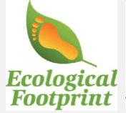**Measure your ecological footprint:**

Choose any of these sites to see how our life choices affect our environment:

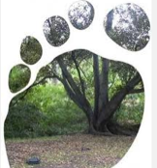

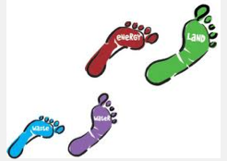

1. http://www.powerhousemuseum.com/online/bigfoot/

2. <http://footprint.wwf.org.uk/>

3. http://www.epa.vic.gov.au/ecologicalfootprint/calculators/personal/introduction.asp

Tell me which website you used to calculate your ‘ecological footprint’’ ……………

Briefly explain what you learnt from doing the ‘Ecological Footprint” survey?

|  |
| --- |
|  |
|  |
|  |
|  |
|  |
|  |
|  |
|  |
|  |
|  |
|  |

**3. Conserving Natural Resources**   
With many human on the planet trying to survive, our natural resources are being used up. Some of the environmental issues that scientist can help us with include:

|  |  |  |  |  |  |
| --- | --- | --- | --- | --- | --- |
| **Issue:** | **Importance** | **Issue** | **Importance** | **Issue** | **Importance** |
| deforestation, |  | energy |  | shortages in water, power, oil gas |  |
| food production. |  | land  clearing |  | rivers  drying up |  |
| soil  erosion |  | climate  change |  | global  warming |  |
| extinction  of animals |  | air  pollution |  | water  pollution |  |
| waste management |  | animal management |  | population  growth |  |

1. Read the list carefully.
2. **Colour each space GREEN** if you know of, or have heard of the environmental issues.
3. Find out the meanings of the issues you are not aware of.
4. Discuss the issues on the list with your supervisor, or research these environmental issues.
5. Use the numbers 1 – 15 to put “1” next to the **MOST important** issue, “2” for the NEXT most important (in your opinion). Use all the numbers up to 15 to let me know your list of MOST important to LEAST important environmental issues. Discuss your list with other people - do they agree with your opinion?

**Save the Planet!**

As a scientist, your job is to research ways to:

* Conserve our **natural resources**
* Identify alternative **energy** sources
* Invent ways to save or create **energy**.

There might be some ideas in this website:

[*http://forteachersforstudents.com.au/CEC-Education/fact-sheets.php*](http://forteachersforstudents.com.au/CEC-Education/fact-sheets.php)

Read the information on the next page to get some ideas about saving Earth’s natural resources. Organise your ideas:



*What can we do to save our natural resources?*

*How can I find out about this topic?*

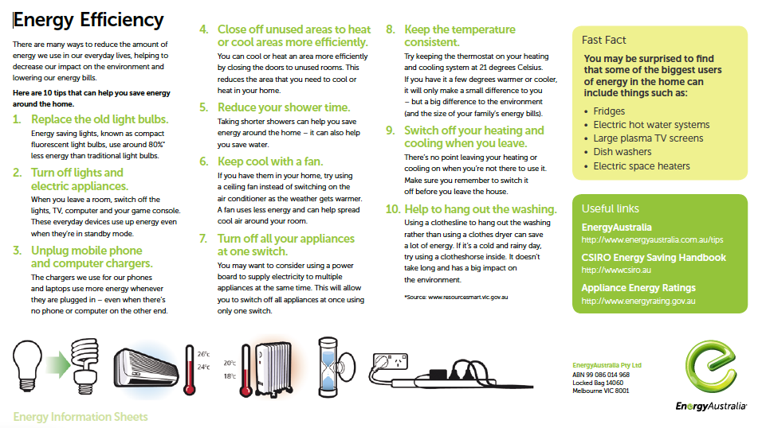Source: *http://www.energyaustralia.com.au/about-us/media-centre/educational-resource*

**Week 2**

**Tell the World How to Save Our Natural Resources**

Create **SOMETHING** that will remind people to be careful with our natural resources: Poster, Story, Advertisement, Song, Game, News Article, TV Interview,

You are expected to follow a procedure called the ***Design Process***. The Design Process is a series of steps that include:

**Design Brief**

Choose an environmental issue that interests you.

Decide how you will tell others about your issue.

**Hint**: Talk to many people; think of as many different possibilities as you can. When you have collected many ideas, it will be easier to choose the ones that interest you most.

Explore some ideas at the links below, or use a local library to find books and information about natural resources and environmental issues.

<http://www.nrdc.org/reference/kids.asp>

<http://education.nationalgeographic.com.au/education/fm/?ar_a=3>

<http://education.nationalgeographic.com.au/education/kd/?ar_a=5>

**Question**

**What will I choose?**

* *You can choose one of the environmental issues previously mentioned or search the Internet or library for others.*
* You can choose a local issue *(if there is something happening in your neighbourhood)* or a global issue *(something that affects the whole planet.)*

**How can scientific knowledge and process be used to understand your issue?**

* What types of Science will you need to learn about your issue?

**How has this issue affected the world?**

* What are the future consequences if we don’t solve this problem?
* What can humans do to manage the problem or solve the problem?

**What can humans do differently to conserve natural resources?**

* As a scientist who has found out about this issue, what suggestions can you make to your family, friends, neighbours and the public?

**Plan**

This step requires you to *plan* your investigation, *take notes* in point form and focus on the key elements. Complete a rough draft first.

Do not be concerned about presentation at this point. Focus on the research and rough draft. These are ‘think boxes’ for you to store your ideas:

My topic is:

What are some questions I have about this topic?

Where and how will I find my information? References I will use.

What are the future consequences of ignoring this environmental issue?

What do I want to tell people about this issue?

What should people do to use Earth’s resources wisely?

**Communicate**

**DO IT!** You have found interesting information; you have created good ideas of your own.

A good scientist finds way to tell others about their research, discoveries and inventions. Organise your ideas so that you can share them with others.

Think about an attractive, clear, engaging presentation to get others interested in your topic.

**Evaluate**

Look over your work: can you see ways to improve it so that your messages and ideas are clear?

Ask someone else to check over your work and suggest improvements.

Check your work against the checklist on the next page.

Scientist’s report to “Save Our Resources” Assessment:

|  |  |  |  |  |  |  |  |
| --- | --- | --- | --- | --- | --- | --- | --- |
| **My topic is:**  ……………………………………………………… | | **Student Self-Assessment** | | | **Teacher**  **Assessment** | | |
| **High** | **Medium** | **Low** | **High** | **Medium** | **Low** |
| **DESIGN** | Selected a suitable topic for researching into environmental issues. |  |  |  |  |  |  |
| Collected a wide range of information and resources to learn about the topic. |  |  |  |  |  |  |
| Took notes and ideas from a variety of sources: encyclopaedias, books, pamphlets, papers, websites, TV shows. |  |  |  |  |  |  |
| **QUEST-ION** | Thought of questions about my topic. |  |  |  |  |  |  |
| Asked others to suggest questions. |  |  |  |  |  |  |
| **PLAN** | Looked in different places for ideas and information. |  |  |  |  |  |  |
| Collected and organised information and materials to create my project. |  |  |  |  |  |  |
| Organised time to do research thoroughly and complete the project. |  |  |  |  |  |  |
| **COMMUNICATE** | Work is neat and clear. |  |  |  |  |  |  |
| The problems are identified. |  |  |  |  |  |  |
| The solutions are achievable. |  |  |  |  |  |  |
| People who read / see my work will want to be more careful with natural resources. |  |  |  |  |  |  |
| **EVALUATE** | Work has been proofread and edited. |  |  |  |  |  |  |
| Others have read the work and commented. |  |  |  |  |  |  |
| This work will help others understand how to save our natural resources. |  |  |  |  |  |  |

**Assessment:** In your own words or pictures, explain your understanding of ‘natural resources.”

|  |
| --- |
|  |
|  |
|  |
|  |
|  |
|  |

In your opinion, what are the three main issues for the Earth’s environment that Scientists need to find solutions for?

|  |
| --- |
|  |
|  |
|  |
|  |
|  |
|  |

|  |  |  |  |
| --- | --- | --- | --- |
| Tick or color the column that shows how well you understood your Science work: ( = I still need help; = I did OK. = Excellent! |  |  |  |
| I can explain what ‘natural resources’ are. |  |  |  |
| I understand the difference between ‘renewable and ‘non-renewable’ resources. |  |  |  |
| I understand that my life’s choices have environmental impacts. |  |  |  |
| I followed the design process to investigate an environmental issue and communicate what I discovered. |  |  |  |
| I worked to the best of my ability. |  |  |  |

**Appendix C1: Ways of Conserving Natural Resources**  
  
**Conserving Trees**  
Trees give us the oxygen we breathe, the paper we use, the fruit we eat, the shade we need and are essential for the survival of wildlife. To help save this natural resource, we can help out at home by doing the following:

* Use only recycled paper products. It takes a lot of trees to make a small amount of paper. Look for opportunities to ‘reduce re-use and recycle’ paper.
* Avoid using paper unnecessarily. For instance, printing every piece of information is not always necessary.
* Plant a tree whenever you can!

**Conserving Water**  
Water is a basic resource for all human life. We clean with water, we cook with water, and we water our plants with water. Several parts of the world are now facing water shortages. Conserving water is important for the stability of our environment.

People can save water by:

* fixing all leaking pipes – every drop is precious.
* turning the tap off as you brush your teeth.
* not dumping things in the seas and rivers and lakes. The water becomes polluted and sea animals suffer.
* 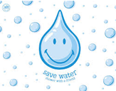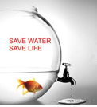collecting rainwater and using it to water gardens and plants and to wash cars.

**Conserving Energy**  
Our main source of energy is oil and gas, which is used for petrol to make cars and machinery move. Oil and gas takes millions of years of natural processes to create coal, oil and gas. When we use up the available resources of oil and gas – there will be no more.

Generating electricity for power relies on extracting coal from the ground – but this natural resource is becoming scarce. Generating electricity from coal also creates greenhouse gases, which are not good for the environment.

We can help by:

* Choosing to walk or ride a bike instead of driving. It saves the environment and it's healthy for you too.
* Using energy efficient lights and bulbs.
* remembering to switch off all electrical appliances when we are not using them.
* Buying products such as air-conditioners and refrigerators that have energy star ratings. These use less electricity and help reduce the energy costs.

