**Science Inquiry**

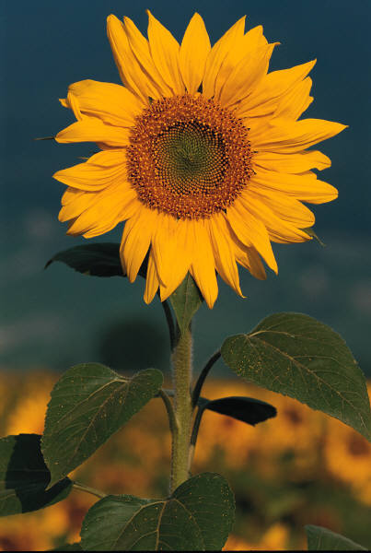

**What are the stages in the life cycle of a plant?**

Backyard Science

Take a walk outside for 5 minutes. It could be in your backyard, front yard, nature strip, local park or even at the beach (if you live near one). Can you see living things around you?

Make a list some of the living things you saw:

**LIVING THINGS AROUND ME**

Did your list contain some plants?

Check out this YouTube video showing how a pea seed germinates.

<http://www.youtube.com/watch?v=eDA8rmUP5ZM>

C:\Users\lmarcon\AppData\Local\Microsoft\Windows\Temporary Internet Files\Content.IE5\K975LXFD\MC900116048[1].wmf

**FOR YOU TO DO**

Check out this website:

<http://splash.abc.net.au/media/-/m/106388/?source=upper-primary-science>

Use the information on the website to answer these questions:

1. List some of the different seeds described in the video.
2. What are sprouts?



Just imagine…. A world without plants!

Think about how plants are important to us. You may like to think about what you ate for breakfast, or what sorts of products you use. Write your thoughts in the box on the next page.

My thoughts – life without plants.

**C:\Users\lmarcon\AppData\Local\Microsoft\Windows\Temporary Internet Files\Content.IE5\O1MM9CQ8\MC900437485[1].wmf**

If seeds are planted upside down, their roots will still grow downwards and the shoots will grow upwards. This is called gravitropism. Check this out at <http://plantsinmotion.bio.indiana.edu/plantmotion/earlygrowth/germination/germ.html>

1. In the box below, draw a flow chart of a plant’s life cycle. You can colour it to make it look as attractive as possible. I have started with the mature plant for you.

C:\Users\lmarcon\AppData\Local\Microsoft\Windows\Temporary Internet Files\Content.IE5\K975LXFD\MC900391454[1].wmf

C:\Users\lmarcon\AppData\Local\Microsoft\Windows\Temporary Internet Files\Content.IE5\K975LXFD\MC900391454[1].wmf

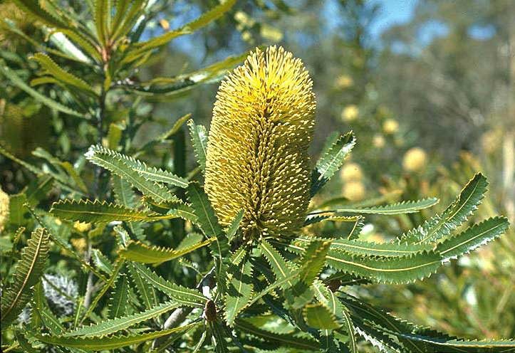

Banksia aemula

C:\Users\lmarcon\AppData\Local\Microsoft\Windows\Temporary Internet Files\Content.IE5\XGYY5H84\MC900140189[1].wmf

Did you know:

Lots of Australian plants like the Banksia have thick coverings surrounding their seeds. This is called a seed coat and it is often only broken after a bushfire.

D

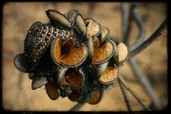

Banksia seed pods