Exploring absorbency: testing paper towels
Written by Deakin Science Ed @Geelong
Introduction
Watch this video on absorbing: https://vimeo.com/user114149768/review/415383009/1ec280d532.
You will need to enter a password: abc123
Answer the following questions:
- What makes a really good piece of paper towel? What features does it have? What would you want it to do?

- How can we give these features a score? How can we give an overall score?

Investigation 1: Paper absorbency
In this activity, we will explore what makes a really good piece of paper towel?

Use the investigation planner below, plan and conduct an investigation to answer the questions.

Plan for your investigation: What are you investigating? How are you going to investigate it?

Can you measure how much water a piece of paper absorbs?

Record, show and explain your results in the investigation planner below.
- How can you represent in your workbooks what’s happening before, during and after the water is added to the paper?

PREDICT
Before you start, rank the types of paper from strongest to weakest. Number 1 is the strongest. Why do you think is? Records you thoughts in the planner. Think also about what has to be the same and what can be different? How can you make sure the test is fair? For example, should you use a piece of paper that is exactly the same size?
EXPERIMENT
- Three or four different types of paper (e.g. paper towel, newspaper, tissue, toilet paper.).
- A jug of water.
- A glass or cup
- A measuring tool, e.g. an eye dropper or a teaspoon
- Towels for mopping up.
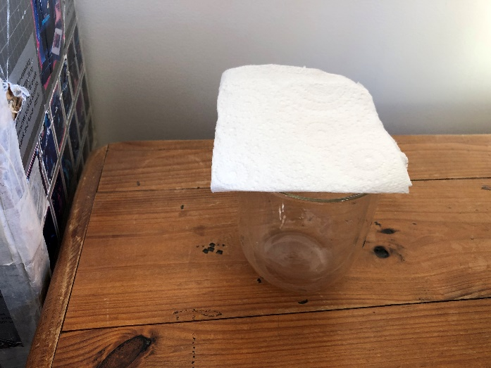
Place your paper on top of a glass or cup. Slowly add water using an eye dropper or a teaspoon to the paper. How much water can you add to the paper before it stops holding the water and the water starts to go through the paper into the glass? Remember, add the water as slowly as you can. Some types of paper may only take one drop, others may take lots of water.

Investigation 2: Paper absorbency
This time introduce a weight like a coin on the glass. How much water can you add before the weight goes through the paper? Does the paper just collapse or does it stay on top? The water must go into the glass or cup.
At the end, decide which paper absorbs the most amount of water? Think about how can we measure this?
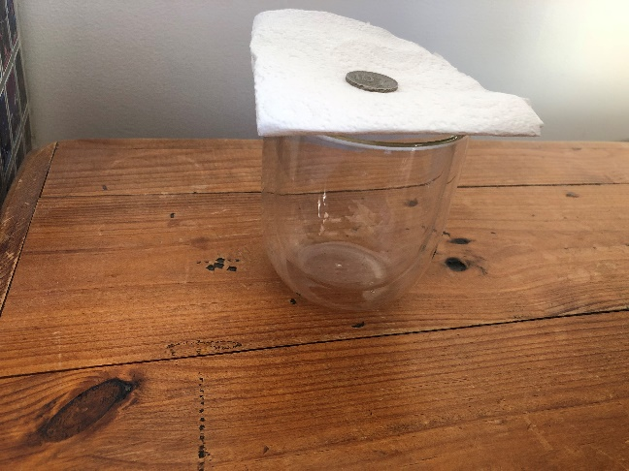
Extra activity: What else could you do? Design your own activity to measure the absorbency of the paper. What could you do differently (different liquids maybe)
Question for my investigation
I will keep the same
I will observe or measure
This is what I predict will happen and reasons for my prediction:

This is how I show and explain the results:

My Investigation Planner

