**SCIENCE**

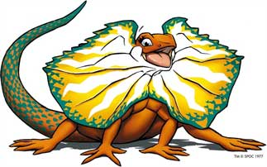

**Who are the desert survivors?**



**What is adaptation?**

**What is a desert?**

**What survives in the desert?**

**How do they survive?**

### These are the questions you will investigate.

It is hard to imagine how any form of life can survive in the extreme temperatures and dryness of the desert. Yet even in such extreme conditions there are many animals and plants.

### Their behaviours and physical features have adapted so that they can survive and thrive under these conditions.

### You have the opportunity to study, explore and conduct experiments to learn about the physical and behavioural features of desert plants and animals.



**You will:**

* Develop basic knowledge about animal and plant desert adaptation.
* Conduct an experiment and record observations on desert survival.
* Demonstrate the understanding on physical and behavioural features.
* Record all observations.

**WHAT YOU WILL NEED**

**Equipment for Experiments**

There are a number of different experiments that you can choose to do. Check the lists at the start of activities to see the materials that you will need .

You should also be able to use materials and equipment that you have at home for a lot of the activities.

**Reference Sources**

Throughout this course you may be asked to **research** a topic, person or idea.

**Safety**

Science experiments are fun but you must **always work safely and with you’re an adult at home. Always read instructions and warnings carefully.**

**Introduction**

**What is Adaptation?**

Before you begin your study on desert survivors we need to understand what is meant by the word **ADAPTION.**

**What is meant by adaptions?**

It means **change** in living thing so they can survive in their environment.

**How does this happen?**

Adaptations evolve by **natural selection** over thousands of year. If conditions in the environment favour a particular characteristic such as waxy leaves to prevent dehydration the plant will be more likely to survive and reproduce so more and more of the characteristic will evolve and adapt to their environment.

Desert animals also have many adaptations to help them survive in the desert climate. Many are nocturnal, meaning active during the cool night rather than the hot daylight hours. The kangaroo rat conserves water by excreting a solid urine rather than liquid.

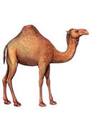

In conclusion it is all about the survival of the fittest as without these adaptations life would not exist.

**Deserts and Adaptations**

**You will complete activities on how animals and plants have adapted to survive in their environments. The activities have been broken down into the following three parts:**

**Part 1 – Deserts**

What you already know

Background information

**Part 2 – Desert plant**

How they adapt (changed) to suit desert conditions

**Part 3 – Experiments**

Two experiments on *Water Loss* and *Water Consumption.*

**Follow the lessons in sequence.**



**Part 1– Deserts**



**What do you know about deserts?**

**Are deserts deadly? Why or why not?**

Write at least 6 words (in the hexagons) that you associate with deserts.

**Background Information on Deserts**

**What is a Desert?**

A desert is defined by its lack of water that is its dryness. Another word for lack of water is *aridity* or *arid.* There is very little or no rainfall making the area extremely difficult for people, animals and plants to survive.

People, animals and plants need to adapt (change) their behaviour (way they live) and physical characteristics (way they look) in order to survive the heat and lack of water.

**Australian Deserts**

Australia has many arid and semi-arid climates. Did you know that 20% of Australia is covered by desert? These areas are generally hot; they reach high temperatures during the day but cool down during the night. The change is due to the absence of water. There are 10 deserts in Australia. Highlighted below on the left are the locations and names of Australia’s deserts and to the right a satellite of their location.

|  |  |
| --- | --- |
| [File:IBRA 6 Deserts legend.png](http://upload.wikimedia.org/wikipedia/commons/a/aa/IBRA_6_Deserts_legend.png) |  |

**Humans Surviving in a Desert**

People have the ability to learn about their world and choose new behaviours. We have the knowledge to dress appropriately and think ahead. Early explorers did not have the extensive knowledge of deserts like the indigenous people of the region and many died from malnutrition and lack of water.

The early explorer John McDouall Sturt who travelled from Adelaide to Darwin in the mid-1800s made the following observations:

*“The heat now became so great that it was almost unbearable, the thermometer every day rose to 42 0C or 47 0C in the shade, whilst in the direct rays of the sun from 60 0to 66 0C, however, the night was bitterly cold that we were glad to put on anything to keep us warm.*

*The stillness of death reigned around us, no living creature was heard…….the surface was marked all over with the tracks of native dogs……….no grass…..”*

He survived but many died during the trip due to lack of food and water.

|  |  |
| --- | --- |
| http://upload.wikimedia.org/wikipedia/de/4/4b/Routes_of_John_McDouall_Stuart2.jpg  *Sturt’s journey in 1859.* | The harshness of the desert makes it difficult for people to survive but today explorers, locals and visitors are well aware of the plants, animals and conditions to survive the desert.  In addition dark skin is identified as a human adaptation to environments with high-UV. This includes the Australian desert. This protects people from burning and skin cancers. |

**Plants Surviving in a Desert**

Plants like people and animals can circulate water in their system to avoid dehydration. All plants have stomata (small opening) in their leaves where water can evaporate. Desert plants close this opening during the day to avoid dehydration and open it at night to cool down. This helps to prevent water loss.

Having smaller and fewer leaves decrease the number of stomata therefore the amount of water lost. Other adaptations include:

|  |  |
| --- | --- |
| * Leaves with waxy surfaces to help stop water from escaping. * Light-coloured hairs to reflect the sun’s heat. * Dropping leaves during the dry season. * Storing water inside the leaves. | http://www.rgsq.org.au/rgsqsite/spinifex.jpg  *Spinifex – common Australian desert plant.* |

**Animals Surviving in a Desert**

Animals have changed over the thousands of years to adapt to desert conditions. Their physical look which includes changes in colour—to reflect the heat, formation of hair to lower loss of water, long eyelashes to protect eyes from the sand and changes to blood temperature. Also desert animals are smaller and have less skin for sweating and loss of water. Some have hard-shelled skin to also reduce sweating.

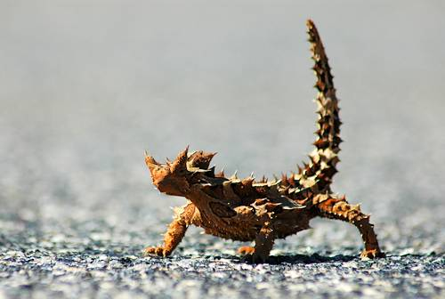

*Thorny Devil.*



**Think about the following questions:**

* What do we think we know about…..?
* How do you think it survives the conditions?
* What challenges would plants face in the desert?
* What challenges would animals face in the desert?
* What features might help them survive?
* What behaviours might help them survive?

The next activities will focus on exploring evaporation (loss of water) of plants through experimentation.

[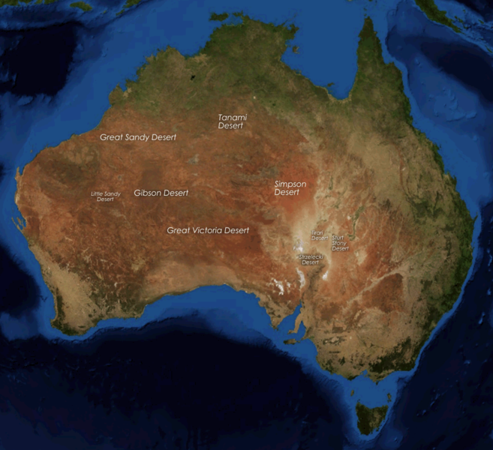](http://upload.wikimedia.org/wikipedia/commons/e/e6/Australia_deserts.PNG)

*Satellite photo of Australia and its deserts.*

**Part 2 – Plant Adaptations**

Plants need to have adaptations that allow them to survive without water for an unpredictable time. Different plants have different adaptations. Below are three common adaptations.

**1. Drought Resisters: Adaptations to *Store* a Lot of Water**  
It’s not only about getting the water, it’s also about storing the water. Plants that conserve water in their leaves, fruit, stems or roots are called succulents. Because water escapes through [leaf surfaces](http://www.gondwananet.com/australian-desert-plants.html), a common adaption is to reduce that surface. Many desert plants have small spiny leaves, often long and slender. Some have glossy leaves to reflect the sun’s heat, others have waxy leaves to prevent the water from escaping.

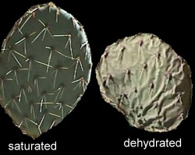 [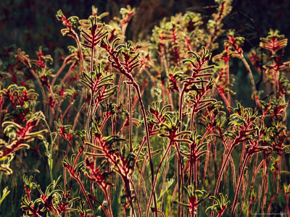](http://affiliates.allposters.com/link/redirect.asp?item=4204428&AID=432506826&PSTID=1&LTID=2&lang=1)

Cactus *Kangaroo Paw can flower for weeks when it’s raining,*

*then it just closes up and waits for more rain.*

Some plants have powdery surfaces, or surfaces covered in small hair. The Desert Pea has foliage and the stem is covered with hair to conserve water.

[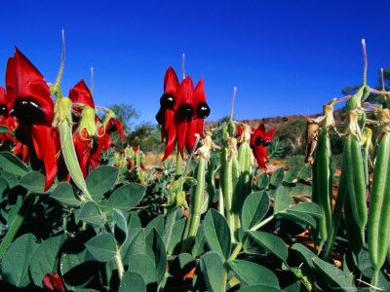](http://affiliates.allposters.com/link/redirect.asp?item=4071022&AID=432506826&PSTID=1&LTID=2&lang=1)

Smaller leaves and waxy covering on leaves prevents the loss of water.

**2.Drought Resisters: Adaptations to *Consume* a Lot of Water**  
Many Australian desert plants such as trees and scrubs have either a very [deep root system](http://www.gondwananet.com/australian-desert-plants.html) that reaches to the groundwater, or a very spread out [root system](http://www.gondwananet.com/australian-desert-plants.html) which extend far beyond the tree canopy and lie just below the surface. These extensive root systems can capture a lot of water once the rains come along.

**3. Colour in Plants**  
This can be done by staying out of the sun, by shading (e.g., spines/fur), by posture and orientation (e.g., orienting leaves vertically to minimise surface area directly hit by sun), by insulation and by shiny surfaces that reflect the sun such as the silvery white bark of the ghost gum.

[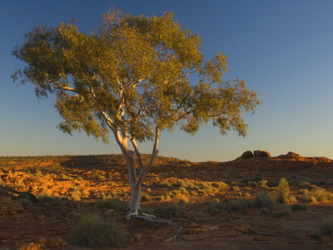](http://affiliates.allposters.com/link/redirect.asp?item=6064698&AID=432506826&PSTID=1&LTID=2&lang=1)

**Let’s Experiment**

Experimenting is a very important part of Science.

Scientists discover how life functions and knowledge is power!

**You will be conducting two experiments which focus on:**

**1. Water Loss—**in this experiment you will test for water loss in leaves and explore what happenswhen placed in various conditions.

**2. Water Consumption**—experiment how much water is consumed by small and large leaves.

You will also complete a *Scientific Report* to report your findings.

*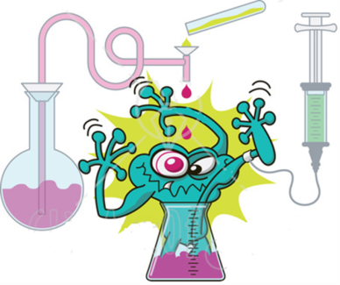*

|  |
| --- |
| **Experiment 1–**MCj02921160000[1]**Water Loss**  In this experiment you will be testing water loss in plants in various conditions and compare the differences. Your experiment will include the following:  **Title:**  Water Loss in Plants.  **Aim:**  The aim of the experiment is to see which condition creates less water loss.  http://cdn.freecoloringsheets.net/samples/Study/Thinking_Boy.png**Hypothesis:**  Now that you’ve had a think about the materials and have acquired knowledge through your background reading I would like you to predict what might happen.  Write your hypothesis in your *Scientific Report* provided.  Remember this is a prediction; the experiment will prove you right or wrong. It is in the analysis where you will explain your results and outcomes.  **What you need:**   * Several large leaves (make sure they are green). * Several small leaves (make sure they are green). * Vaseline or a cream to coat barrier. * Several snap-locked plastic bags. * 2 paper bags.   **Method:**   * Divide your leaves into two groups—large and small­. * Place several (must be the same in each) small in one plastic bag and several large in another. * Smear Vaseline on small and large leaves.   **Experiment continued**   * Place small leaves in a paper bag. * Place large leaves in a paper bag. * Keep one bag empty.   You should now have 7 bags of leaves. If necessary label each bag or colour-code them, e.g. red – large leaves with Vaseline, etc.      *bag with leaves empty bag*  http://www.kooziez.com/wp-content/uploads/2011/06/Black-Sun.jpgPlace all leaves outside in a sunny position for 24 hours. Observations and recordings will take place over a 24-hour period.  **Collecting results:**  In a science lab results would be collected and measured using specialised equipment. As you are not in a laboratory you will observe the results using your senses—EYES and TOUCH!  last poem  **Experiment continued**  You will record results after 3 hours, followed by another 3 hours during the day. You will leave the leaves overnight and record results early in the morning.  What changes (if any) did you observe?  **Recording results:**  You will record in dot point what you see and touch.  For example:   * *Bead of water formed on the plastic ………..wet to touch……..*   Results should be recorded in the table provided in the *Scientific Report.*  **Writing your report:**  Before you start writing your *Scientific Report* consider the following questions:   * *Which condition produced the most moisture (water loss?) Why?* * *http://1.bp.blogspot.com/-eLsNtemxLW4/T0PgV-Xz7ZI/AAAAAAAABrQ/zwYpJyz7U-Y/s1600/questions.gifWhich the least? Why?* * *Does shade prevent water loss?* * *Does a barrier prevent water loss?* * *How is this related to the desert?* |

bd20016_**Scientific Report**

**Water Loss**

**Name**

**Title of Experiment**

\_\_\_\_\_\_\_\_\_\_\_\_\_\_\_\_\_\_\_\_\_\_\_\_\_\_\_\_\_\_\_\_\_\_\_\_\_\_\_\_\_\_\_\_\_\_\_\_\_\_\_\_\_\_\_\_\_\_\_\_\_

\_\_\_\_\_\_\_\_\_\_\_\_\_\_\_\_\_\_\_\_\_\_\_\_\_\_\_\_\_\_\_\_\_\_\_\_\_\_\_\_\_\_\_\_\_\_\_\_\_\_\_\_\_\_\_\_\_\_\_\_\_

**Introduction/Aim**

|  |
| --- |
| The purpose of the experiment is |

**Hypothesis**

|  |
| --- |
| It is hypothesised that |

**Materials and Equipment**

|  |
| --- |
| Materials used were:  — |

**Method/Procedure**

|  |
| --- |
| The procedure which I followed is listed below: |

**Results/Data Recording LARGE LEAVES**

|  |  |  |  |
| --- | --- | --- | --- |
|  | **After 3 hours** | **6 hours** | **Morning** |
| **Plastic bag** |  |  |  |
| **Vaseline** |  |  |  |
| **Paper bag** |  |  |  |

**Results/ Data Recording SMALL LEAVES**

|  |  |  |  |
| --- | --- | --- | --- |
|  | **After 3 hours** | **6 hours** | **Morning** |
| **Plastic bag** |  |  |  |
| **Vaseline** |  |  |  |
| **Paper bag** |  |  |  |

**Discussion and Analysis of Results**

|  |
| --- |
| *Circle the correct word below and give reasons why and explain your results.*  My hypothesis was correct/incorrect because ... |

|  |
| --- |
| MCj02921160000[1]**Experiment 2 – Water Consumption**  In this experiment you will be testing the amount of water consumed (taken in) by leaves.  **Title:**  Water Consumption in Leaves.  **Aim:**  The aim of the experiment is to see which leaves (large or small) consume the most amount of water.  **Hypothesis:**  Now that you’ve had a think about the materials and have acquired knowledge through your background reading I would like you to predict what might happen.  http://cdn.freecoloringsheets.net/samples/Study/Thinking_Boy.png  Write your hypothesis in your *Scientific Report* provided.  Remember this is a prediction; the experiment will prove you right or wrong. It is in the analysis where you will explain your results and outcomes.  **What you need:**   * One large leaf and one small leaf. * Two containers with lids. * One litre of water   http://scene.asu.edu/habitat/activities/activity_things/OvalLeafShapes_small.gif  **Method:**   * Place each leaf stem in a separate container with 500 ml of water. * Cover each container with plastic wrap to reduce surface evaporation. Do not cover the leaves, just the top of the container itself. * Place all containers in the same location in the habitat. * After 2 hours, come back and see which leaf shape has used the most water by measuring the water gone (evaporated) from the container.   **Experiment continued**  **Record results**:  Calculate how much water was lost for each individual leaf by subtracting the amount of water left in the container from the beginning amount. Measurements can be taken at different time points or just once.  **Graphing results:** Make a [bar graph](http://scene.asu.edu/habitat/data_present.html#b_graph) with leaf shape listed on the horizontal axis and amount of water lost on the vertical axis. Graph the changes (data) you recorded. If the water loss is tracked over time, make a line graph with time on the x-axis and average water loss in ml on the y-axis.  *You can complete the graph on the page provided.*  http://www.kooziez.com/wp-content/uploads/2011/06/Black-Sun.jpgPlace all leaves outside in a sunny position and leave.  **Scientific Report:**  Complete your findings in your *Scientific Report* provided. |

bd20016_**Scientific Report**

**Water Consumption**

**Name/Year Level/Date**

|  |  |
| --- | --- |
| Name: |  |
| Year Level: |  |
| Date: |  |

**Title of Experiment**

\_\_\_\_\_\_\_\_\_\_\_\_\_\_\_\_\_\_\_\_\_\_\_\_\_\_\_\_\_\_\_\_\_\_\_\_\_\_\_\_\_\_\_\_\_\_\_\_\_\_\_\_\_\_\_\_\_\_\_\_\_

\_\_\_\_\_\_\_\_\_\_\_\_\_\_\_\_\_\_\_\_\_\_\_\_\_\_\_\_\_\_\_\_\_\_\_\_\_\_\_\_\_\_\_\_\_\_\_\_\_\_\_\_\_\_\_\_\_\_\_\_\_

**Introduction/ Aim**

|  |
| --- |
| The purpose of the experiment is |

**Hypothesis**

|  |
| --- |
| It is hypothesised that |

**Materials and Equipment**

|  |
| --- |
| Materials used were:  — |

**Method/Procedure**

|  |
| --- |
| The procedure which I followed is listed below: |

**Water Consumption Results**

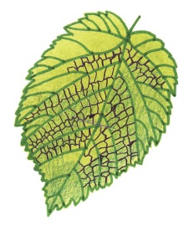

**Discussion and Analysis of Results**

|  |
| --- |
| *Circle the correct word below and give reasons why and explain your results.*  My hypothesis was correct/incorrect because ... |

**Plant Comparisions**

Now that you have completed your experiment and anlaysed results let’s see if you can compare the leaves of this acacia (desert plant and this oak tree (forest plant).

How are the leaves and other features of these two plants different?

Why might that be?

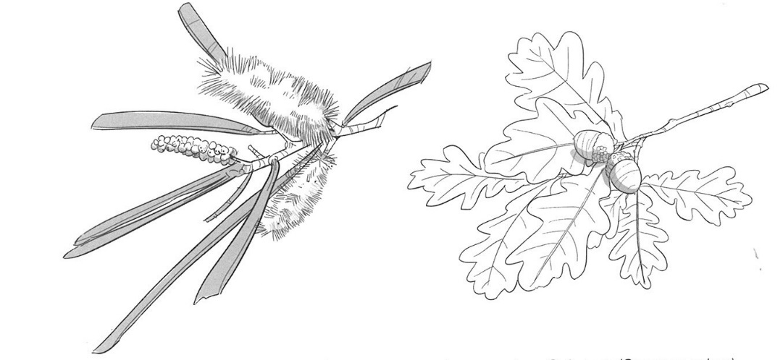

Leaves of the Mulga tree Leaves of an Oak tree

*Desert of Australia Forests of Europe*

\_\_\_\_\_\_\_\_\_\_\_\_\_\_\_\_\_\_\_\_\_\_\_\_\_\_\_\_\_\_\_\_\_\_\_\_\_\_\_\_\_\_\_\_\_\_\_\_\_\_\_\_\_\_\_\_\_\_\_\_\_

\_\_\_\_\_\_\_\_\_\_\_\_\_\_\_\_\_\_\_\_\_\_\_\_\_\_\_\_\_\_\_\_\_\_\_\_\_\_\_\_\_\_\_\_\_\_\_\_\_\_\_\_\_\_\_\_\_\_\_\_\_

\_\_\_\_\_\_\_\_\_\_\_\_\_\_\_\_\_\_\_\_\_\_\_\_\_\_\_\_\_\_\_\_\_\_\_\_\_\_\_\_\_\_\_\_\_\_\_\_\_\_\_\_\_\_\_\_\_\_\_\_\_

\_\_\_\_\_\_\_\_\_\_\_\_\_\_\_\_\_\_\_\_\_\_\_\_\_\_\_\_\_\_\_\_\_\_\_\_\_\_\_\_\_\_\_\_\_\_\_\_\_\_\_\_\_\_\_\_\_\_\_\_\_

\_\_\_\_\_\_\_\_\_\_\_\_\_\_\_\_\_\_\_\_\_\_\_\_\_\_\_\_\_\_\_\_\_\_\_\_\_\_\_\_\_\_\_\_\_\_\_\_\_\_\_\_\_\_\_\_\_\_\_\_\_

\_\_\_\_\_\_\_\_\_\_\_\_\_\_\_\_\_\_\_\_\_\_\_\_\_\_\_\_\_\_\_\_\_\_\_\_\_\_\_\_\_\_\_\_\_\_\_\_\_\_\_\_\_\_\_\_\_\_\_\_\_

\_\_\_\_\_\_\_\_\_\_\_\_\_\_\_\_\_\_\_\_\_\_\_\_\_\_\_\_\_\_\_\_\_\_\_\_\_\_\_\_\_\_\_\_\_\_\_\_\_\_\_\_\_\_\_\_\_\_\_\_\_

\_\_\_\_\_\_\_\_\_\_\_\_\_\_\_\_\_\_\_\_\_\_\_\_\_\_\_\_\_\_\_\_\_\_\_\_\_\_\_\_\_\_\_\_\_\_\_\_\_\_\_\_\_\_\_\_\_\_\_\_\_

**Animal Adaptations**

**You will complete activities which are broken into 3 parts. They are:**

**Part 1— Introduction**

- Website and/or poster

- Background information

- Animal comparisons

**Part 2— Experiments**

Two experiments (choose one or both) on *Do Lighter Colours Keep You Cool.*

**Part 3— Research**

You will research and present a brief project highlighting the adaptations of an animal and plant of your choice.

**Let’s begin our journey into the desert …………**



**Introduction**

Let’s begin by looking closely at some Australian animals and how they have adapted to living in the harsh desert.

Go to:

<https://alicespringsdesertpark.com.au/connect-with-nature/animals> to learn about the plants and animals of Central Australia.

If you cannot access the internet, look closely at the picture on the following page and list below some of the characteristics and behaviours that help these animals survive in the desert.

|  |
| --- |
|  |

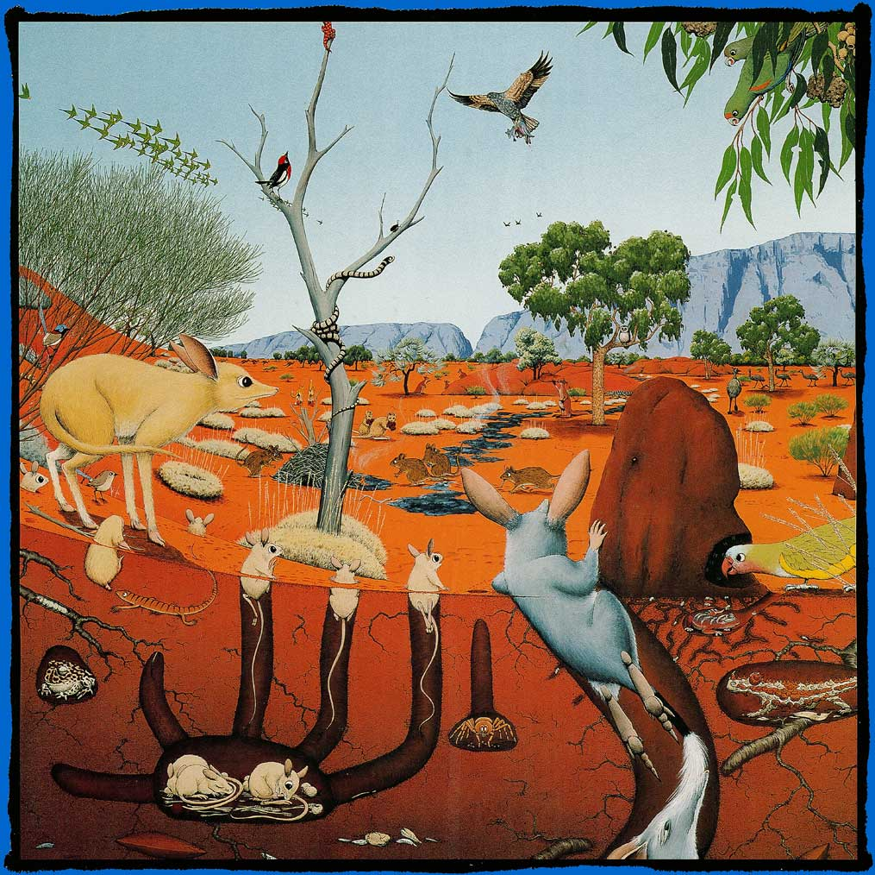

**Background Information**

In order to survive, desert animals have developed a number of ways of adapting to their habitat. The most common adaptation in behaviour is staying in the **shade** of plants or rocks or by **burrowing underground** in the heat of the day. Many desert animals are **nocturnal**: they stay inactive in shelter during the day and hunt at night when it is cool.

Some animals get all the **moisture from food,** they need from the insects, plants and seeds they eat, and do not need to drink water. Most **pass little moisture** out of their bodies. They **do not have sweat glands** and pass only small amounts of concentrated urine.

Fat increases body heat, so some desert animals have **concentrated the body's fat** in one place, such as a hump or tail, rather than having it all through the body. Many desert animals have light-coloured skin, hair and fur. Also **lighter colour reflects** the sun keeping them cool.

Some animals develop unique ways of surviving. The [Thorny Devil](http://www.kidcyber.com.au/topics/thornydev.htm), a lizard that lives in Australian desert areas, has a body that channels raindrops directly into 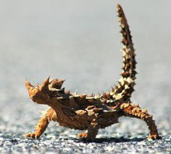its mouth when rain falls.

The [Water-Holding Frog](http://www.frogsaustralia.net.au/frogs/display.cfm?frog_id=127) spends most of the year under the ground in Australian desert areas, and develops a sort of cocoon that enables them to store water to keep them going through the dry times. When it rains, they emerge to lay their eggs in puddles. The eggs hatch within days and the tadpoles develop quickly, before the water dries out.

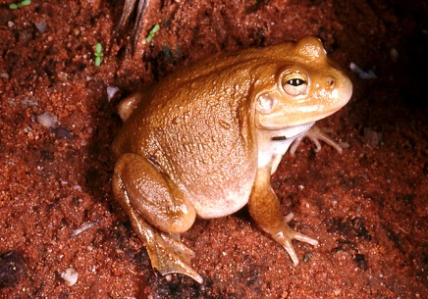

**Animal Adaptions Introduction continued**

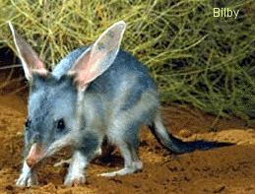The Bilby’s behaviour is staying in the shade of plants or rocks or by burrowing underground in the heat of the day. The Bilby also has large ears where heat is expelled allowing it to cool down.

The camel is not native to Australia but was introduced in the 1800s. [Camels](http://www.kidcyber.com.au/topics/camel.htm) are one of the few large mammals to survive in the desert, and have many special adaptations to help them such as long eye lashes to protect them from the blowing sand. Most importantly they have a hump on their back which is full of fat, which serves as a food store.

Find out more about the camel on the following page.

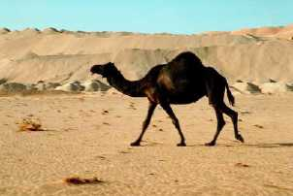

**Camel Adaptations**

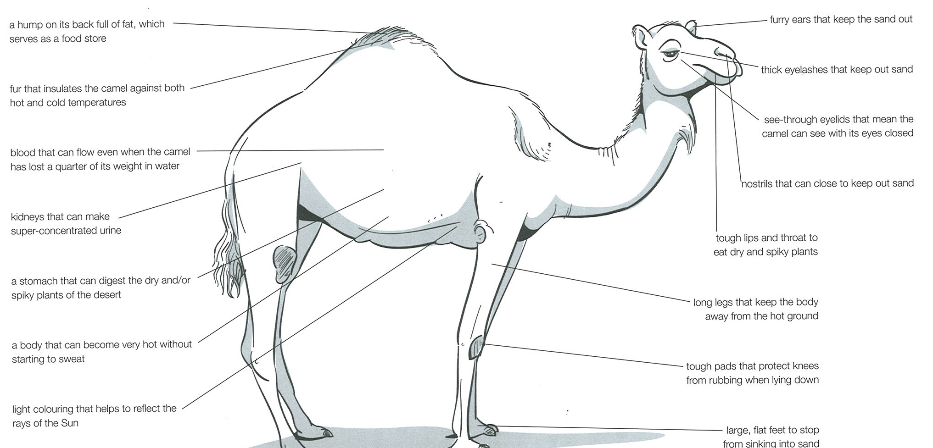

**Animal Comparisons**

Now that you have read about a few animal adaptations, look at the two animals below. The Bilby is found in the Australian desert and the fox in Europe.

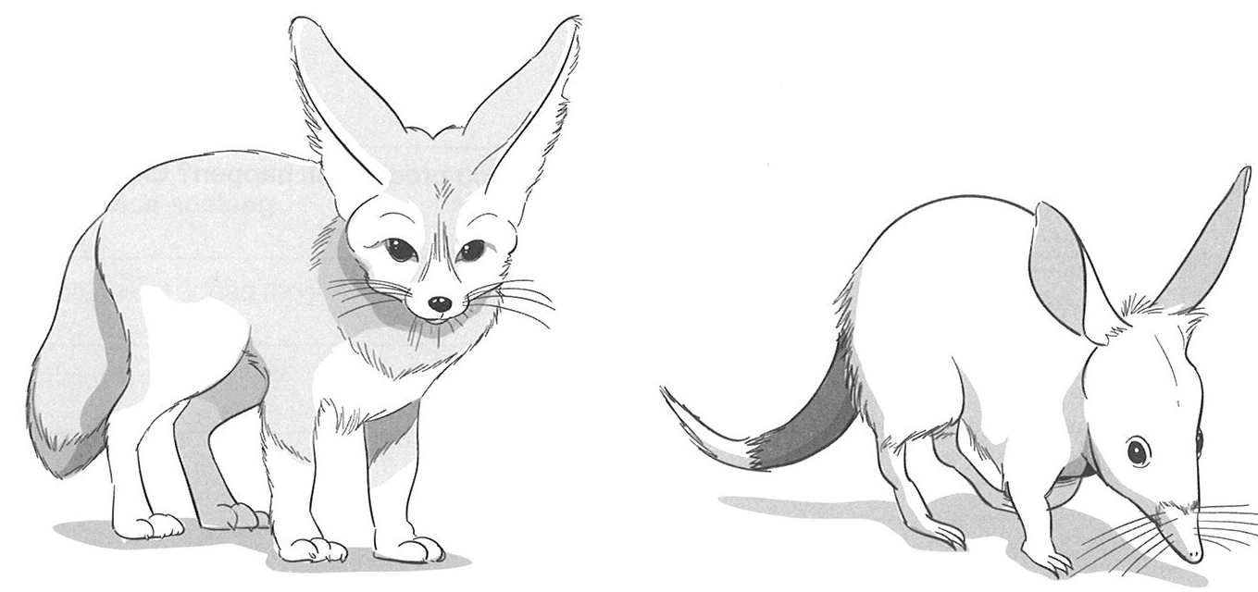

How are they different?

\_\_\_\_\_\_\_\_\_\_\_\_\_\_\_\_\_\_\_\_\_\_\_\_\_\_\_\_\_\_\_\_\_\_\_\_\_\_\_\_\_\_\_\_\_\_\_\_\_\_\_\_\_\_\_\_\_\_\_\_\_

\_\_\_\_\_\_\_\_\_\_\_\_\_\_\_\_\_\_\_\_\_\_\_\_\_\_\_\_\_\_\_\_\_\_\_\_\_\_\_\_\_\_\_\_\_\_\_\_\_\_\_\_\_\_\_\_\_\_\_\_\_

\_\_\_\_\_\_\_\_\_\_\_\_\_\_\_\_\_\_\_\_\_\_\_\_\_\_\_\_\_\_\_\_\_\_\_\_\_\_\_\_\_\_\_\_\_\_\_\_\_\_\_\_\_\_\_\_\_\_\_\_\_

\_\_\_\_\_\_\_\_\_\_\_\_\_\_\_\_\_\_\_\_\_\_\_\_\_\_\_\_\_\_\_\_\_\_\_\_\_\_\_\_\_\_\_\_\_\_\_\_\_\_\_\_\_\_\_\_\_\_\_\_\_

What features do they have that allows them to survive in their environment?

\_\_\_\_\_\_\_\_\_\_\_\_\_\_\_\_\_\_\_\_\_\_\_\_\_\_\_\_\_\_\_\_\_\_\_\_\_\_\_\_\_\_\_\_\_\_\_\_\_\_\_\_\_\_\_\_\_\_\_\_\_

\_\_\_\_\_\_\_\_\_\_\_\_\_\_\_\_\_\_\_\_\_\_\_\_\_\_\_\_\_\_\_\_\_\_\_\_\_\_\_\_\_\_\_\_\_\_\_\_\_\_\_\_\_\_\_\_\_\_\_\_\_

\_\_\_\_\_\_\_\_\_\_\_\_\_\_\_\_\_\_\_\_\_\_\_\_\_\_\_\_\_\_\_\_\_\_\_\_\_\_\_\_\_\_\_\_\_\_\_\_\_\_\_\_\_\_\_\_\_\_\_\_\_

\_\_\_\_\_\_\_\_\_\_\_\_\_\_\_\_\_\_\_\_\_\_\_\_\_\_\_\_\_\_\_\_\_\_\_\_\_\_\_\_\_\_\_\_\_\_\_\_\_\_\_\_\_\_\_\_\_\_\_\_\_

**Animal Comparisions continued**

Could each live in the other’s environment? Why or Why not?

\_\_\_\_\_\_\_\_\_\_\_\_\_\_\_\_\_\_\_\_\_\_\_\_\_\_\_\_\_\_\_\_\_\_\_\_\_\_\_\_\_\_\_\_\_\_\_\_\_\_\_\_\_\_\_\_\_\_\_\_\_

\_\_\_\_\_\_\_\_\_\_\_\_\_\_\_\_\_\_\_\_\_\_\_\_\_\_\_\_\_\_\_\_\_\_\_\_\_\_\_\_\_\_\_\_\_\_\_\_\_\_\_\_\_\_\_\_\_\_\_\_\_

\_\_\_\_\_\_\_\_\_\_\_\_\_\_\_\_\_\_\_\_\_\_\_\_\_\_\_\_\_\_\_\_\_\_\_\_\_\_\_\_\_\_\_\_\_\_\_\_\_\_\_\_\_\_\_\_\_\_\_\_\_

\_\_\_\_\_\_\_\_\_\_\_\_\_\_\_\_\_\_\_\_\_\_\_\_\_\_\_\_\_\_\_\_\_\_\_\_\_\_\_\_\_\_\_\_\_\_\_\_\_\_\_\_\_\_\_\_\_\_\_\_\_

\_\_\_\_\_\_\_\_\_\_\_\_\_\_\_\_\_\_\_\_\_\_\_\_\_\_\_\_\_\_\_\_\_\_\_\_\_\_\_\_\_\_\_\_\_\_\_\_\_\_\_\_\_\_\_\_\_\_\_\_\_

\_\_\_\_\_\_\_\_\_\_\_\_\_\_\_\_\_\_\_\_\_\_\_\_\_\_\_\_\_\_\_\_\_\_\_\_\_\_\_\_\_\_\_\_\_\_\_\_\_\_\_\_\_\_\_\_\_\_\_\_\_

\_\_\_\_\_\_\_\_\_\_\_\_\_\_\_\_\_\_\_\_\_\_\_\_\_\_\_\_\_\_\_\_\_\_\_\_\_\_\_\_\_\_\_\_\_\_\_\_\_\_\_\_\_\_\_\_\_\_\_\_\_

\_\_\_\_\_\_\_\_\_\_\_\_\_\_\_\_\_\_\_\_\_\_\_\_\_\_\_\_\_\_\_\_\_\_\_\_\_\_\_\_\_\_\_\_\_\_\_\_\_\_\_\_\_\_\_\_\_\_\_\_\_

**Part 2 Let’s Experiment**

***Do Lighter Colours Keep You Cool?***

One of the physical adaptions is lighter hair and fur colour on animals. Lighter colours reflect (keep away or bounce back) heat from the sun. You will be conducting an experiment to investigate this further.

Choose one of the two experiments, depending on the materials you have available. If you like you can complete both.

You will also complete a *Scientific Report* to report your findings.

**

http://t2.gstatic.com/images?q=tbn:ANd9GcTMmJGPC2wZMHPAiClSZsT5Iijp-WxjdHAmOAsvNYygz_FVtpQmXR9Bj9S3TQ***Option 1*** *–* Using a **thermometer** to test whether lighter colours

keep you cool.

|  |
| --- |
| MCj02921160000[1] **Do Lighter Colours Keep You Cool?**  **Title:**  Do Lighter Colours Reflect the Sun and Keep You Cool?  **Aim:**  The aim of the experiment is to see whether lighter colours keep you cool.  http://cdn.freecoloringsheets.net/samples/Study/Thinking_Boy.png  **Hypothesis:**  Now that you’ve had a think about the materials and have acquired knowledge through your background reading I would like you to predict what might happen.  Write your hypothesis in your *Scientific Report* provided.  **What you need:**   * thermometer * two containers with lids (must be identical) * large sheet of black paper * large sheet of white paper * sticky tape or elastic band * water.   **Method:**   * Fill each container to the top with water and close lid. * Completely wrap around the container with the black paper and tape down. * Completely wrap around the other container with white paper and   tape down.  **Experiment continued**   * Place each container outside in the sun. * Depending on the outside temperature you can leave the containers out for 1–4 hours.     **Collecting and recording results:**   * Carefully remove the lid and place thermometer in the water to record temperature. Do this with both containers. Write down results.   http://t2.gstatic.com/images?q=tbn:ANd9GcTMmJGPC2wZMHPAiClSZsT5Iijp-WxjdHAmOAsvNYygz_FVtpQmXR9Bj9S3TQhttp://t2.gstatic.com/images?q=tbn:ANd9GcTMmJGPC2wZMHPAiClSZsT5Iijp-WxjdHAmOAsvNYygz_FVtpQmXR9Bj9S3TQ   * **Optional**: You can do this once or several times over a given period of time such as every hour for 4 hours.   Results should be recorded in the table provided in the *Scientific Report.*  Make sure they are clearly set out and complete a graph if you have taken multiple readings.  **Writing your Scientific Report**  When writing your report consider the following:   * *If lighter colours keep you cool – how does this happen?* * *What was interesting about your experiment? Why?* * *What went well with your investigation?* * *What didn’t go well? How might you change it to improve it?* |

bd20016_**Scientific Report**

**Do Lighter Colours Keep You Cool?**

**Name**

|  |  |
| --- | --- |
| Name: |  |
| Year Level: |  |
| Date: |  |

**Title of Experiment**

\_\_\_\_\_\_\_\_\_\_\_\_\_\_\_\_\_\_\_\_\_\_\_\_\_\_\_\_\_\_\_\_\_\_\_\_\_\_\_\_\_\_\_\_\_\_\_\_\_\_\_\_\_\_\_\_\_\_\_\_\_

\_\_\_\_\_\_\_\_\_\_\_\_\_\_\_\_\_\_\_\_\_\_\_\_\_\_\_\_\_\_\_\_\_\_\_\_\_\_\_\_\_\_\_\_\_\_\_\_\_\_\_\_\_\_\_\_\_\_\_\_\_

**Introduction/ Aim**

|  |
| --- |
| The purpose of the experiment is |

**Hypothesis**

|  |
| --- |
| It is hypothesised that |

**Materials and Equipment**

|  |
| --- |
| Materials used were:  — |

**Method/Procedure**

|  |
| --- |
| The procedure which I followed is listed below: |

**Results – data**

|  |  |  |  |  |
| --- | --- | --- | --- | --- |
| **Container** | **\_\_\_\_\_\_ hours** | **\_\_\_\_\_\_ hours** | **\_\_\_\_\_\_ hours** | **\_\_\_\_\_\_ hours** |
|  | Temperature    **\_\_\_\_\_\_\_\_ 0**C | Temperature  **\_\_\_\_\_\_\_\_ 0**C | Temperature  **\_\_\_\_\_\_\_\_ 0**C | Temperature  **\_\_\_\_\_\_\_\_ 0**C |
|  | Temperature  **\_\_\_\_\_\_\_\_ 0**C | Temperature  **\_\_\_\_\_\_\_\_ 0**C | Temperature  **\_\_\_\_\_\_\_\_ 0**C | Temperature  **\_\_\_\_\_\_\_\_ 0**C |

**Temperature of Water**

**Temperature**

**Discussion and Analysis of Results**

|  |
| --- |
| *Circle the correct word below and give reasons why and explain your results.*  My hypothesis was correct/incorrect because ... |

***Option 2*** *—*Using **cloth** to test whether lighter colours keep you cool.

|  |  |  |  |  |  |  |  |  |  |  |  |  |
| --- | --- | --- | --- | --- | --- | --- | --- | --- | --- | --- | --- | --- |
| MCj02921160000[1] **Do Lighter Colours Keep You Cool?**  In this experiment you will be investigating whether light or dark colours absorb more heat by making observations with wet towels.    **Title:**  Do Lighter Colours Reflect the Sun and Keep You Cool?  **Aim:**  The aim of the experiment is to see whether lighter colours keep you cool.  **Hypothesis:**  http://cdn.freecoloringsheets.net/samples/Study/Thinking_Boy.pngNow that you’ve had a think about the materials and have acquired knowledge through your background reading I would like you to predict what might happen.  Write your hypothesis in your *Scientific Report* provided.  **What you need:**   * Cloth such as a tea towel or hand towel (**must be identical material and**   **size**). One should be a light colour another black or very dark.   * http://www.highsnobiety.com/news/wp-content/uploads/2009/05/gallery-1950-original-fake-hand-towel.jpgOne cup of water.   http://stealthdirect.com.au/images/products/110803015711_White-Hand-Towels.jpg  **Method:**   * Pour the one cup of water on one of the towels making sure it is all absorbed. * Do the same for the other. Make sure it is the same amount of water. * Place the towel carefully outside in the sun. * Depending on the outside temperature check your towel after 15–30 minutes or 1-hour intervals. Record results in the *Scientific Report.*   **Recording Results**  **How to check absorption**  There are several methods you can use depending on the equipment you have at home. I suggest you choose one of the following:   * last poemTOUCH, SIGHT and WEIGHT—observe and touch the towels. Which looks and feels damp? Which has dried the quickest? Check the weight by using either scales or informal weighing by balancing with your hands. It’s not the most efficient method but one that may provide you with an indication of the absorbency rate. * ABSORBANT PAPER—wrap each towel with an absorbent paper, pat down and leave for 30 seconds. Unwrap and compare the dampness of each.   http://thumb1.shutterstock.com/thumb_small/169/169,1271562048,14/stock-vector-hand-paper-towels-roll-51163870.jpg  **Record your results**  This will vary depending on the method of recording. If you are weighing the towel you should weight it once you have poured the water and then after each interval. Remember to add the time and weight. For example:   |  |  |  | | --- | --- | --- | |  | **Light coloured towel** | **Dark coloured towel** | | Initial weight | 500 grams | 500 grams | | 10 minutes in the sun | 250 grams | 400 grams | | 15 minutes in the sun | 200 grams | 380 grams |   If you are checking informally by sight and touch I suggest you jot down in point form your observations.  **Graphing—**if you have weighed your results and collected data you can create a line or bar graph to show your results. Refer to the graph page in the Scientific Report. |

bd20016_**Scientific Report**

**Do Lighter Colours Keep You Cool?**

**Name/ Year Level/Date**

|  |  |
| --- | --- |
| Name: |  |
| Year Level: |  |
| Date: |  |

**Title of Experiment**

\_\_\_\_\_\_\_\_\_\_\_\_\_\_\_\_\_\_\_\_\_\_\_\_\_\_\_\_\_\_\_\_\_\_\_\_\_\_\_\_\_\_\_\_\_\_\_\_\_\_\_\_\_\_\_\_\_\_\_\_\_

\_\_\_\_\_\_\_\_\_\_\_\_\_\_\_\_\_\_\_\_\_\_\_\_\_\_\_\_\_\_\_\_\_\_\_\_\_\_\_\_\_\_\_\_\_\_\_\_\_\_\_\_\_\_\_\_\_\_\_\_\_

**Introduction/ Aim**

|  |
| --- |
| The purpose of the experiment is |

**Hypothesis**

|  |
| --- |
| It is hypothesised that |

**Materials and Equipment**

|  |
| --- |
| Materials used were:  — |

**Method/Procedure**

|  |
| --- |
| The procedure which I followed is listed below: |

**Results – data**

|  |  |  |
| --- | --- | --- |
|  | http://stealthdirect.com.au/images/products/110803015711_White-Hand-Towels.jpg**Light coloured towel** | http://www.highsnobiety.com/news/wp-content/uploads/2009/05/gallery-1950-original-fake-hand-towel.jpg**Dark coloured towel** |
| Initial weight |  |  |
| \_\_\_ minutes in the sun |  |  |
| \_\_\_ minutes in the sun |  |  |
| \_\_\_ minutes in the sun |  |  |
| \_\_\_ minutes in the sun |  |  |

**Temperature of Water**

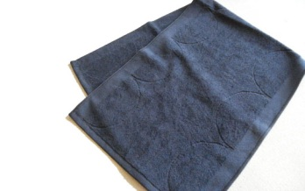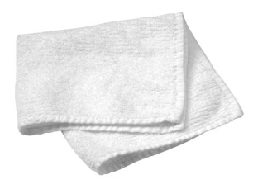

**Temperature**

**Discussion and Analysis of Results**

|  |
| --- |
| *Circle the correct word below and give reasons why and explain your results.*  My hypothesis was correct/incorrect because ... |

MCj04247880000[1]**Part 3 Let’s Research!**

**For You to Do**

**Investigate a desert animal or plant of your choice.**

In the last three weeks you have read about, discussed and experimented on how animals and plants adapt to the Australian desert.

In the last three weeks you have investigated animal adaptations. It is now time for you to tell me about an Australian desert animal and plant and how they have used science to improve our way of life.

To complete you will follow a procedure called the Design Process. The Design Process is a series of steps that include:

## You will be guided through the steps in the process so it will not be complicated. Turnover and begin your research project. Good luck!

**Where Do I Start?**

Carefully read all the information in following pages to familiarise yourself with the process. If you have any questions, please contact your teacher. Good luck!

**Design Brief**

**You are required to write and illustrate information on one Australian desert animal and plant (of your choice) and outline its adaptations.**

**Question**

You will need to think about the following:

**Which will I choose?**

* *Which animal will I choose? How? Where?*
* *Which plant will I choose? How? Where*
* Do I choose a mammal, reptile, shrub, flowering plant………?

**What are their adaptations?**

Describe their adaptations that enable them to survive in the desert.

**What are their structural features?**

Identify the structural features and explain how these features assist survival in the desert.

**How do I communicate the ideas?**

Communicate the ideas using text and labelled diagrams.

**Plan**

This step requires you to *plan* your investigation, *take notes* in point form and focus on the key elements. Complete a rough draft first.

Do not concern yourself about presentation at this stage. The focus is on the **research** and rough **draft**. Refer to your experiments, reading and discussions. In addition research information on the internet, library, etc.

**Evaluate**

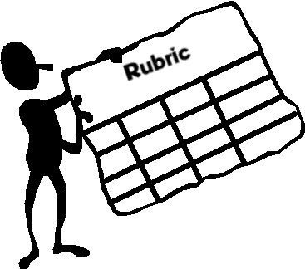**Have you found enough information?**

**Presentation**

**How Will You Present the Information?**

Will you: handwrite; use Word; Publisher; PowerPoint; other?

Keep it simple and focus only on highlighting the adaptions.

Examples on following page…….

**Have a look at the two examples on the following page for inspiration!**

**Student Examples**

