**Science Inquiry**

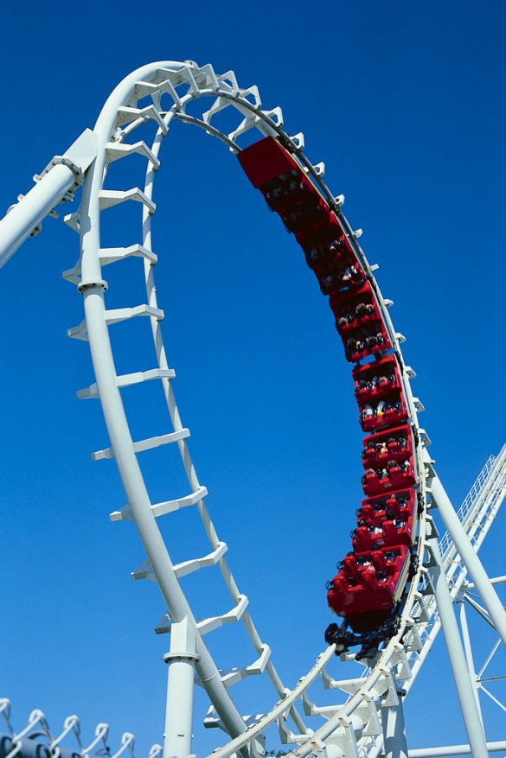

**How does an invisible force affect things?**

**Activities**

**C:\Program Files\Microsoft Office\MEDIA\CAGCAT10\j0305257.wmf**

By the end of these activities you will:

* Explore how forces can act on other objects.
* Help to explain results to an experiment.
* Safely use equipment and follow instructions.
* Record observations.

**For you to do – Activity: “Bendy water”**

In this experiment, you are going to see if water can be bent by a comb *without touching it*.

|  |
| --- |
| Materials:   * A plastic comb (like the one you use to comb your hair) * A tap   Method:   1. Turn on the tap slowly so that you have a very thin stream of cold water running 2. Using the comb, bring it close to the running water without touching it. What did you notice? 3. Now pass the comb through your hair 15 times 4. Again move the comb towards the running water but do not touch the water with it. |

A picture of my observations:

|  |  |
| --- | --- |
| Labelled diagram of water (no combing of hair) | Labelled diagram of water (once hair was combed) |

|  |
| --- |
| Do you have any questions about your observations? Write them here: |

C:\Users\crt\AppData\Local\Microsoft\Windows\Temporary Internet Files\Content.IE5\K975LXFD\MC900016661[1].wmf

Hopefully you have noticed that the water bent towards the comb. Don’t worry if you did not see this. It does not mean that your experiment didn’t work! There may be a scientific reason for this. The website below may help you.

<http://www.wikihow.com/Bend-Water-with-Static-Electricity>

If you can, try the activity again or use a blown up balloon instead of the comb. Rub it against your hair for 15 seconds.

**For you to do – Activity: “But Why?”**

Fill in the gaps to help you understand the science behind this.

|  |  |  |  |
| --- | --- | --- | --- |
| negative | towards | rubs | hair |
| attracted | static | stream | comb |

When an object ________against another, a type of electricity called _________electricity is made. This happened when the ________was passed through your ________. The comb became “charged” with __________ particles. These are called electrons. When the charged comb was brought near the _________ of water, the water was __________to the comb. Water has both positive and negative charges in its molecules. The positive ones were attracted __________the comb.

C:\Users\crt\AppData\Local\Microsoft\Windows\Temporary Internet Files\Content.IE5\XGYY5H84\MC900379063[2].wmf

Did you notice that the charged comb did not have to touch the water for it to bend? There was an invisible *force* acting between the comb and the water. Can you think of any other invisible forces?

**For you to do – Evaluation**

Put a tick the box that describes your learning.

|  |  |  |  |
| --- | --- | --- | --- |
|  | I am good at this | I am nearly there | I need help with this |
| I observed that forces can act on objects indirectly. |  |  |  |
| I can explain the result to an experiment. |  |  |  |
| I can safely use equipment and follow instructions. |  |  |  |
| I can record observations with a labelled diagram. |  |  |  |

[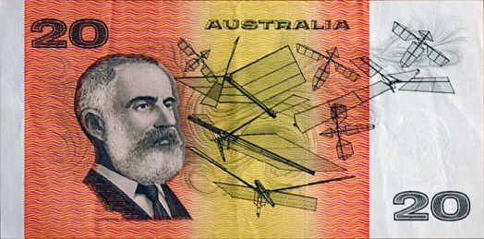](http://upload.wikimedia.org/wikipedia/en/f/fb/Aud20p.jpg)**DID YOU KNOW...**

On an old $20 bank note there is a picture of Australian inventor Lawrence Hargrave. He discovered that a curved wing surface gave more lift than a flat one. In 1894 he used this discovery to fly five metres in his box kite! This was well before the “first” airplane flight by the Wright Brothers in 1903.

**Activity**

By the end of this activity you will:

* **C:\Program Files\Microsoft Office\MEDIA\CAGCAT10\j0305257.wmf**Make a prediction
* Ask a question about an experiment and modify it follow instructions
* Safely use equipment and
* Make observations of what happened
* Suggest reasons for your observations

**C:\Users\crt\AppData\Local\Microsoft\Windows\Temporary Internet Files\Content.IE5\K975LXFD\MC900078622[1].wmf**

**I wonder what would happen if…**

Think about the Activity 1. Did you think about what would happen if you used hot water instead of cold? Scientists often come up with other questions they would like the answers to. They *modify* their experiments to find out more information.

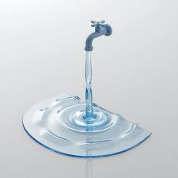

Here are some examples of other questions about the bendy water experiment.

* Does it matter if the hair is straight or curly?
* What happens if I pass the comb through my hair 10 times instead of 15?
* Does it make a difference if the comb is wet or dry?

This is Lawrence Hargrave with his box kite.

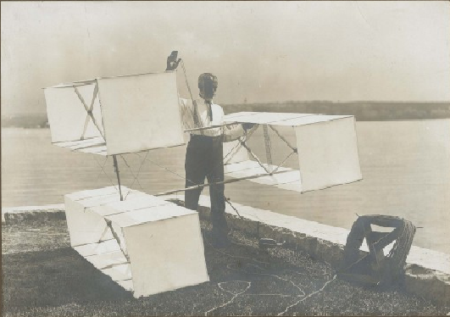

Courtesy of Powerhouse Museum.

He had to experiment many, many times before he was able to fly his box kite. He would try a design, test it, then modify it. The starting point is always a “wondering”. I wonder what would happen if ….

**For you to do – Activity 3 “More information please”**

For this activity, I would like you to modify the “Bendy Water” experiment. You may choose an example from the previous list or even better, make up your own question.

C:\Users\crt\AppData\Local\Microsoft\Windows\Temporary Internet Files\Content.IE5\K975LXFD\MC900434667[1].wmfFill in the following table about your experiment.

|  |
| --- |
| I wonder what would happen if… |
| I predict that … |

Now complete the experiment.

|  |
| --- |
| My observations (a labelled diagram is OK): |
| I discovered that … |
| I think this happened because… |

**For you to do – Evaluation**

Put a tick the box that describes your learning.

|  |  |  |  |
| --- | --- | --- | --- |
|  | I am good at this | I am nearly there | I need help with this |
| I can make a prediction. |  |  |  |
| I can ask a question to modify my experiment. |  |  |  |
| I can make observations of my findings and record my results. |  |  |  |
| I can safely use equipment to perform an experiment. |  |  |  |
| I can suggest reasons for my results. |  |  |  |