Exploring dissolving
Written by Deakin Science Ed @Geelong
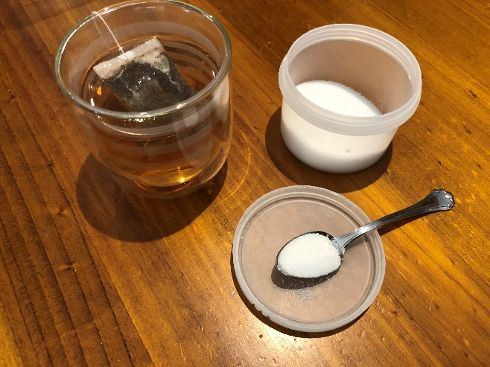
Introduction
Watch this video on dissolving https://vimeo.com/414609896
Answer the following questions:
- What do you think happens to the sugar in my tea when it goes into the cup?

- Draw and show what might be happening to the water and the sugar mixing together in my tea cup.

Investigation 1: Sugar dissolving
In this activity, we will explore what happens when we add sugar to water.

Use the investigation planner below, plan and conduct an investigation to answer the questions.

Plan for your investigation: What are you investigating? How are you going to investigate it?

Can you measure how much water it takes to make sugar dissolve?

Record, show and explain your results in the investigation planner below.
- What do you observe as the stages of dissolving? How can you represent this in your work books?
- Imagine you have a very powerful microscope. What is happening at the particle level. Represent what you think happens to the sugar in the water as it dissolves? How can you represent before, during and after the sugar is added to the water?

EXPERIMENT
- Put a teaspoon of sugar (approx. 5grams) into a small dish.
- Use an eyedropper or a teaspoon to drop water onto the sugar, count out 10 drops at a time.
- Draw what the sugar look like after each 10 drops.
- What evidence do you have that the sugar is not simply ‘disappearing’?
- Imagine you have a really powerful microscope that can see what is happening at the level of sugar molecules and water molecules. Represent what you think you could see through such a microscope.

Question for my investigation
I will keep the same
I will observe or measure
This is what I predict will happen and reasons for my prediction:

This is how I show and explain the results:

My Investigation Planner

Investigation 2: Dissolving different powders
Equipment for each group:
- 2 glasses or containers that are the same, 2 spoons.
- Choose two different powders: Select from baking powder, flour, salt or sugars eg, icing sugar, caster sugar, brown sugar.
- Access to hot water.

Follow the method from Investigation 1. Do you notice anything that is different with different types of powders.
Answer these questions
- What might affect the time it takes for the powder to dissolve? (temperature of the water, whether you stir or not, amount of water). Why might these variables affect the dissolving rate?
- If you were going to test whether the amount of water made a difference, how would you do that? What would you keep the same? What would you measure? What would you need to be clear about (e.g. how to judge when the sugar is completely dissolved)

Predict: Which would dissolve the quickest, which the slowest.
Ask for ideas about how to design an experiment to compare the dissolving rate for the different sugars. What (variables) would need to be kept the same?
Each group then decides on one variable they are going to test. They must present their plan for discussion before proceeding.

