**SCIENCE**

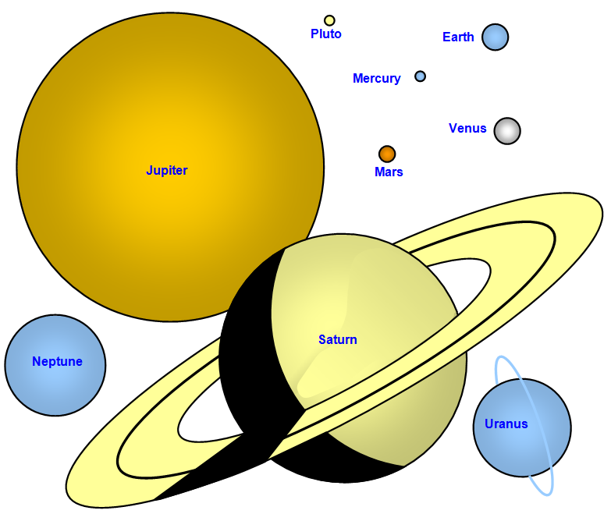

# What is Earth’s Place in Space?



## Welcome to Space

|  |
| --- |
| People have always looked with wonder at the movement of the celestial bodies in the sky. From the earliest astronomers such as Galileo to the advance technology of today we seek answers to the big questions about our solar system. http://cnx.org/content/m20189/latest/graphics2.png  These activities give opportunities to explore, observe and investigate our solar system to answer the following question:  **What is Earth’s Place in Space?**  **You will:**   * Develop basic knowledge about The Solar System. * Conduct an experiment and record observations on how craters are created. * Demonstrate the understanding on the Earth’s and Moon’s rotation through role play. * Record observations on the movement of the Earth and Moon. |

**What do you know?**

## Let’s begin with what you already know about our Solar System. At the end of the module you will reflect on your learning.

MCj04247880000[1]

## For you to do

## Write in dot point what you know about each of the topics in the boxes. Add more boxes if you need more space.

**EARTH**

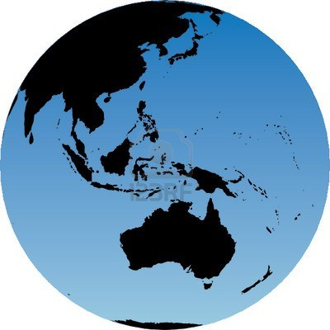

**What do you know? continued**

Sun

**Planets**

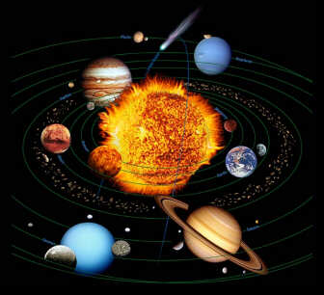

**Background Information**

Now that you have outlined your own understanding of the Solar System let’s take a snapshot of what scientists have discovered.

To do this you can view one or all three **YouTube videos** presented or/and **read** the information on pages 7 and 8. In addition you can explore some or all of the **websites** for further information.

MCj04247880000[1]

**Activity** —**For you to do**

Firstly view, listen and read the information presented. You have the option of pausing and rewinding if you have missed information. You do not have to take notes. You can choose to include your family, have a discussion….. Enjoy the experience!

Secondly, view, listen and read again. This time jot down words or/and phrases or facts and information that are new to you.

This will prepare you for your next task. Good luck!

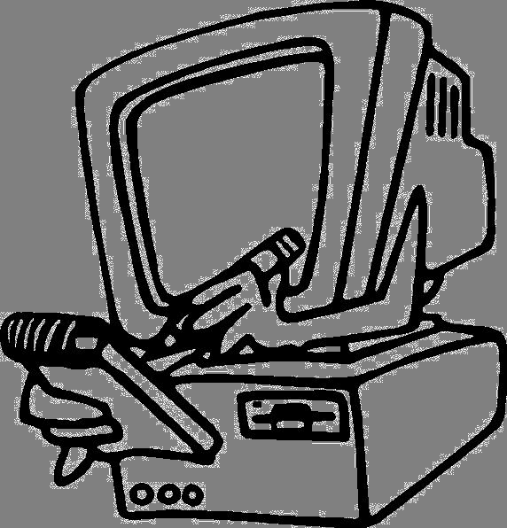

|  |
| --- |
| **Vocabulary**  You may be unfamiliar with some of the words used in the videos, websites and text. Please refer to the *Space Vocabulary* section at the back of this booklet. |



**YouTube videos**—The videos explore, describe and provide animated and real footage of the Solar System. The videos are:

|  |
| --- |
| **Space School**  This video explores the Solar System through animated visuals and narration.  [**www.youtube.com/watch?v=z_RAEESmsrs**](http://www.youtube.com/watch?v=z_RAEESmsrs) |
| **The Solar System—A brief glance**  This video explores all the planets together with text and music. The text is detailed and at times challenging but you do have the option of pausing if you have missed information.  [**http://www.youtube.com/watch?v=fmxi3HvK2Js**](http://www.youtube.com/watch?v=fmxi3HvK2Js) |

**Background information continued**

|  |
| --- |
| **The Solar System by Licoti**  Again this video explores the Solar System using both animated and real footage. There is no text, yet the visuals will enhance your appreciation of the Solar System.  <http://www.youtube.com/watch?v=KP6weKb47HQ> |

**Websites**

<http://nineplanets.org/tour/>

<http://www.solarviews.com/eng/homepage.htm> (have a view at each planet in detail and glossary)

<http://science.nationalgeographic.com/science/space/solar-system/>

**Information continued**



**Reading**

The following two pages outlines facts on what scientists have discovered about Earth’s Place in Space.

Read through so that you begin with a brief understanding on the topic. You will study the facts more closely later.

|  |
| --- |
| **The Sun, Moon and Earth**  The Earth is a planet in orbit around the Sun. The **orbit** takes slightly more than one year = 365 ¼ days – so we add an extra day to our calendar, 29th February, every fourth year which we call a leap year.  As the Earth slowly orbits the Sun, it rotates on its **axis** one every 24 hours (a day). The rotation of the Earth causes the rising and setting of the Sun and it is the reason we have night and day. The tilt of the Earth’s **axis** does not change as is goes around the Sun. This causes the seasons.  The Moon is a **satellite** of the Earth. It orbits the Earth once a month about 30 days.  We see the Moon from the Earth because the Moon reflects light from the Sun. The Moon itself does not emit light. The Sun is the only body in our Solar System that gives us light.  http://archive.d83.org/Teachers/wdmedia/wdmedia/gradelevel/2/planet/intro.png |

**Background information continued**

|  |
| --- |
| **The Solar System and beyond**  The Sun, Earth and Moon belong to the Solar System, which includes all the space objects that are in orbit around the Sun. A *space object* refers to naturally occurring objects in Space such as planets, asteroids, and comets. Space objects in the Solar System are visible because light from the Sun reflects off them to reach our eyes.  The Sun is the largest object in the Solar System, The Sun is so big that the planets and **asteroids** of the Solar System are attracted to it and revolve in orbit around it. The whole Solar System is moving at great speed through the **Galaxy**. Our Solar System is part of the **Milky Way Galaxy**, which contains tens of billions of stars. Our Universe comprises of billions of galaxies.  milky way  courtesy-www2.lns.mit.edu |

MCj04247880000[1]

**Activity** —**For you to do**—from your notes complete the following on the

next two pages.

1. **List** some of the **new** words and phrases that were presented in the Background Information. *This is new information that you have learnt not those listed earlier on.*
2. Write a short **summary paragraph** about what you’ve learned using as many of the list words as you can.
3. Complete your summary by inserting a **picture** of the important concept you have described.

**FOCUS ON THE FACTS—The Solar System**

|  |  |  |  |  |  |  |
| --- | --- | --- | --- | --- | --- | --- |
| New Words | | | | | | |
|  |  | |  | |  | |
|  |  | |  | |  | |
|  |  | |  | |  | |
| Phrases | | | | | | |
|  | |  | |  | |  |
| In My Own Words: A Summary | | | | | | |
|  | |  | |  | |  |
| Picture (label) | |  | |  | |  |
|  | |  | |  | |  |
| **Optional Challenge:**  Definitions of new terms: | |  | |  | |  |
| **-**  **-** | |  | |  | |  |

*Please attach addition paper if you require more space.*

**Taking a closer look at our Solar System**

|  |
| --- |
| MCj04247880000[1] **Activity** —**For you to do**  In this activity you will be observing a snapshot of the Solar System |

Turn to the following page and view the Solar System in detail. The image provides you with a snapshot of the Sun, Asteroids, Comets and Planets. It highlights their size, order to the Sun and physical look.

Spend some time taking a closer look and think about the following questions:

* *Which would be the hottest/coldest planet? Why?*
* *Which would be the brightest/darkest planet? Why?*
* *If there was life on a planet which one would be most likely/less likely? Why?*
* *Using your finger follow the blue line of the planet’s travel around the sun. Which planet would have the shortest/longest journey around the sun? Why?*

[**http://science.nationalgeographic.com/science/space/solar-system/**](http://science.nationalgeographic.com/science/space/solar-system/)



**Facts to Remember**

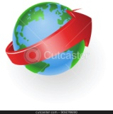The sun does not move, it is the centre of the Solar System.

All planets rotate on their axis

All planets travel around the sun.

There are 140 moons (also known as satellites)

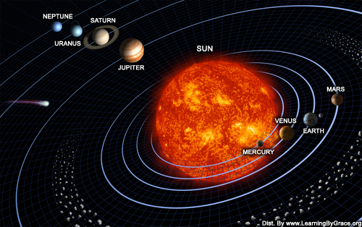

|  |
| --- |
| **MCj04247880000[1] Activity** —**Now let’s take a closer look at our own planet EARTH**  In this activity you are role-playing what an observer on the Earth might see based on how the Sun, Moon and Earth move. |

****Read the information below as it will help you complete your role play!

The Earth is the third planet from the Sun and the fifth largest. The Earth orbits (moves around) the Sun every 365 days (one year). The Earth also spins around its axis every 24 hours (one day). The moon revolves every 27 days.

**Seasons**

|  |
| --- |
| The Earth tilting on its axisThe Earth tilts (axis) at an angle of 23.5 degrees.  This means that different parts of the globe receive varying amounts of sunlight during the year, creating the seasons.  **http://startswithabang.com/wp-content/uploads/2008/07/earthrotate.gifDay and night**Imagine a rod going from the North Pole through the centre of the Earth and out of the South Pole. Over the course of 24 hours, the planet spins once around this central rod or 'axis'. When we're facing the Sun, the sky is light and it's daytime. Then we turn away from the Sun and it’s night.  **Moon**  **Moon** is the only [natural satellite](http://en.wikipedia.org/wiki/Natural_satellite) of the [Earth](http://en.wikipedia.org/wiki/Earth),and the [fifth largest](http://en.wikipedia.org/wiki/List_of_natural_satellites) satellite in the [Solar System](http://en.wikipedia.org/wiki/Solar_System). It is ¼ the size of the Earth. The Moon always shows the same face. It is covered in craters formed by Meteorites and Asteroids. The Moon is the brightest object in the sky after the [Sun](http://en.wikipedia.org/wiki/Sun), although its surface is actually very dark, similar to that of coal. Its prominence in the sky is its phases.. The Moon's gravity influence produces the [ocean tides](http://en.wikipedia.org/wiki/Ocean_tides).  **Phases of the Moon.**  http://en.es-static.us/upl/2012/06/moon_phases.jpeg  http://www.worldngayon.com/wp-content/uploads/2012/07/science.gifWhich phase can you currently see? |

|  |
| --- |
| **MCj04247880000[1] Activity** —**Revolving Role-Play**  In this activity you are role-playing the movement of the Sun, Moon and Earth. |

**You will need:**

* 1 torch
* 1 world globe or a large ball with a map of Australia (create one with colour paper) and attach.
* Small ball (this will be the moon)
* Clip board with pen
* One or two people (as the sun does not move you may only need one person)

**Preparation**

* Find an area for the group with enough room for the ‘Moon’ and ‘Earth’ to walk around the ‘Sun’. You will role play the Earth.
* Position the Sun (torch) to face you and shine the light toward ‘Australia.
* Position the moon behind you.

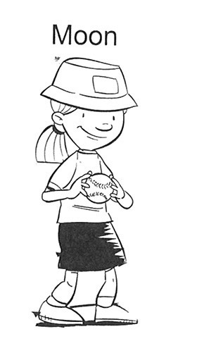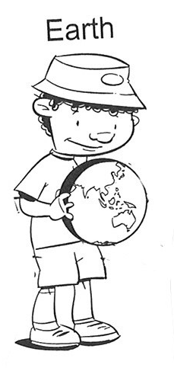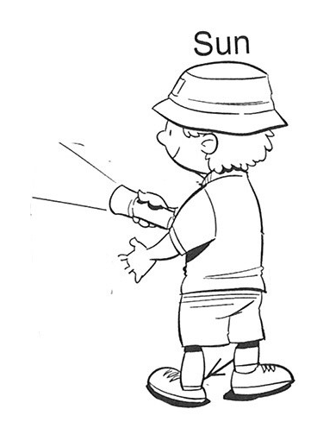

**Revolving play continued**

* If possible darken the room (allow you to view the torch’s light)
* Making sure the ‘Sun’ is still. Begin by slowly spinning the ‘Earth’ in a clockwise direction. **Make sure your body does not block the torches light.**
* *What is happening to Australia? Did you observe day and night?*

|  |  |
| --- | --- |
|  |  |

* The ‘Moon’ is now to move around the ‘Earth’. *What is happening? Does the shape of the Moon change when observing from the Earth?*



**Revolving play continued**

* Now it is time for the ‘Earth’ and ‘Moon’ to revolve around the ‘Sun’. Do this in a clockwise direction. Remember the ‘Sun’ (torch) must always shine on the earth. *What observations have you made? Seasons?*



* Change positions and observe your role.
* Discuss your observations with your team. Record them in the *Role-play observations* below and on the next page.

More interesting facts!

* Earth orbits the Sun at an average distance of about 150 million kilometres every 365.2564 mean solar days. Wow!
* The four seasons are a result of Earth's axis of rotation being tilted more than 23 degrees.

**Role Play observations**

|  |  |  |
| --- | --- | --- |
| **Earth:** | **Observation** | **Explanation** |
| Spinning on its axis |  |  |
| Moon revolving around the Earth |  |  |
| Earth revolving around the Sun |  |  |
| Moon | Observation | Explanation |
| Moon revolving around the Earth—  phases |  |  |
| Other | Other | Other |

**What is Earth’s Place in Space?**

In the next activities you will:

- Research and produce a detailed study on a chosen feature of the Solar System (travel brochure).

- Create a visual representation of the Solar System.

- Observe the night and day sky and make observations.

|  |  |  |
| --- | --- | --- |
| **Get ready for a journey**  **. . . . . Out of this world!**   |  | | --- | | * Can humans survive on any of the planets? * How long would it take to reach a planet? * Is there life on the other planets? * What is it like to be an astronaut? * Is a space travel holiday a possibility in the near future? * What sort of transport, clothes and food would you need for your space holiday? | |  |

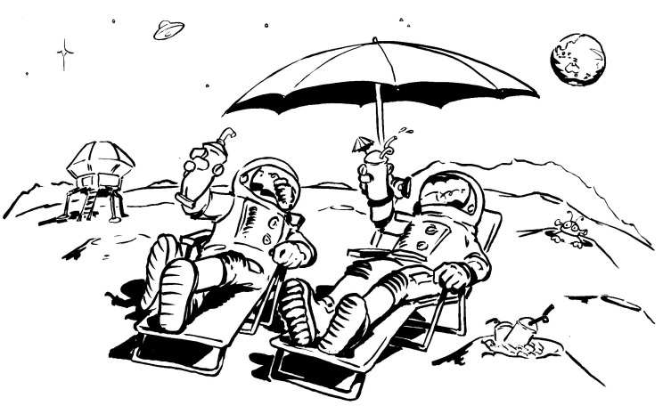

**Activity**

|  |
| --- |
| http://www.spacetourseg.com/Media/Space_Tours.gif  *You are going to be a travel agent selling holidays in space!* |

You will need to choose a “space place” as the holiday destination. It will be important for you to have knowledge of your “space place”.

Spend some time researching and investigating this place—for example a planet, major moon, meteorite or comet.

How will you “sell” your space place to your clients? They will need information. You will be using the information provided and your own research to prepare one of the following publications to persuade them.

* **Option 1**—Prepare a design brief and develop a *multimedia slide* show presentation e.g. *PowerPoint* to entice people to take a space voyage and to experience either a destination or travel within the solar system. This should be a maximum of 8 frames and include text, images and reference sources.
* **Option 2**—Prepare a design brief and develop a *colourful brochure* that will tempt people to visit your ‘Space Place’. Will it be the Moon, Saturn, Mars or somewhere else? Once again you can use your research notes to help.

**Background Information**

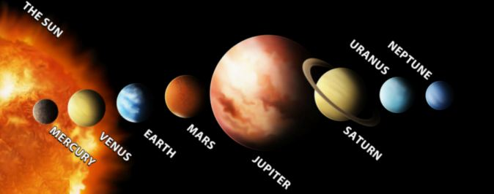

Before you choose your *Space Destination* read through the information below and on the following pages. In addition the following websites will provide further information and interactives.

[www.solarsystem.nasa.gov/planets/](http://www.solarsystem.nasa.gov/planets/profile.cfm)

The information is presented in order from the sun. In addition Asteroids, Meteorites and Comet information is presented in the order in which they appear in the Solar System.

|  |  |  |
| --- | --- | --- |
| **SUN**  [Color image of the sun.](http://solarsystem.nasa.gov/multimedia/display.cfm?IM_ID=2166) | | The sun is a star, a hot ball of glowing gases at the heart of our [solar system](http://solarsystem.nasa.gov/planets/index.cfm). Without the sun's intense energy and heat, there would be no life on Earth. Alhough it is special to us, there are billions of stars like our sun scattered across the Milky Way galaxy. |
| Sun-scorched Mercury is only slightly larger than [Earth's Moon](http://solarsystem.nasa.gov/planets/profile.cfm?Object=Moon). Like the Moon, Mercury has very little atmosphere to stop impacts, and it is covered with craters. Mercury's dayside is super-heated by the [sun](http://solarsystem.nasa.gov/planets/profile.cfm?Object=Sun), but at night temperatures drop hundreds of degrees below freezing. Mercury's egg-shaped orbit takes it around the sun every 88 days. | | **MERCURY**  [Black and white image of Mercury.](http://solarsystem.nasa.gov/multimedia/display.cfm?IM_ID=7543) |
| **VENUS**  [Color image showing Venus topography](http://solarsystem.nasa.gov/multimedia/display.cfm?IM_ID=9603) | Venus is a dim world of intense heat and volcanic activity. Similar in structure and size to Earth, Venus' thick, toxic atmosphere traps heat in a runaway "greenhouse effect." The scorched world has temperatures hot enough to melt lead. Venus spins slowly in the opposite direction of most planets. | |
| Earth is an ocean planet. Our home world's abundance of water -- and life -- makes it unique in our Solar System. Other planets, plus a few moons, have ice, atmospheres, seasons and even weather, but only on Earth does the whole complicated mix come together in a way that encourages life -- and lots of it. | **EARTH**  [Color image showing the full disk of Earth.](http://solarsystem.nasa.gov/multimedia/display.cfm?IM_ID=9643) | |
| **MARS**  [Water-ice clouds, polar ice, polar regions, and geological features can be seen in this full-disk image of Mars.](http://solarsystem.nasa.gov/multimedia/display.cfm?IM_ID=10167) | Mars is a cold desert world. It is half the diameter of Earth and has the same amount of dry land. Like Earth, Mars has seasons, polar ice caps, volcanoes, canyons and weather, but its atmosphere is too thin for liquid water to exist for long on the surface. Evidence for water now exists mainly in icy soil and thin clouds. | |
| Asteroids are rocky, airless worlds that orbit our sun, but are too small to be called planets. Tens of thousands of these "minor planets" are gathered in the main asteroid belt, a vast doughnut-shaped ring between the orbits of Mars and Jupiter. Asteroids that pass close to Earth are called Near-Earth Objects (NEOs). | **ASTEROIDS**  [Black and white image of asteroid Eros.](http://solarsystem.nasa.gov/multimedia/display.cfm?IM_ID=1887) | |
| **METEORITES**  [Color image of meteorite on Mars.](http://solarsystem.nasa.gov/multimedia/display.cfm?IM_ID=10293) | Little chunks of rock and debris in space are called meteoroids. They become meteors -- or shooting stars -- when they fall through a planet's atmosphere; leaving a bright trail as they are heated to a bright glow by the friction of the atmosphere. Pieces that survive the journey and hit the ground are called meteorites. | |
| Jupiter, the most massive planet in our Solar System -- with dozens of moons and an enormous magnetic field -- forms a kind of miniature Solar System. Jupiter does resemble a star when viewed from the Earth. The planet's swirling cloud stripes are punctuated by massive storms such as the Great Red Spot, which has raged for hundreds of years. | **JUPITER**  [A true-color image of Jupiter taken by the Cassini spacecraft. The Galilean moon Europa casts a shadow on the planet's cloud tops.](http://solarsystem.nasa.gov/multimedia/display.cfm?IM_ID=9523) | |
| **SATURN**  [Color image of full image of Saturn.](http://solarsystem.nasa.gov/multimedia/display.cfm?IM_ID=8983) | It is not a solid planet but made up of gases! Adorned with thousands of beautiful ringlets, Saturn is unique among the planets. All four gas giant planets have rings -- made of chunks of ice and rock. Like the other gas giants, Saturn is mostly a massive ball of hydrogen and helium. | |
| |  | | --- | |  |   It is not a solid planet but made up of gases. Nearly a twin in size to Neptune, Uranus has more methane in its mainly hydrogen and helium atmosphere than Jupiter or Saturn. Methane gives Uranus its blue tint. | **URANUS**  [Color image of Uranus with small moon in front of it.](http://solarsystem.nasa.gov/multimedia/display.cfm?IM_ID=10191) | |
| **NEPTUNE**  [Voyager 2 captured this image of Neptune in 1989.](http://solarsystem.nasa.gov/multimedia/display.cfm?IM_ID=2424) | Dark, cold and whipped by supersonic winds, Neptune is the last of the hydrogen and helium gas giants in our Solar System. It is not solid. More than 30 times as far from the sun as Earth, the planet takes almost 165 Earth years to orbit our sun. In 2011 Neptune completed its first orbit since its discovery in 1846. | |
| Comets are cosmic snowballs of frozen gases, rock and dust roughly the size of a small town. When a comet's orbit brings it close to the sun, it heats up and spews dust and gases into a giant glowing head larger than most planets. The dust and gases form a tail that stretches away from the sun for millions of kilometers. | **COMETS**  [Color image of comet against a background of stars.](http://solarsystem.nasa.gov/multimedia/display.cfm?IM_ID=2323) | |

Now you can choose your destination and the format of your presentation.

|  |
| --- |
| * *Develop* a research action plan which should include:   • how you will conduct your research  • research questions or headings  • resources required   * As you research save any images that may be useful for your brochure or multimedia presentation. * It will be important for you to document your sources for all information and images. * Use the *Research report notes* and the *Organisational Checklist* we’ve provided for your planning. |

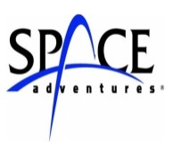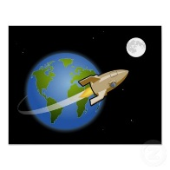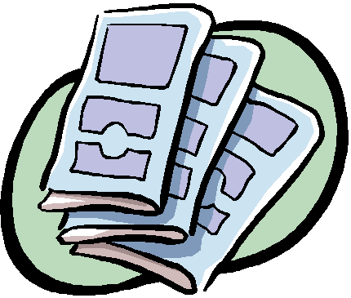

|  |  |
| --- | --- |
|  | |
| **Space Holiday—Travel Brochure** | |
| **Your task:**  *Design* and *produce* a travel brochure advertising the attractions of the planet or moon that you have chosen. (This could be produced using a computer program such as *Microsoft Publisher*, *Microsoft Word* or similar software. If you are unable to do this, try another way.) |  |
| **Why use a brochure?**  One way that people learn about places, people, or things that they do not know is by reading about them. But what if they don't have time to read a whole book or they just want a quick overview of the subject? Businesses often use brochures to inform, educate, or persuade — quickly. They use a brochure to grab the reader’s attention and get them interested enough to want to know more.  A travel brochure may show beautiful pictures of exotic places — making you want to visit that city or country. These types of brochures tell enough about a place to get your interest and make you want to know more.  **What information should you include in your brochure?**  The brochure is not an in-depth study but it should give enough information to grab and keep the reader’s interest from start to finish.  It shouldn't contain so much information that it overwhelms the reader. Choose 2 to 3 key points to describe your space holiday. If there are other important elements, consider listing them in a simple bullet list somewhere in your brochure.  **What will your brochure look like?**  You must decide the best format to present your information. Different formats work best for brochures with lots of text, lots of pictures, small blocks of text, lists, charts, or maps. You'll need to find the format that works best for you. Have a look at other brochures to get some ideas.   * Before creating your publication, check the *Assessment rubric* on the following page for reminders of the criteria. * On completion of your publication, check the *Assessment rubric* againto see that you have met the criteria. | |

|  |
| --- |
| Carefully read the following information to help you with your:   * Planning * Research * Presentation |

**Activity**

|  |
| --- |
| **Make a model Solar System**  **Aim**: The aim of this activity is to create a model of the Solar System.  You will be:   * **naming** the planets of our solar system * describing the relative **sizes** of our planets and their relative **distances** from the sun * describing the planets in terms of their **distinguishing features** |

**Method**

You have several options offered to you depending on time and materials available. One is outlined in detail in this module but there are many others you can choose from. Some are outline below and over the page.

|  |  |
| --- | --- |
| *http://thinkcrafts.com/files/2011/02/FloraCraft-Solar-System.jpg*  *Polystyrene balls, placing the Sun in the centre.* | *http://t0.gstatic.com/images?q=tbn:ANd9GcTTFzvMM0FCsHrjRPnAAOjDtygUq6ojYQXvZQ4m7B3oKq9DNh3swOsnDTY3*  *Colour paper on poster* |
| *http://bloximages.chicago2.vip.townnews.com/tetonvalleynews.net/content/tncms/assets/v3/editorial/1/95/195e68f0-70fa-11e0-a628-001cc4c002e0/4db85cdd49141.image.jpg*  *Using fruit to represent the planets* | *http://www.preschools4all.com/image-files/space-lesson-plans-mobile.jpg*  *Paper mobile* |

|  |  |
| --- | --- |
| **Solar System examples continued** |  |
| *http://2.bp.blogspot.com/_ruBaQaeHSx8/SwWG0DhahVI/AAAAAAAAFkQ/621n_yNf3dQ/s1600/Solar+System.JPG*  *Paper mache or polystyrene on spokes* | *http://www.redtedart.com/wp-content/uploads/2012/05/Solar-System-FIMO-1024x682.jpg*  *Using plastescne or play dough* |
| *http://www.artforhomeschool.com/wp-content/uploads/2011/11/ignaciosolarsystem4.jpg*  *Illustrate the solar system* | *http://4.bp.blogspot.com/-9QUTi3OtI9s/TnenbRP0c5I/AAAAAAAAC9Q/k4Fivl1SfRo/s1600/solar+system+mat.bmp*  *Use 3D models and draw the line of orbit.* |

Your model should show the relative sizes of the planets, the order and distances from the sun. Try to incorporate some of the obvious major features of the planets into your model such giant storm on Jupiter, the polar caps of Mars or the oceans and land and water of Earth would be examples of this.

**Websites**

View and read the information on the websites given in this module for further information on each planet. Keep the information brief but highlight important facts in point form only.

**Activity**

|  |
| --- |
| **Sky Tours—from your backyard!**  In your final activity on *Our Place in Space* you will be making observations skywards from your back yard. |

Many of the features of our Solar System can be viewed from you backyard.

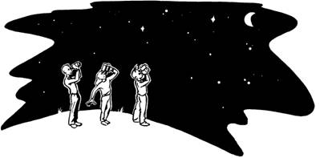**What will you expect?**

Initially, try to locate all objects with the naked eye. After making naked eye observations, a small telescope or binoculars could be used to see more detail. Astronomy

**Observation Log and Sketch Template**

**Draw what you saw in the circle. In point form only describre your observations – *When? Where? What? Why?***

As the Earth rotates on its axis during the night, stars seem to move slowly across the sky—rising in the east and setting in the west, like the Sun during the day.

Observe the movement on the Sun and Moon from your backyard or inside your own home over a 12 hour period.

Record the movement such as Harry and Jai’s pictures below.

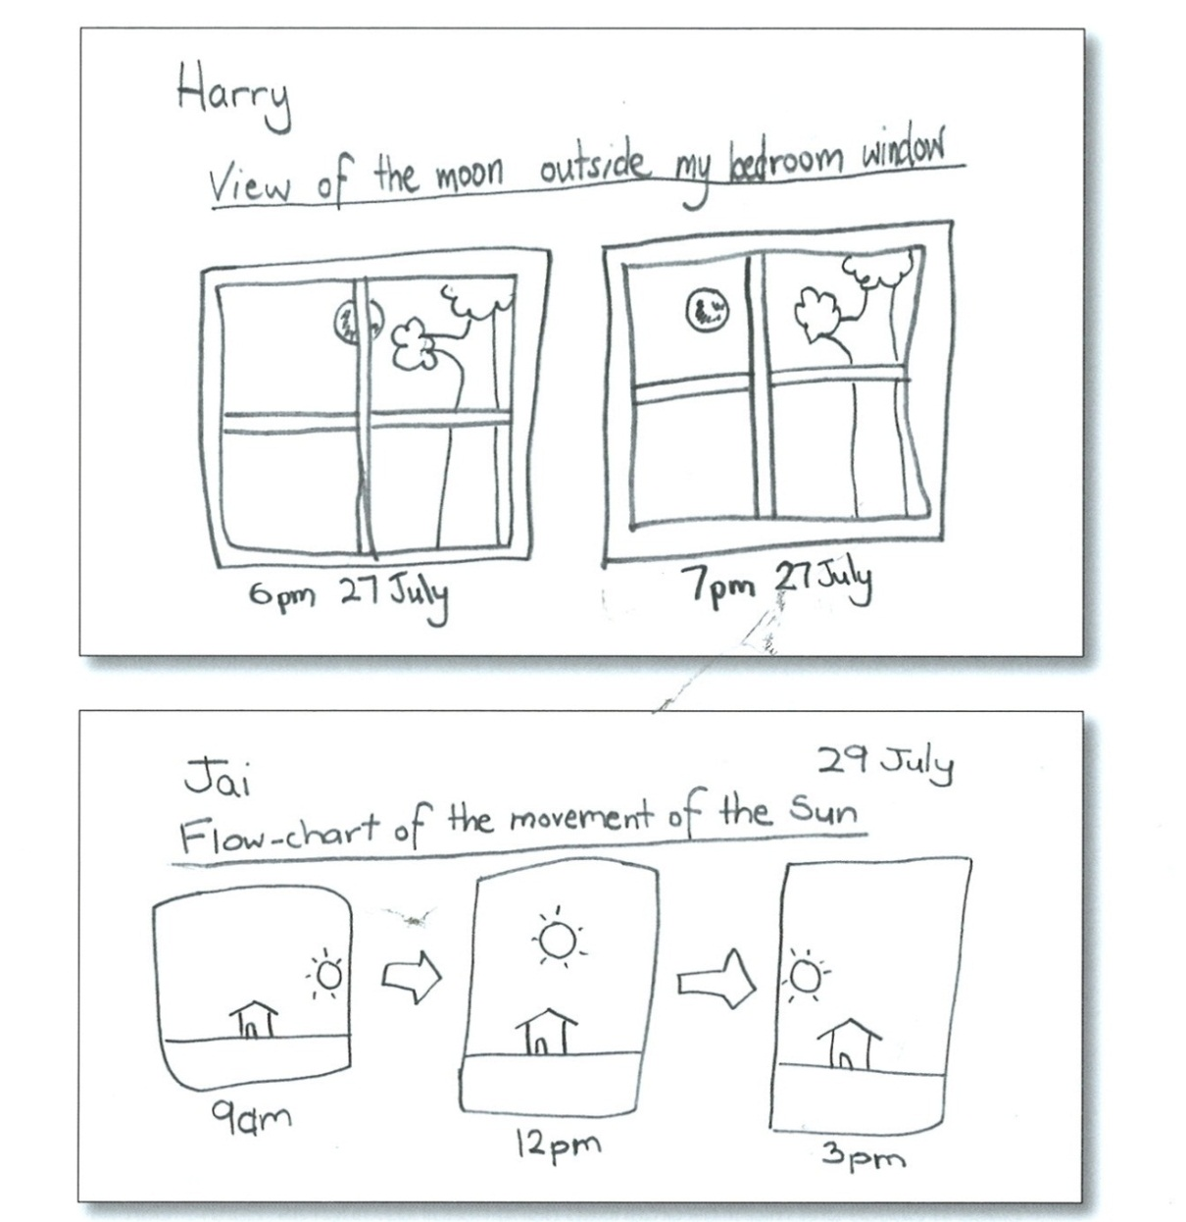

*Important note: Do not stare into the Sun. It’s bright light is damaging to the eyes!*

|  |
| --- |
| **Space Vocabulary** |
| asteroid — small, rocky body that orbits the sun. Most are located between Mars and Jupiter in a region called an asteroid belt; also called planetoids.  astronomy — study of celestial bodies, what they are made of and their magnitudes and motions.  atmosphere — the gases that surround a planet or moon, held in place by the force of gravity.  axis — imaginary line through poles of a planet, about which it rotates.  comet — body of ice and dust in orbit around the sun that develops a tail of ions and dust as it approaches the sun.  corona — sun’s outer part, visible as a halo during a total solar eclipse around the edge of the moon.  crater — bowl-shaped hole on a surface made by a volcanic explosion or the impact of a body such as a meteoroid.  density — measure of an object’s mass in relation to how much space it occupies.  eclipse — effect caused by one body casting a shadow on another. A solar eclipse occurs when the moon passes between the sun and Earth, casting a shadow on Earth. A lunar eclipse occurs when Earth passes between the sun and the moon, casting a shadow on the moon.  gas giants — largest four planets in the Solar System (Jupiter, Saturn, Uranus, and Neptune) made largely of dense gaseous atmosphere.  geocentric — discredited theory that Earth is the centre of the Solar System.  gibbous phase — when a moon or planet shows more than half, but not all, of its face.  gravity — seeming force of attraction felt between two or more objects with mass.  heliocentric — theory that the sun is in the centre of the Solar System.  **Space Vocabulary**  infrared — invisible part of light, with longer wavelengths that are felt as heat radiation.  light-year — distance light travels in a vacuum in one year, approx 5.88 trillion miles  magnetosphere — magnetic field of a planet  mass — measure of the amount of matter an object contains, not dependent on gravity.  meteor — mass of rock or metal that enters Earth’s atmosphere, usually burning up before reaching the planet’s surface.  meteorite — mass of rock or metal that has survived friction of Earth’s atmosphere to reach the surface.  meteoroid — dust and debris that travel through space and become meteors when they enter Earth’s atmosphere.  meteor shower — large number of meteors burning upon entering Earth’s atmosphere, occurring when Earth’s orbit passes through debris from a comet.  moon — natural satellite of a planet.  nebula — cluster of stars, or a cloud of dust particles and gases.  orbit — path followed by a star, planet, or satellite around a more massive body.  penumbra — outer and lighter part of the shadow created by an eclipse.  phase — size of the illuminated portion of a planet or moon.  pole — end of an axis, or the point where an axis meets the surface of a planet (geographic); either end of a magnet and points where the magnetic forces originate (magnetic).  planet — low-mass body that orbits a star.  rotation — turning around a centre or an axis, or to turn in a circle.  **Space Vocabulary**  satellite — small object, natural or artificial, that orbits a larger object.  solar flare — explosion on the sun’s surface causing a flaming arch millions of miles long, due to a shift in the sun’s magnetic field.  solar system — planets and bodies that orbit the sun and any group comprising a central star and orbiting planets.  solar wind — stream of charged particles emitted from the sun.  sunspot — darker and slightly cooler region on the surface of the sun, created when powerful magnetic fields stop the circulation of gases.  terrestrial — smallest planets in the solar system, made primarily of rock.  ultraviolet — powerful radiation, or energy, that has a wavelength shorter than light.  umbra — dark central zone created by an eclipse.  volume — amount of space an object occupies.  wane — decrease in the phase of a moon or planet.  wax — increase in the phase of a moon or planet. |
| **Spring equinox** - day and night are each 12 hours long and the Sun is at the midpoint of the sky and rises in the east. **Summer solstice** - the longest daytime of the year, when the Sun is at its most northern point in the sky. **Autumn equinox** - day and night are each 12 hours long and the Sun is at the midpoint of the sky and rises in the east. **Winter solstice** - the shortest daytime of the year, when the Sun is at its most southern point in the sky. |