**Science**

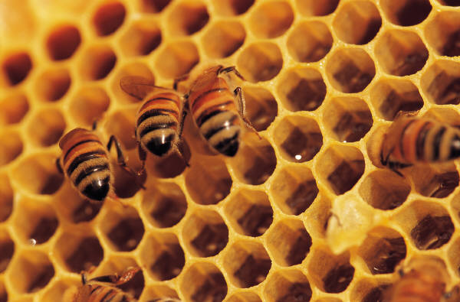

**What role do mini-beasts play in our environment?**

**Activities**

C:\Program Files\Microsoft Office\MEDIA\CAGCAT10\j0305257.wmfYou will:

* Summarise your understanding of mini-beasts by filling in a PMI chart.
* Classify mini-beasts into 4 classes.
* Define what an *exoskeleton* is.

**FOR YOU TO DO: Activity - Website activity** – Go to:

<http://tinyurl.com/nbdcqmb>

Use this information to fill in the chart below. It’s a P M I chart.

P = Plus = good things; M = Minus = not so good; I = interesting things you learnt.

|  |  |  |
| --- | --- | --- |
| P | M | I |
|  |  |  |

C:\Users\lmarcon\AppData\Local\Microsoft\Windows\Temporary Internet Files\Content.IE5\9A53F8CX\MC900083970[1].wmfBugs like the ones in this video belong to the group of living things called ARTHROPODS. There are lots of types of arthropods. Arthropods have a hard outer covering called an exoskeleton. These little critters wear their skeleton on the outside. *Exo* means “outside” in the Greek language.

The numbers of legs and body divisions help to classify bugs into smaller classes. These are

* insects (beetles)
* arachnids (spiders)
* myriapods (centipedes, millipedes)
* crustaceans (slaters, crabs and crayfish)

**FOR YOU TO DO: Activity – Classifying mini-beasts**

Take a look at the images of mini-beasts on the next page. Classify, then *cut and paste* the pictures of the arthropods under the correct headings on the page that follows.

|  |  |  |
| --- | --- | --- |
| Green Carabid beetle | Centipede | Goliath beetle |
| Lady bug | Sac spider | Bumblebee |
| Redback Spider | Blue crab | Common housefly |
| Slater | Grasshopper | Stick insect |

|  |  |  |  |
| --- | --- | --- | --- |
| Arachnids | Insects | Myriapods | Crustaceans |
| * 2 body parts * 8 legs * No antennae or wings | * 3 body parts – head, thorax and abdomen * 6 legs | * 1 pair of antennae * Many small body segments * Many legs | * Number of legs can vary * 2 pairs of antennae * 3 body sections * Mostly found in the ocean but also include slaters |

**DID YOU KNOW?**

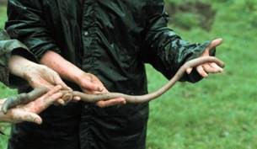

Museum Victoria - Giant Gippsland Earthworm

….that the East Gippsland Earthworms can grow up to 3 metres in length? The one in the photograph needs two people to hold it up!

When they were first discovered in the 1870s people thought they had found a snake. When scientists at the National Museum of Victoria investigated further, they described it as a new species of earthworm and called it *Megascolides Australis* – the Giant Gippsland Earthworm. Why do you think scientists decided that it was not a snake but an Earthworm?

**Activities**

C:\Program Files\Microsoft Office\MEDIA\CAGCAT10\j0305257.wmfYou will:

* Study the life cycle of a butterfly.
* Label a flow chart with the major stages of a butterfly’s life cycle.
* Complete a short mini project about the life cycle of an insect or spider.
* Link the role of bees to our own survival.

You have learnt how to classify arthropods and we discovered the features of these animals, such as the exoskeleton.

One problem that arthropods face is growth. Remember that they are covered by a hard outer skeleton, the exoskeleton. The skeleton is not very elastic making growth very difficult.

However insects have developed a clever solution to this problem.

**FOR YOU TO DO: Activity: Looking at life cycles**

1. Have you read the children’s book, “The Very Hungry Caterpillar” by Eric Carle?

Although this book is written for a younger audience, it introduces us to an important scientific phenomenon - life cycles. Have another listen to this story at:

<http://tinyurl.com/7rrq28x>

or read the story once again.

1. Study the life cycle of the butterfly.

Fill in the missing words with one from the list below:

chrysalis adult egg larva

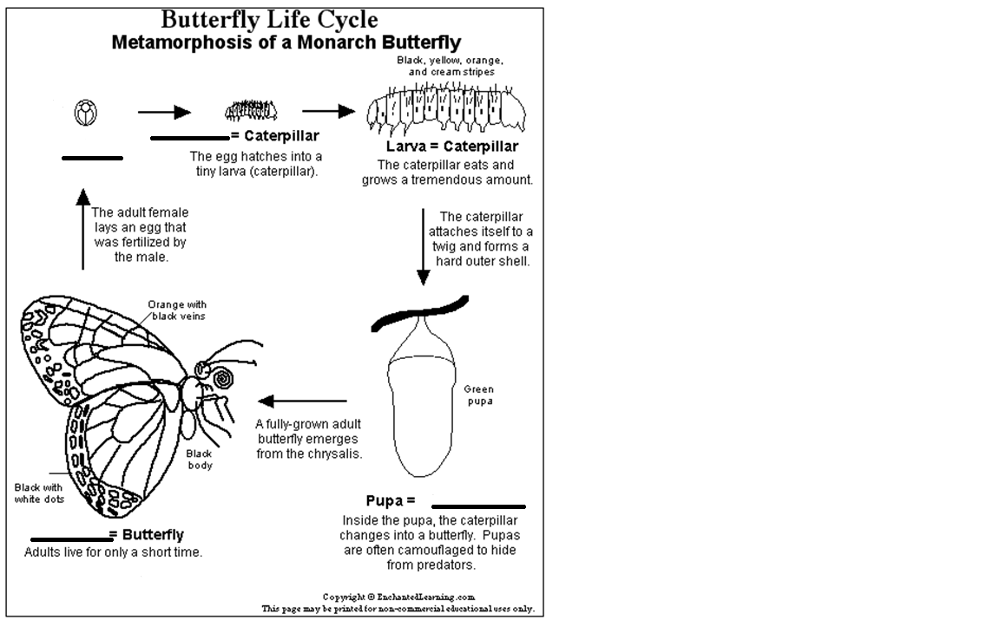

http://www.enchantedlearning.com/subject 1

The Lifecycle of the Butterfly 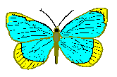

|  |  |  |  |
| --- | --- | --- | --- |
| dogs | adult | larva | metamorphosis |
| pod | grow | leaf | changes |

There are 4 stages in the life cycle of a butterfly. This lifecycle is very different from that of animals such as humans, ______ and cats. The cycle begins when __________ female butterflies lay eggs where it is safe, such as under a _______. The eggs slowly hatch and grow into ___________. The general word for insects going through this stage is called _________. Caterpillars then eat lots of leaves and _______ ready for the next stage in their life cycle. The pupa occurs when the caterpillar wraps itself inside their own _____ called a chrysalis. Inside this chrysalis the caterpillar _________ from the pupa into the beautiful butterfly.

**FOR YOU TO DO: Activity: Mini-project**

For this task you are to choose an insect or spider (not butterfly) and find out about its:

* lifecycle
* habitat (where it lives)
* body features
* food
* how it moves around
* how it is helpful to our environment
* any other interesting facts

You will need to do some research at a library, from your own collection of books or from the internet. Here are some websites that you may find helpful below.

<http://www.kidzone.ws/animals/lifecycle.htm>

<http://www.kidcyber.com.au/topics/animals.htm>

<http://museumvictoria.com.au/bugs/index.aspx>

You will need to present your information on a small poster. First, complete a rough copy, edit it and start on the good copy. Don’t forget to include a list of all the resources that you used to get your information.

**DID YOU KNOW?**

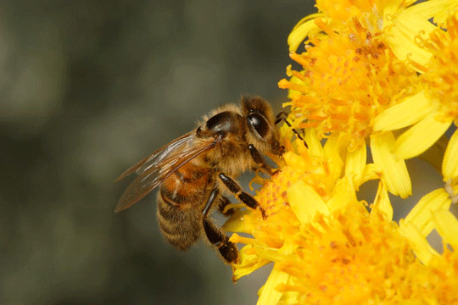

Here a female worker bee is collecting nectar and pollen from a flower. http://museumvictoria.com.au

…that the average hive contains 60 000 bees! Most of these will be female worker bees. As their name suggests, they “work” to keep the hive clean, make and repair wax combs and collect pollen, nectar and water for the male drones and queen bee of the hive. There are also some larger male drones – these bees don’t sting. There will be only one queen bee in the colony and its job is to lay eggs. It is very important to look after our colonies of bees because they pollinate our flowers – if this didn’t happen lots of the foods that we eat would not be around. What would happen to us if bees suddenly disappeared from Earth? Have a chat to someone at your home about this.

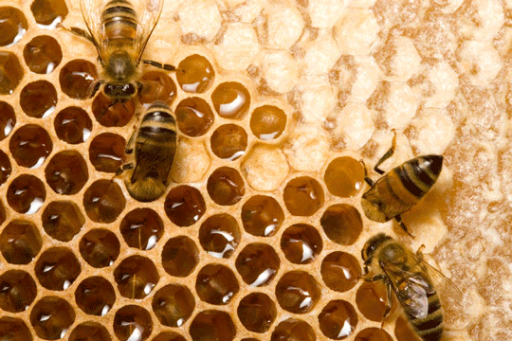

Here the worker bees are filling hive cells with honey. http://museumvictoria.com.au