**Science**

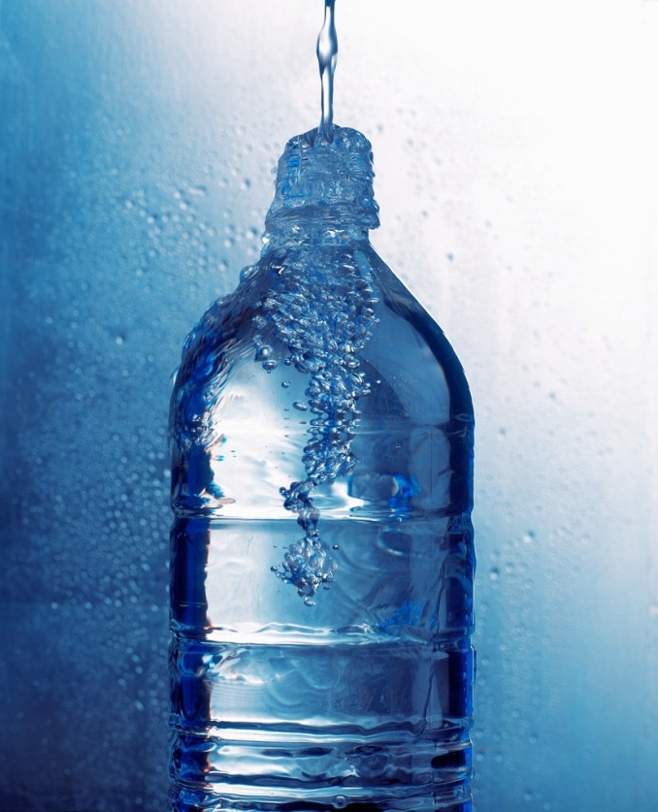

**What are the properties of water?**

**Activities**

C:\Program Files\Microsoft Office\MEDIA\CAGCAT10\j0305257.wmf

* List some uses for water.
* Design a new rover to explore the planet Mars.

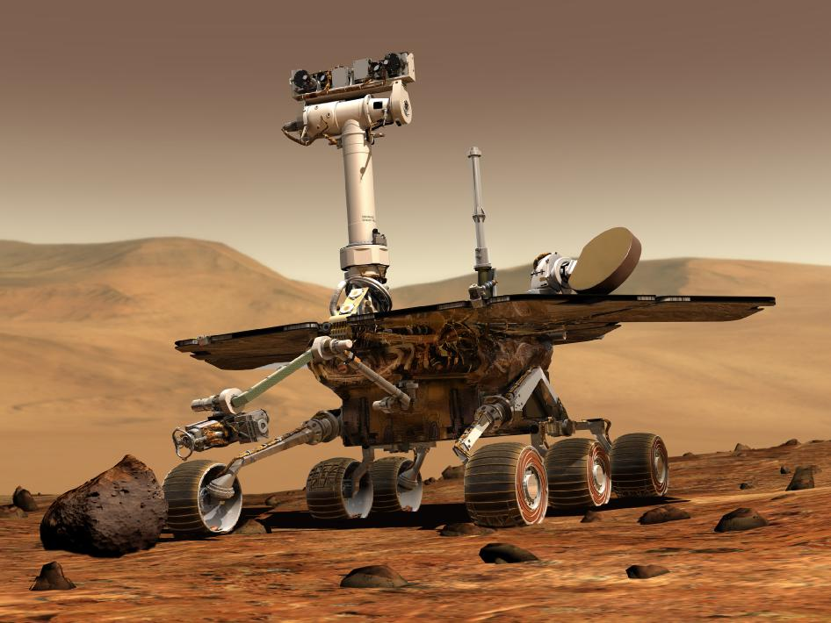

http://www.space.com/24394-mars-rovers-s 1

In 2014, the Mars Exploration Rover, “Opportunity” discovered that the environment on Mars was once very wet and the climate much more mild. This is strong evidence for the existence of past life on Mars! Scientists believe that evidence of water is evidence that life once existed on Mars. They are now more hopeful than ever of finding evidence of past life on this planet. The exploration rovers “Curiosity” and “Opportunity” continue to rove the Martian landscape to this day.

Water is needed to sustain life. Without water, there is no life on Earth. You will learn more about the properties of this valuable resource.

To begin with, list some uses for water:

**FOR YOU TO DO: Activity 1 – Uses of water: Describe or draw.**

**C:\Users\lmarcon\AppData\Local\Microsoft\Windows\Temporary Internet Files\Content.IE5\WBALC7Y9\MC900355963[1].wmf**

C:\Users\lmarcon\AppData\Local\Microsoft\Windows\Temporary Internet Files\Content.IE5\TG1GSW8B\MC900082491[1].wmf**FOR YOU TO DO: Activity - Design brief**

NASA has called for submissions for designs of a new rover for Mars. Your task is to complete your own design for this vehicle. You will need to consider things such as:

* How will the vehicle be powered?
* What materials will it be made out of?
* How big will it be?
* What type of attachments and connections are necessary to collect samples?
* What data will it collect?
* How long is it expected to last?
* Any special design features that will enable it to work on the Martian landscape?

C:\Users\lmarcon\AppData\Local\Microsoft\Windows\Temporary Internet Files\Content.IE5\TG1GSW8B\MC900217146[1].wmfYou may choose to complete this in your own unique way. Some suggestions include:

* Using recycled materials to create a model
* Using constructions blocks (e.g. Lego, Meccano, K’NEX)
* Computer generated design (give the name of the software or game that you used)
* Drawing a poster

Most importantly, don’t forget to give your design a name!

**DID YOU KNOW?**

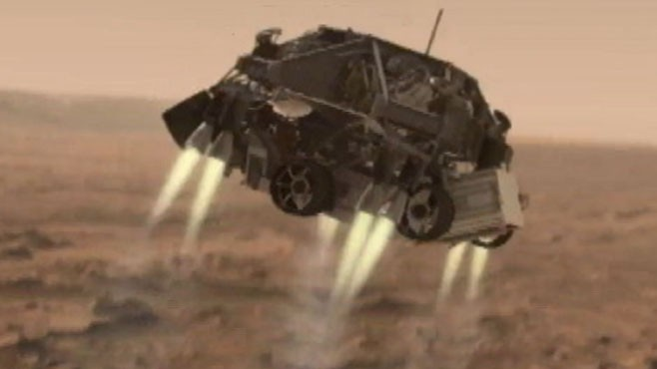

Here is an image of the Curiosity rover landing on Mars.

http://abcnews.go.com/meta/search/imageD 1

The Mars rover, “Opportunity” was only supposed to last 3 months. It is now over 10 years old! Well past its use-by date!

Vehicles like the Opportunity rover need energy to function, and there are no petrol stations on Mars! So engineers attached solar panels to the rover, with the knowledge that after about 3 months, the solar panels would be covered in Martian dust and no longer work. But new discoveries are made every day in Science and to everyone’s surprise, the frequent dust storms on the red planet actually cleaned the solar panels beautifully. Together with the “Curiosity” rover, the “Opportunity” continues to roam the Martian landscape today.

C:\Program Files\Microsoft Office\MEDIA\CAGCAT10\j0305257.wmf**Activities**

You will:

* Learn about a property of water – surface tension.
* Safely perform an experiment related to surface tension.
* Propose a question to learn more about factors that affect surface tension.
* Modify an experiment to learn more about variables which can change surface tension.
* Record an experiment in an simple report

You have learnt about the uses for water. Clearly without it, life would not be possible. Now we are going to learn about some of the properties of water.

A property describes how an object *looks, feels* or *acts*. For example, a property of a liquid like water is that it can flow. A property of clear glass is that it’s transparent – you can see through it.

**FOR YOU TO DO: Activity: Experiment – Can you walk on water?**

You probably can’t but mosquitoes can! Have you ever noticed how small insects seem to land or skim across on the surface of water and don’t sink? You will model this property of water in an experiment.

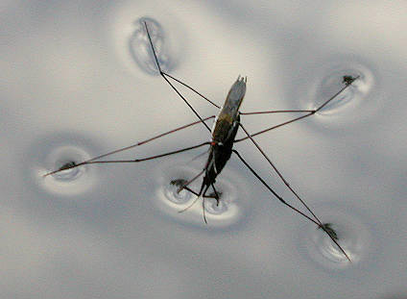

http://easyscienceforkids.com/all-about-mosquitoes

What you need (equipment):

* some small pins or paper clips
* container of water

What to do (method): When the water is very still carefully lower a pin or paper clip onto the surface of the water. You need to do this step very slowly.

If you can float one pin or paper clip, try another. How many could you float on the surface of the water before they all sank?

Results: Draw a labeled diagram of your experiment:

The property of water that you are investigating with this experiment is called *surface tension*. There is a “skin” on the surface of the water where the water molecules hold on tight together. The paper clip is not really floating on the surface; it is sitting on the surface. It is being held up by the surface tension forces that exist between the water molecules.

C:\Users\lmarcon\AppData\Local\Microsoft\Windows\Temporary Internet Files\Content.IE5\TG1GSW8B\MC900078711[1].wmf**FOR YOU TO DO: Activity: Experiment - Finding out for myself**

Now I’d like you to modify this experiment to see if the surface tension is changed by any one of these variables:

|  |  |
| --- | --- |
| * heat * salt * detergent | * oil * soap * free choice |

You will repeat Activity 1, but this time, you need to investigate what happens if something (variable) is changed.

Remember, in Science, you can only *change one variable at a time*. For example - you heat the water and add detergent and discover that you cannot float the pin. You don’t know if the reason why you can’t float the pin is due to the heated water or the detergent!

I would like you to repeat the experiment for two of the variables listed above **or** you can make up any two of your own free choice. *Make sure you only investigate one variable at a time.*

Before doing this experiment you need to write the questions you will investigate. For example:

*“What happens to the surface tension if I use soapy water?”*

For this task you need to:

* Record yourself doing one experiment

*and*

* Write a Scientific report (see below) for the other experiment.

Question: ________________________________________________

________________________________________________________

Purpose: To find out _______________________________________

________________________________________________________

Materials: I used these things:

________________________________________________________

Method: This is what I did:

________________________________________________________________________________________________________________________________________________________________________________________________________________________________________________________________________________________

Results: This is what I found out (describe and draw a picture)

Conclusion: I discovered that ________________________________

________________________________________________________

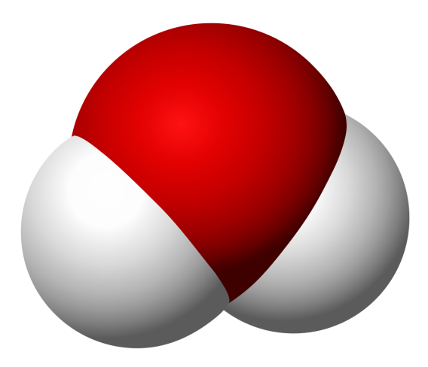**DID YOU KNOW?**

The chemical formula for water is H2O. A single water molecule is made up of 2 hydrogen atoms and an oxygen atom.

A model of it looks like this: