Exploring Evaporation
Written by Deakin Science Ed @Geelong
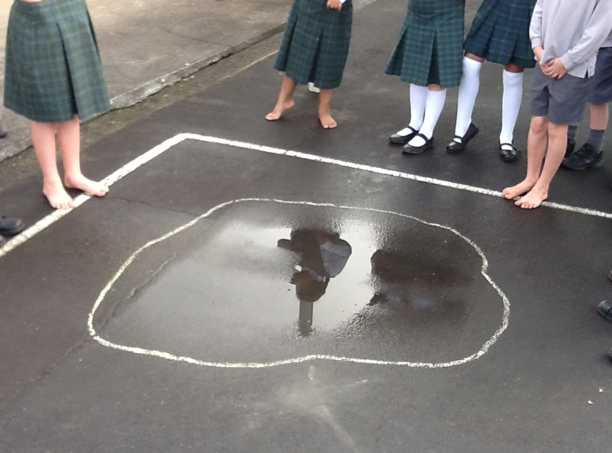
Introduction

Watch this video on water puddle https://vimeo.com/411939942 (Password: 123456)
Answer the following questions:
- What do you think happens to a puddle of water, once the sun comes out?

- Draw and show what might be happening to the water on the ground.

Investigation 1: Water Evaporation
In this activity, we will explore what determines how quickly a glass of water will evaporate.
Watch this video https://vimeo.com/411944864 (Password: 123456)

Use the investigation planner below, plan and conduct an investigation to answer the questions raised by Victor and Annabeth in this video.

Plan for your investigation: What are you investigating? How are you going to investigate it?

Check each day to track evaporation. Can you measure how much water evaporates each day?

Record, show and explain your results in the investigation planner below.

*This is how Victor and Annabeth are investigating into their questions https://vimeo.com/411951476 (Password: 123456) You could design a similar investigation or you might want to design your own investigation.

Question for my investigation
I will keep the same
I will observe or measure
This is what I predict will happen and reasons for my prediction:

This is how I show and explain the results:

My Investigation Planner

Investigation 2: Disappearing Handprints
In this activity, we will explore how quickly a wet handprint evaporates.
Conduct an investigate to see how quickly a wet handprint dries.
- Wet your hand and make a handprint on a paper towel or coloured paper.
- Draw around the handprint and watch as the towel/paper dries.
- You might want to do two handprints and put one in a (page sized) ziplock bag (see the pictures below).
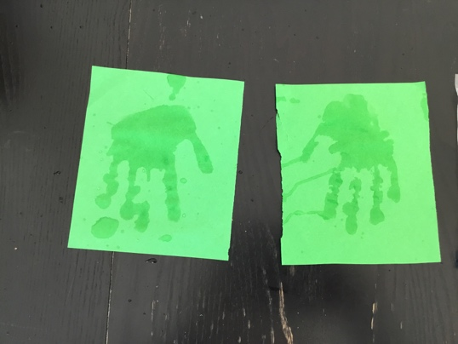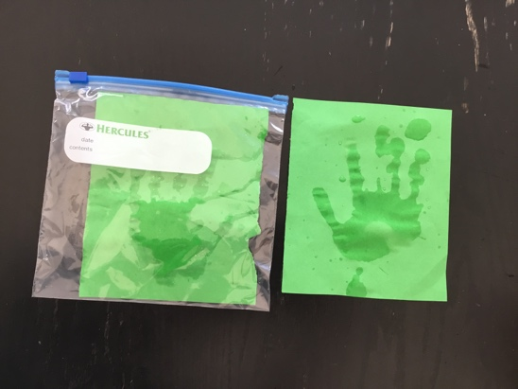
Answer these questions:
- What happens to the handprint on the paper without the ziplock bag, after 10 minutes, and then 20 minutes?

- What happens to the handprint on the paper inside the ziplock bag, after 10 minutes, and then 20 minutes??

- Explain the differences in your observations of the two handprints.

*You might want to check out this video after you have completed your investigations https://www.youtube.com/watch?v=iRLqAhaniyg

